Worksheet 1: Introduction to GameMaker (GM)
Learning Intentions: We are learning to be able to …
Become familiar with the GM environment.

Why are we learning this?
So we can use GM to develop our computational thinking over the coming term.

Success Criteria: I will be successful if I can …
• Correctly answer teacher questions about the GM environment, including the positioning and direction system
• Describe the etiquette GM programmers must follow
• Be able to create, run, save and close a GM file, and retrieve it on-queue.

Instructions:
Acquire and integrate knowledge:
- Read the geometry system and GM etiquette (below the questions on this worksheet).

The following picture applies to questions two through to six:
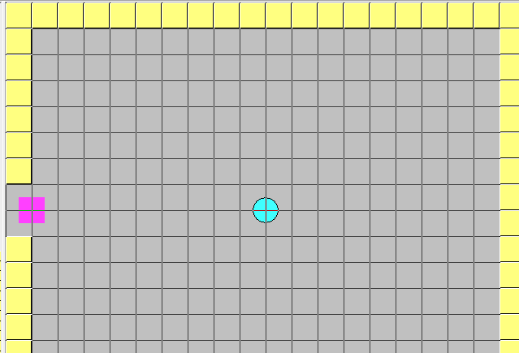

- Assuming the default dimensions of the room have not been changed, give an approximate X and Y position of:
  - The purple square: Click here to enter text.
  - The aqua ball: Click here to enter text.
  - The yellow brick in the bottom right corner: Click here to enter text.

- What direction value (using the GM geometry system) would the aqua ball have to face to be looking towards:
  - The purple square: Click here to enter text.
  - The yellow brick in the bottom right corner: Click here to enter text.

- If the purple square was to move towards the aqua ball in its default direction (0), would the movement be positive, negative or no change along the:
  - X axis: Click here to enter text.
  - Y axis: Click here to enter text.

- If the aqua ball was to maintain its default direction but head towards the purple square, would the movement be positive, negative or no change along the:
  - X axis: Click here to enter text.
  - Y axis: Click here to enter text.

- To practise saving your work, on your computer:
  - Create a new folder to save your GM files in
  - Open GM in advanced mode, and on an empty project add a room by right-clicking on the Rooms folder, and selecting Create Room:
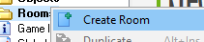
  - Now save the file in your freshly created GM folder – call it “empty game”
  - Hit Play:
  - Close the GM windows once you have finished
  - Re-open GM, and find and load your “empty game” file.

Extend and refine knowledge:
- Browse these game titles - https://www.yoyogames.com/showcase
- Which games have you played, of all these games made in GM?
Click here to enter text.
- Pick one of these games and find the awards it won (they were all made in GM):
Undertale: 2.5 million steam owners
Hotline Miami: 2.2 million steam owners
Risk of Rain: 1.5 million steam owners
Gunpoint: 800k steam owners
Nidhogg: 670K steam owners
Nuclear Throne: 500K steam owners
Hyper Light Drifter: 400K steam owners
VA-11 Hall-A: 150K steam owners
Rivals of Aether: 100K steam owners
(list current as of 2016)

Click here to enter text.

Use knowledge meaningfully:
- Investigate https://opengameart.org/ and start thinking about a game you’d like to make. Download some assets that you think are cool, you can import them later into GM. Keep your files organised.

What makes a good game? Is it better to have better graphics, or better game play? 2D games can be awesome!

Geometry system:

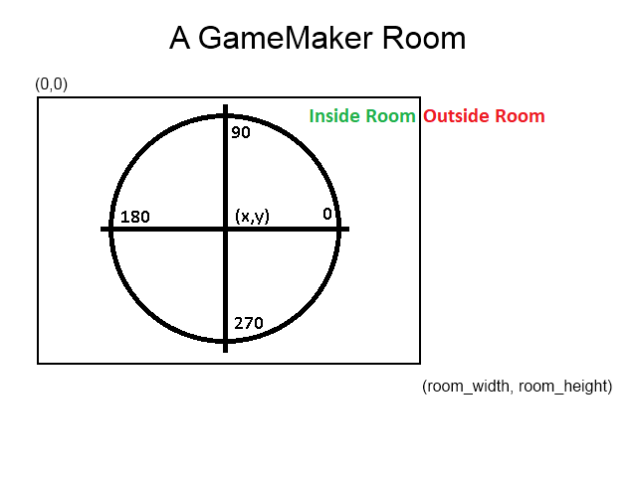

room_width global variable default value = 640

room_height global variable default value = 480

room_speed global variable default value = 30, meaning 30 “steps” (a.k.a. “cycles”) per second.

GM etiquette:
- always name sprites meaningfully (sprite0 is not acceptable)
- always name objects meaningfully (object0 is not acceptable)
- useCamelCase or under_scores when naming.. doesn’t matter which style you use, just be consistent
- consider the device you are building for. For example, if you are developing for a laptop, perhaps your users might not have a precision mouse
- make it clear how to play your games. The user should not have to think unnecessarily for themselves.

