Worksheet 2: Movement
Learning Intentions: We are learning to be able to …
Create sprites for objects, and make control these objects movement.

Why are we learning this?
Animation or movement formulates the basis for nearly all types of graphical games.

Success Criteria: I will be successful if I can …
- Create and explain sprites and their properties
- Move sprites using:
  - Fixed and free movement
  - Alternate direction
  - Use variables in movement and direction

Instructions:
Acquire and integrate knowledge:
- New GM file, and create sprites for an aqua ball and a yellow brick. Use resource 4_web_based\gamemaker81\sprites.html to explain how to create sprites if you need to. Default dimensions fine. Make sure you’ve added an empty room as well.

- Create two new objects:
objBrick
objBall
and assign the sprites:
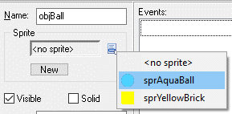
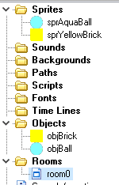

- Draw room with walls around side, and put ball in. Use shift key to draw walls quickly:
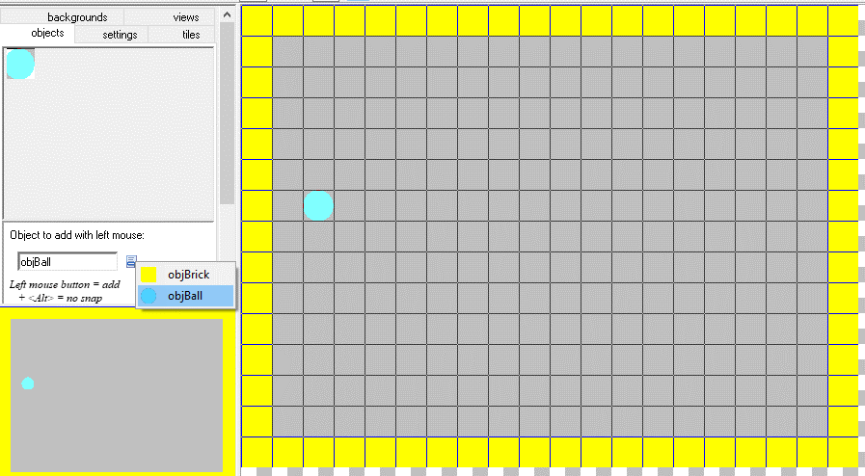

- Double click objBall and then Add Event:
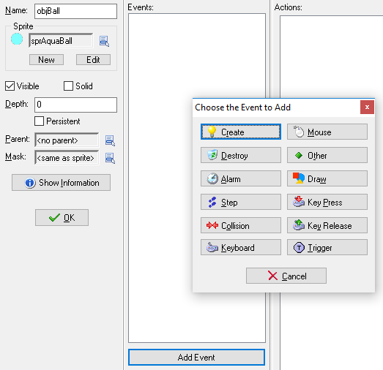

- Use resource 4_web_based\gamemaker81\objects.html for more info on events. For now, choose Create event.

- One at a time, drag and drop the first 6 Move blocks into the Actions panel. Try different settings for each action, play the game to test, then explain (in your own words) what each one does below when the object is created:

Action | Explanation
 | Click here to enter text.
 | Click here to enter text.
 | Click here to enter text.
 | Click here to enter text.
 | Click here to enter text.
 | Click here to enter text.

- What would happen if the follow scripts were put on the Aqua ball on a Create event:

Script | Outcome
 | Click here to enter text.
 | Click here to enter text.

Extend and refine knowledge:
- Remove Create event and add a Keyboard <Right> event:
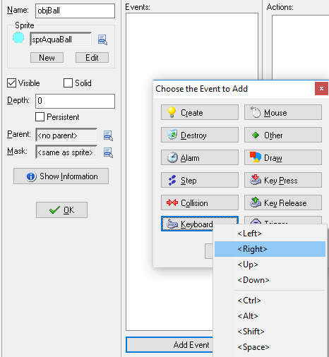
Add a Move Fixed action, but this time click the “Relative” box and put +1 in the Speed:
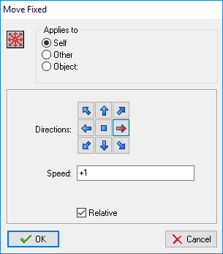
Play the game now and hit Right arrow key. Now change the +1 to a -1. Based on your findings, explain the difference between Relative and Fixed (i.e. not Relative box ticked) Values:
Click here to enter text.

- Add Events and Actions for the other arrow keys.

- Try the other keyboard Events – Key Press and Key Release. What is the difference to both of these, and a regular Keyboard Event?
Click here to enter text.

Use knowledge meaningfully:
- Hidden in the background are “Steps” aka “Cycles”. By default they run at 30 steps per second. Remove all other Events and add a “Step” Event:
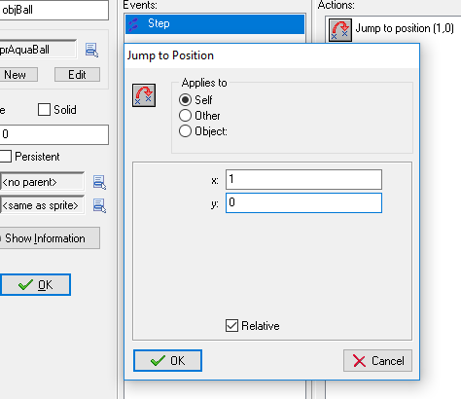
If my steps are 30 per second.. then this object will be moving at 30 pixels per second.

- What happens if I untick the Relative box in the above example? Explain how and why this behaviour happens.
Click here to enter text.

- There are lots more events, and even more when we start scripting using the GML language. Investigate the other events available, and see if you can work out which Event to add a Wrap Screen action to your object, so that if it goes out one side of the room, it appears on the other…

Hint:
