PhoneGap Desktop App
- Start New, Blank, give it a name and hit create project:
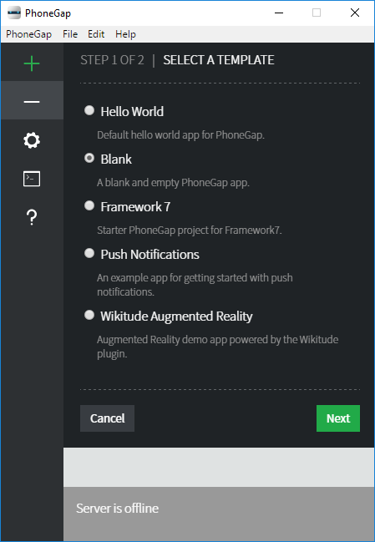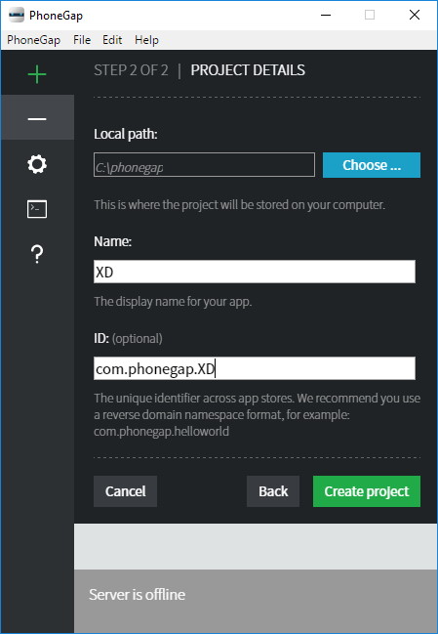

- www folder in project folder is where we build our app: 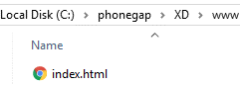

- open index.html in favorite code editor

- code directly underneath the cordova.js script link, between the body tags of the html:

- Emulate, and before clicking the memes button open More tools Developer tools in Chrome:
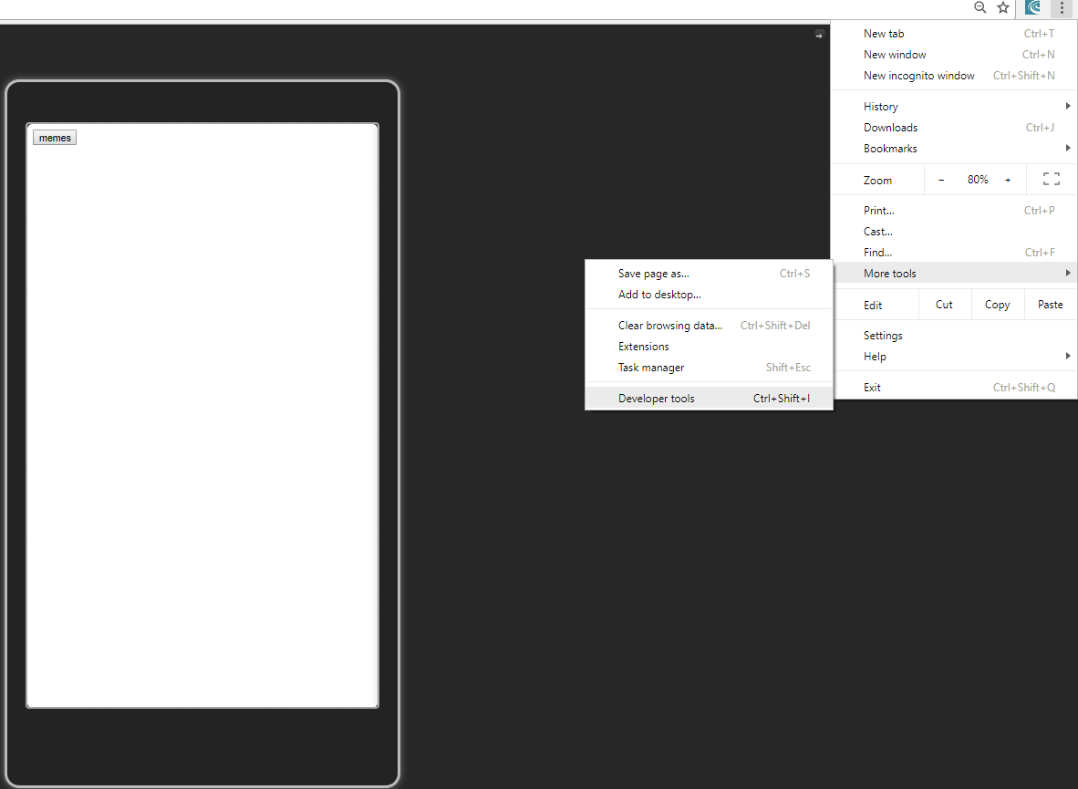
- View Console tab in Develop Tools, and hit memes button. You should see message swag logged in Console window on right (along with a million other messages you can ignore):
