Another screen
- Add an empty html file (ive kept using my last project):
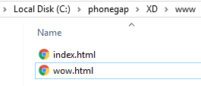

- Put some markup on it:
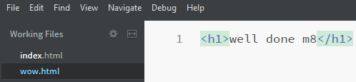

- Add code to index.html (under the last button will do):
- Preview in emulator and hit cool story bro button:
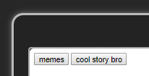
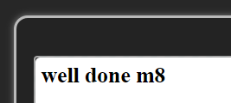

Export to a real phone (iOS or Android)
- Download Adobe PhoneGap Developer app (its free):
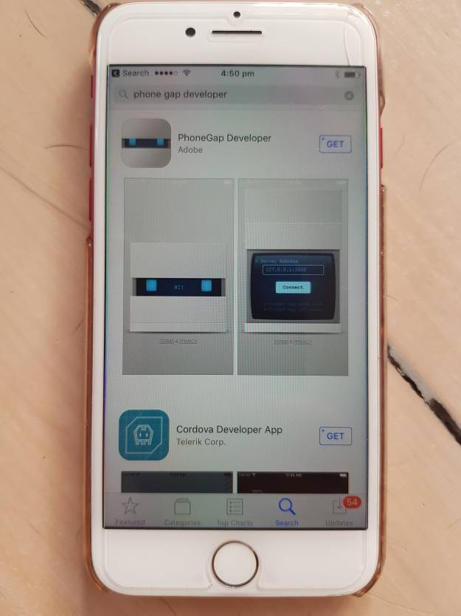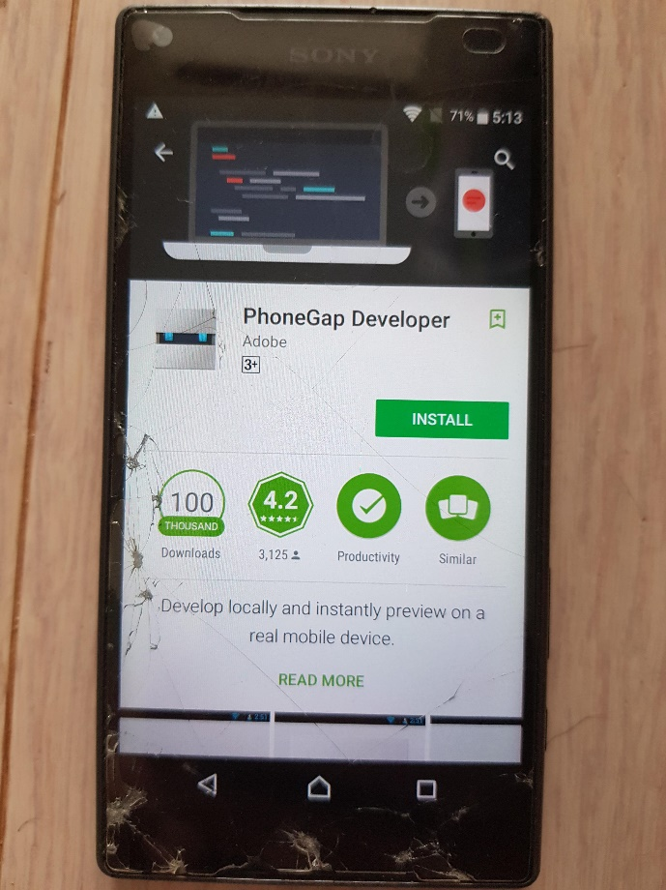
- Connect your phone to the same network as your desktop app, then launch the developer app on your phone:
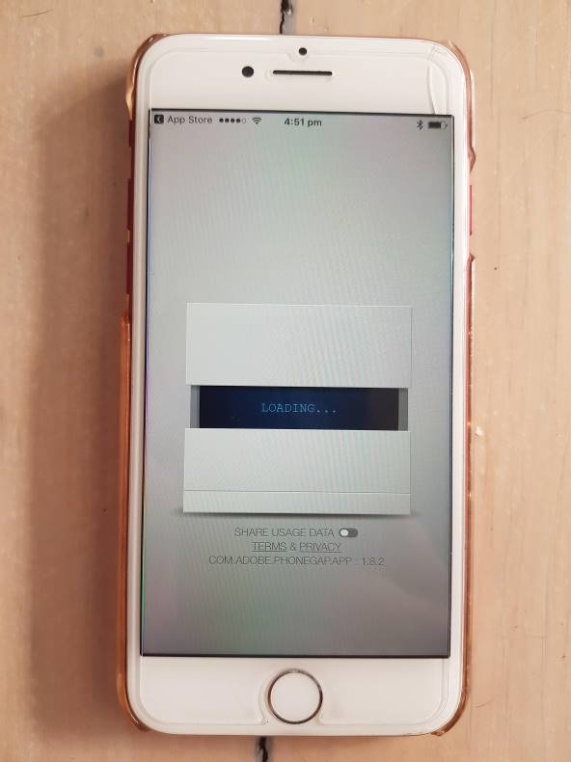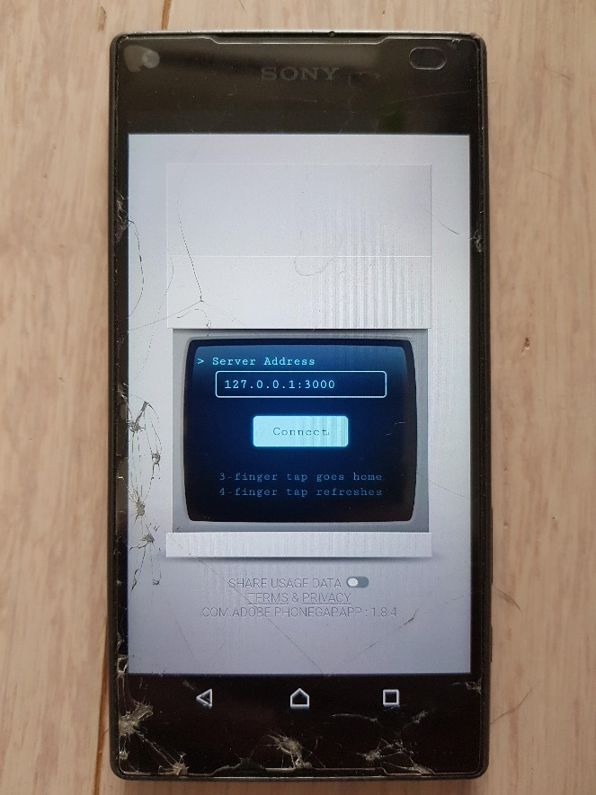
- Input in the IP address that is hosting your app, taken from the PhoneGap Desktop app, and hit Connect:
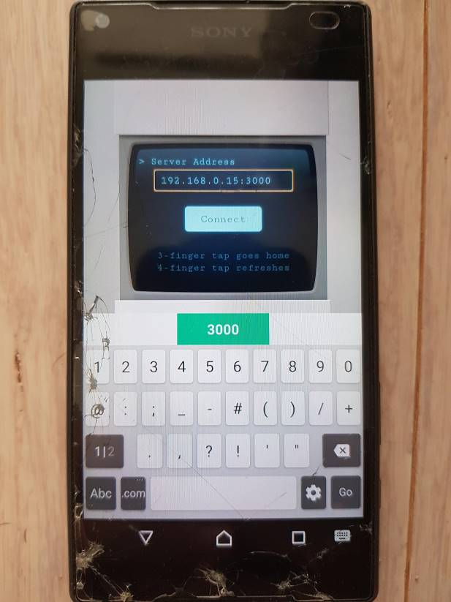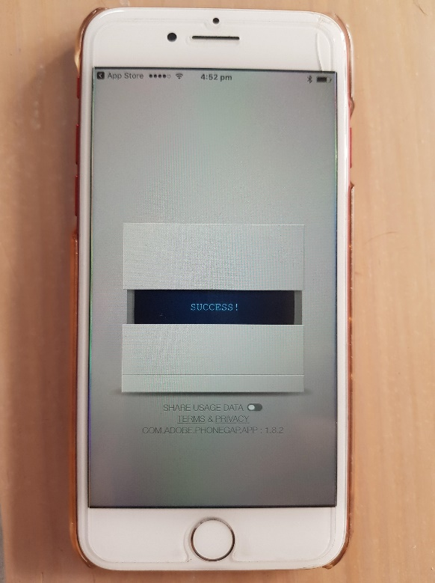

- Test your apps:
