Clean up JS
- Add a file myScripts.js (or whatever you want to call it as long as it has .js)
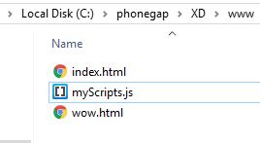

- Condense code to be much cleaner index.html, with programmer comments too:
- Much cleaner myScripts.js also:
- Should still work the same. Try it.

Appendix A: Complete code from index.html so far:

