Googley Maps
- Go to https://developers.google.com/maps/documentation/javascript/get-api-key and get a personal, non-shared API key (and keep it secure and private and don’t tell anyone):
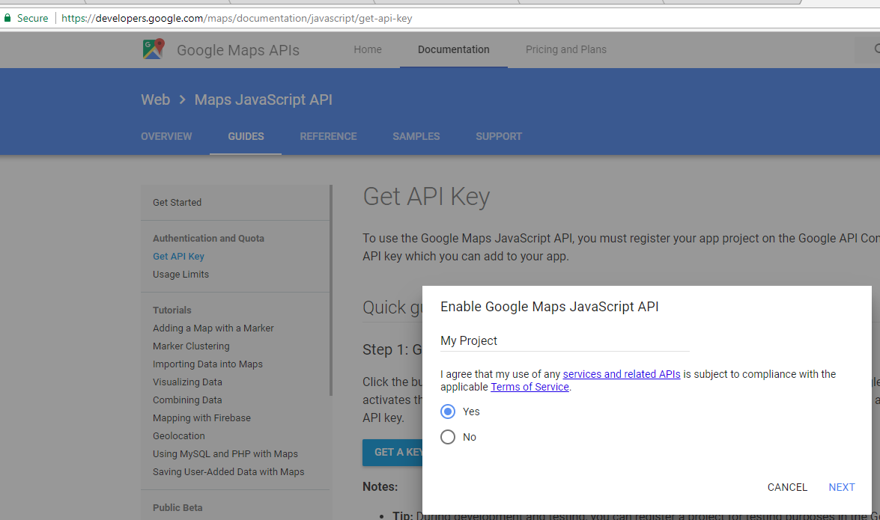
(you will need a gmail account.. and eventually this costs money - https://developers.google.com/maps/documentation/javascript/usage - “Users of the standard API: Free until exceeding 25,000 map loads per 24 hours. After exceeding the free usage limits, billing at $0.50 USD / 1000 additional requests, up to 100,000 per 24 hours.” So maybe just use mine for now?)

- Create new blank project, I called mine googleymaps:
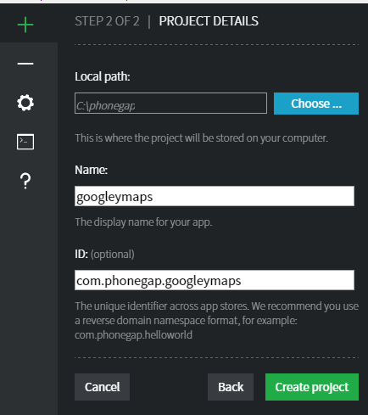

- Add a new file in the same folder called myScripts.js and add this script:

- Add the style and javascript calls to the main index.html:

- The highlighted bit above is the API Key you signed up for in step 1. Test and preview: 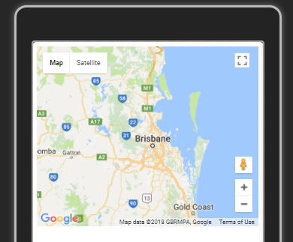

Add yourself to the map as a marker using GPS
Modify the myScripts.js as follows, and when you get asked for permission, Allow:
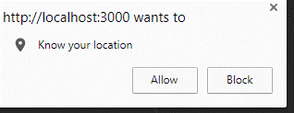
Or on your phone:
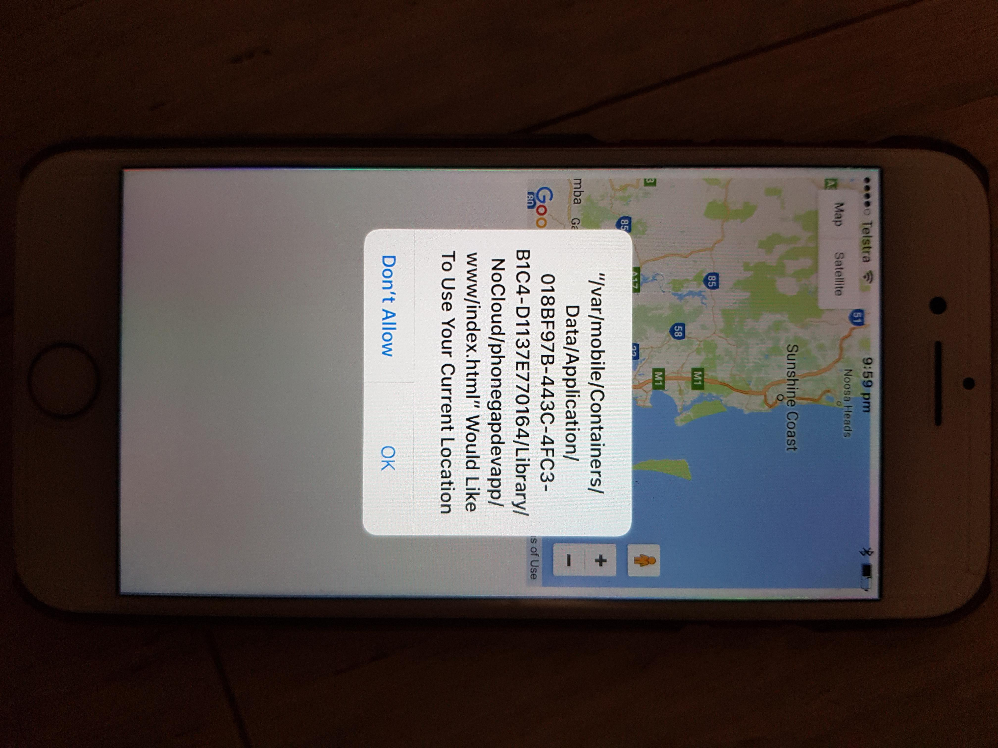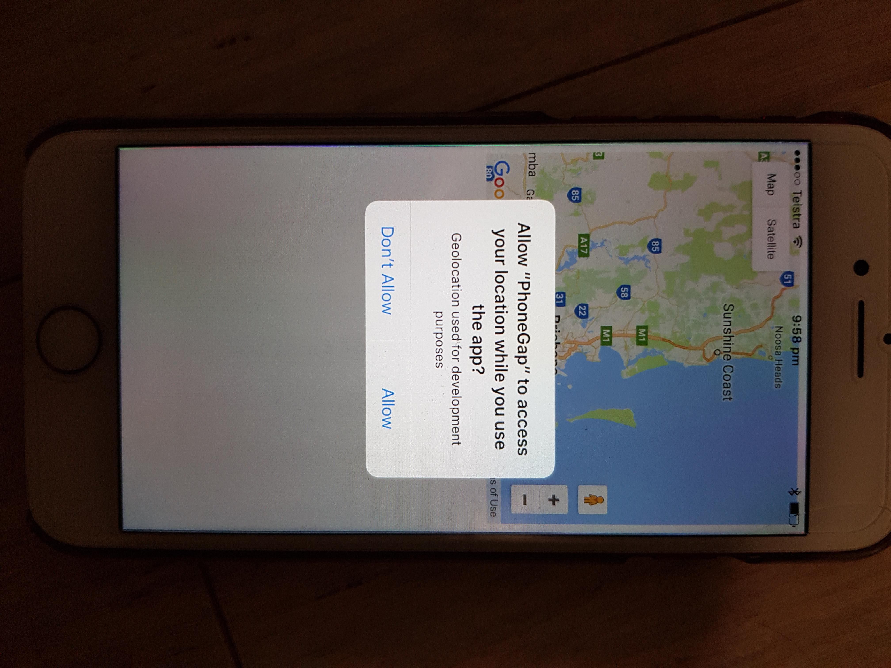

Override the Geolocation to Really Test the Map Marker
In Chrome, Developer Tools, More tools, Sensors:
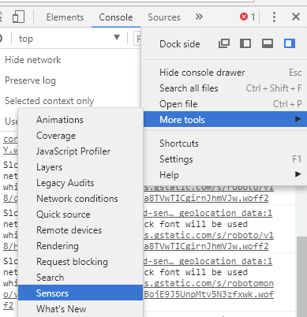
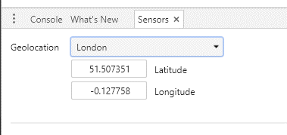
Refresh page – you may have to use http://localhost:3000 (and not the 192.168 IP address).. Google has a “policy to prefer secure origins for powerful new features”.. However http://localhost:3000 is considered a secure origin, so it may help you avoid a non-secure origin:
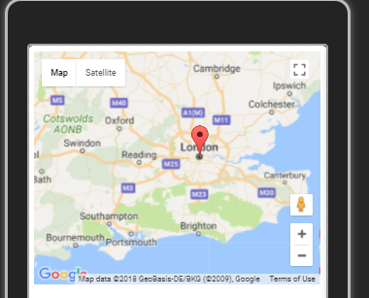

More Markers
Suttons Beach, Redcliffe button add to index.html:
And Javascript in myScripts.js:

