Slice Algorithm
By making sure a rebound isn’t simply “random”, we give control back to the user, and add skill to our game:
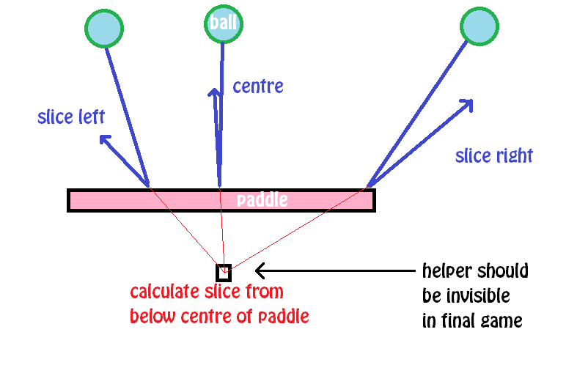

Draw Sprites
Draw Ball, Paddle and Helper sprites, and set costume center for all:

Ball:
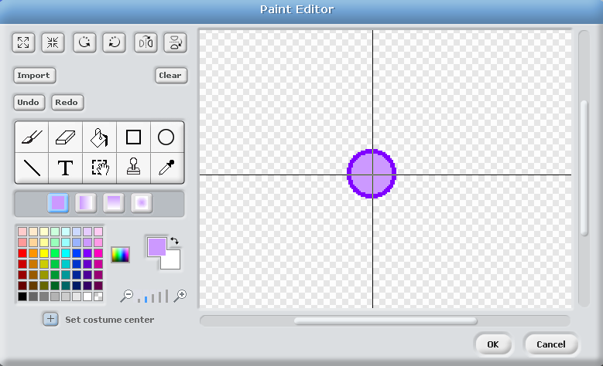

Paddle:
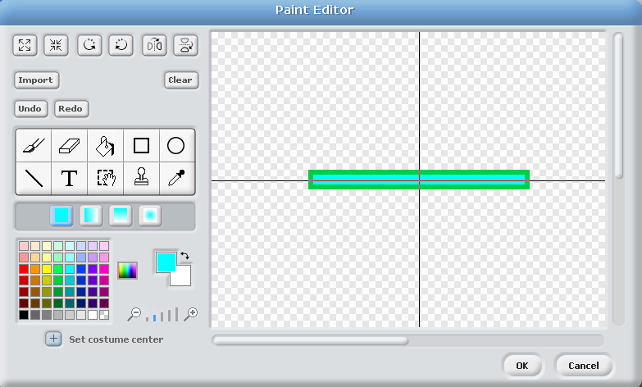

Helper:
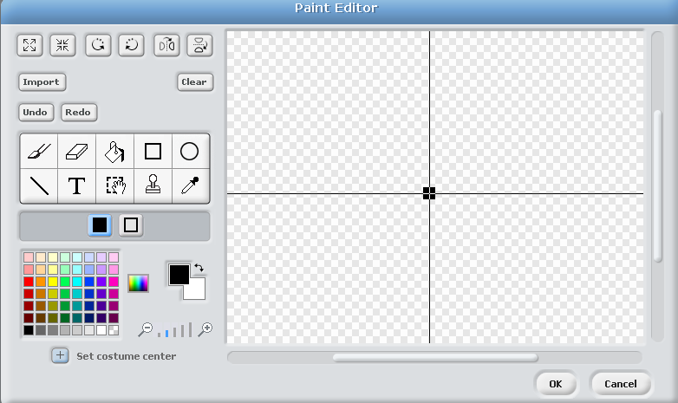

Add Code Blocks

Ball:
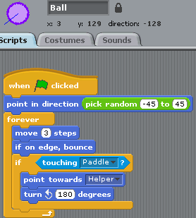

Paddle:
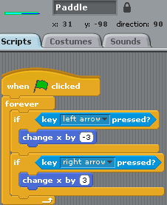

Helper:
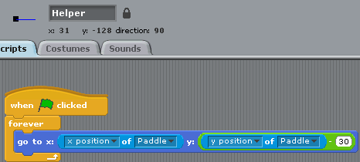

Finished Product:

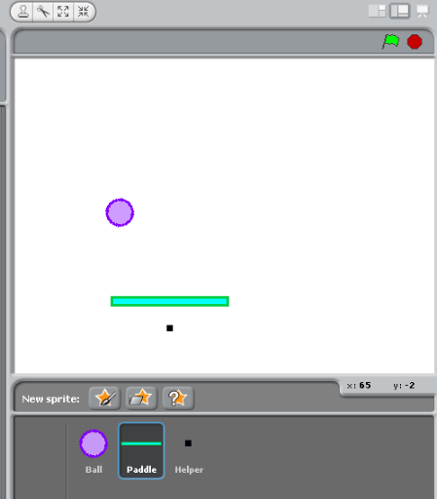

Challenges
Can you improve the game by implementing some of the following features?
- Bottom of screen area = out of bounds zone / game over
- Bricks / blocks:
  - That disappear when hit
  - That rebound the ball when hit
- Scoring:
  - From hitting blocks
  - From staying alive (measuring time)
- Bonuses:
  - That fly through sky
  - That fall from blocks
- Variable ball speeds:
  - That increase with time or score (perhaps increasing the difficulty)
- Advanced bonuses:
  - Two balls
  - Extended paddle size
- This game is a variant of Pong – could you use the physics in this to create a better version of Pong?
  - Can you create a CPU opponent for Pong?
  - Can you create the CPU opponent for Pong that is difficult to beat, but not unbeatable?

