Draw Sprites

Cube:
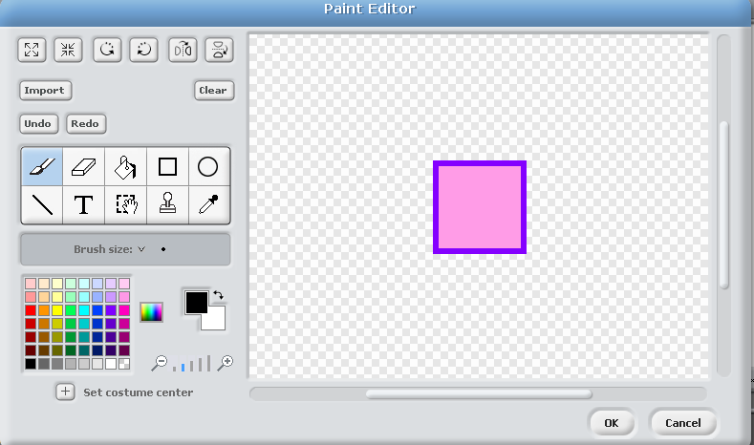

Platform:
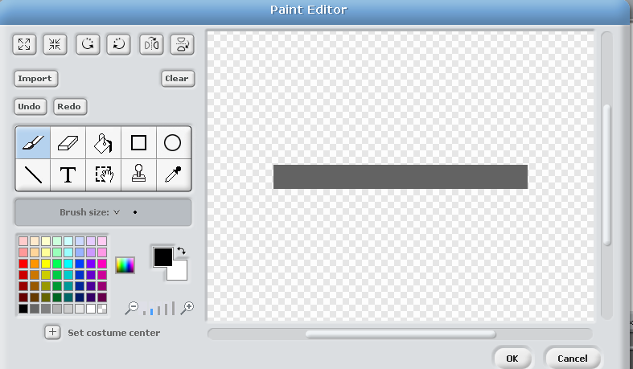

Add Code to Cube
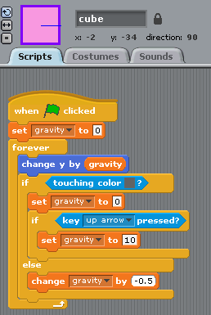

Finished Product:

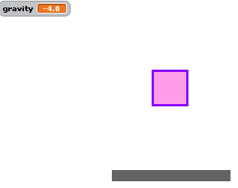

Challenges
Can you improve the game by implementing some of the following features?
- Change the cube to an animated person sprite (stick figure drawings are fine)
- Direction:
  - Right / left
  - Can you do it with a variable (e.g. horizontalSpeed)
- Level:
  - Add another platform to jump to (and a penalty for miss-timing jump)
  - Add a collectible (e.g. gold coin)
- Add enemies and scoring
- Extension: Flappy Bird Challenge
  - Remove the “if touching platform block / stop gravity” and halve anti-gravity boost to create flappy bird physics:
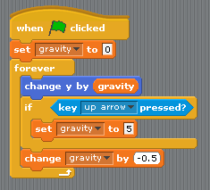
  - Make flappy bird green pipes appear to scroll across room on x-axis
  - Randomize height of green flappy bird pipes that appear
  - Have the green flappy bird pipes continuously appear (indefinitely)

