Catapult Algorithm
Adds “lob” to our flight. You are not expected to understand this:
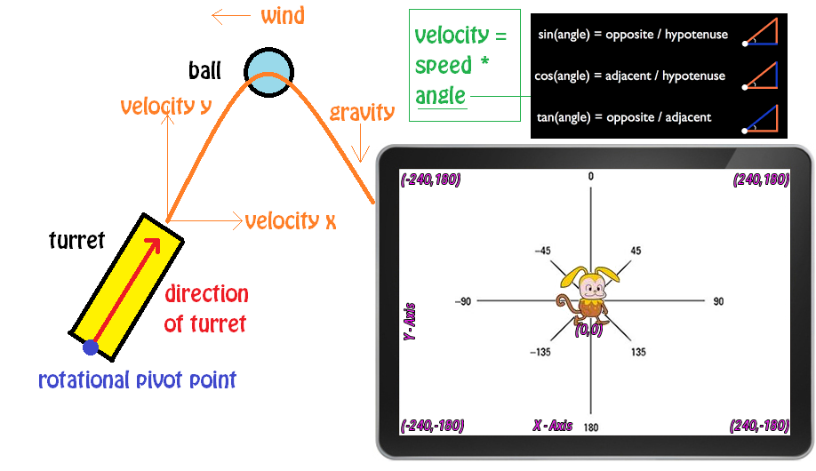

Draw Sprites
Draw Turret and Ball sprites:

Turret:
Draw turret length ways (horizontally), and set the costume centre to the base of turret:
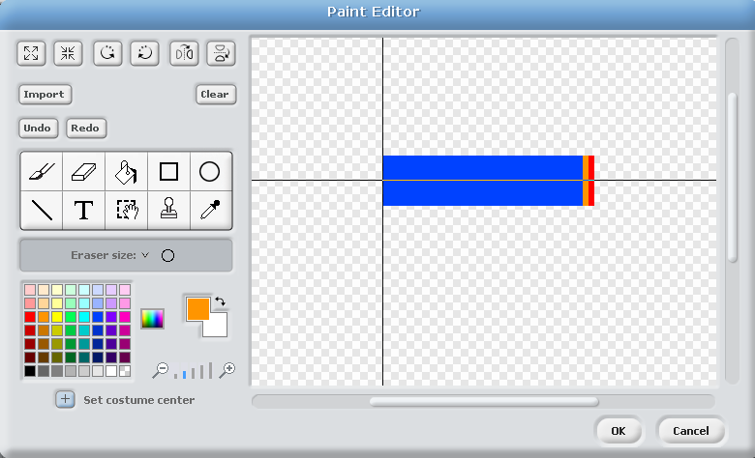

Ball:
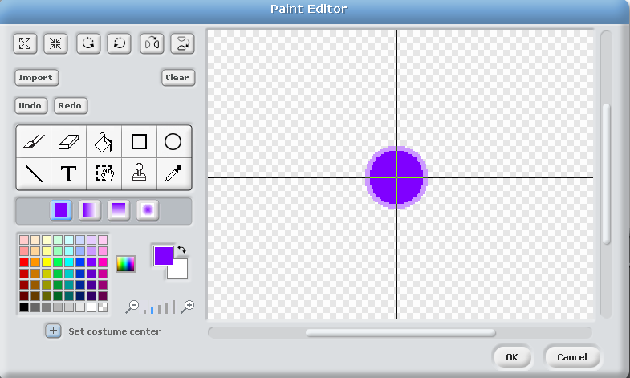

Add Code Blocks

Turret:
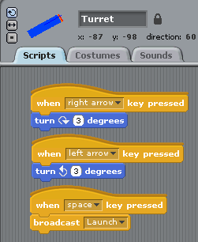

Ball:
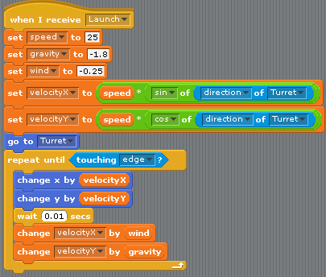

Finished Product:
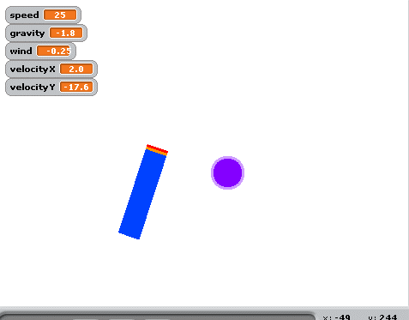

Challenges
Can you improve the game by implementing some of the following features?
- Tweak wind, gravity and speed variables to your liking
- Gameplay:
  - Floating objects to aim at (nothing violent)
  - Scoring
- Primary / secondary firing options
  - Bound to different keys
  - Different speeds
  - Limited ammo
- Bonuses?

