Draw Car Sprite

Front wheel drive:
Set costume centre to middle of front wheels:
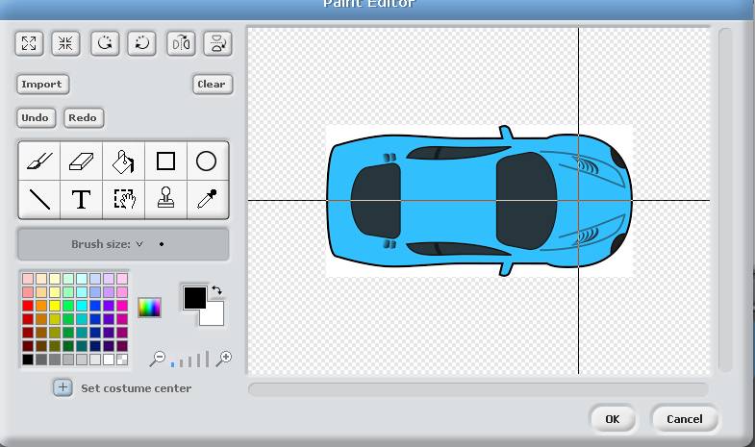

Add Code to Car
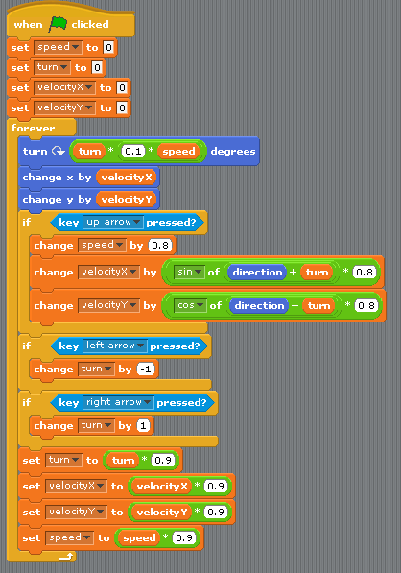

Finished Product:

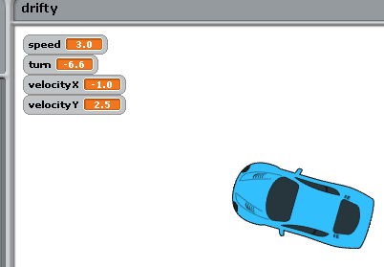

Challenges
Can you improve the game by implementing some of the following features?
- Collisions:
  - Road obstacles
  - Animations for crash
- Course:
  - Stopwatch
  - Lap counter
  - When I am on road, car moves quicker, when I am off road, car has more traction (speed penalty)
- AI car opponent:
  - That chases player, or:
  - Follows course
- Tyre screech using “pen down / draw” blocks
- Tweak car physics
  - Can you create a car with a different “feel”? (e.g. Rear Wheel Drive)
  - Can I choose it from a selector / menu option?
- Advanced:
  - Adapt physics to create a boat or jetski on water, or aerial snowboard on snow
  - Driver – can I enter and exit my car when in close proximity, as well as get out and walk around? (Hint – I don’t drift when I walk)

