Worksheet 1: Introduction to Scratch
Learning Intentions: We are learning to be able to …
Become familiar with the Scratch environment.

Why are we learning this?
So we can use Scratch to develop our computational thinking over the coming term.

Success Criteria: I will be successful if I can …
• Correctly answer teacher questions about the Scratch environment, including the positioning and direction system
• Describe the etiquette Scratch programmers must follow
• Be able to create, run (i.e. with the red stop sign and green flag control blocks), stop, save and close a Scratch file, and retrieve it on-queue.

Instructions:
Acquire and integrate knowledge:
- Read the geometry system and scratch etiquette (below the questions on this worksheet).

The following picture applies to questions two through to six: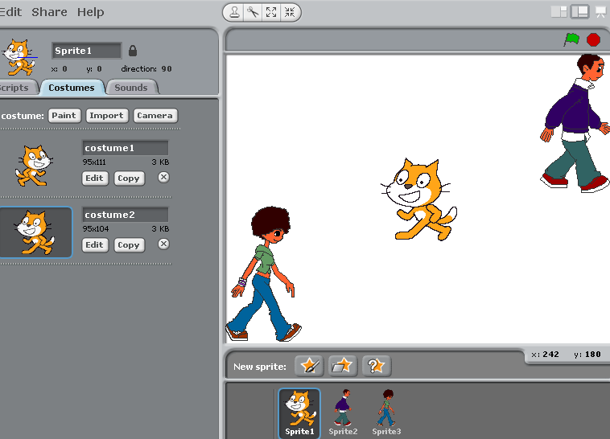

- Identify two ways the above Scratch developer has failed Scratch etiquette:
Click here to enter text.

- Give an approximate X and Y position of:
  - The cat: Click here to enter text.
  - The girl: Click here to enter text.
  - The boy: Click here to enter text.

- What direction value (using the Scratch geometry system) would the cat have to turn to, to be facing:
  - The boy: Click here to enter text.
  - The girl: Click here to enter text.

- If the cat was to move towards the girl, would the movement be positive or negative along the:
  - X axis: Click here to enter text.
  - Y axis: Click here to enter text.

- If the cat was to move towards the boy, would the movement be positive or negative along the:
  - X axis: Click here to enter text.
  - Y axis: Click here to enter text.

- To practise saving your work, on your computer:
  - Create a new folder to save your Scratch files in
  - Open Scratch, and change the colour and look of the cat (using the drawing tools)
  - Now save the file – call it “makeover cat”
  - Close Scratch
  - Re-open Scratch, and find and load your makeover cat file:

Post a screen shot of your makeover cat here.

Extend and refine knowledge:
- Using the internet, investigate the differences between Scratch 2.0, 1.4, and online Scratch. Can you identify some of the positives or negatives of each?

Click here to enter text.

Use knowledge meaningfully:
- There are a lot of Scratch projects on the web that other students and adults (with a lot more time) have completed. Some cool ones are:
  - Minecraft (3D)
  - Super Mario Brothers (and other retro remakes)
  - Procedural terrain generators (e.g. https://wiki.scratch.mit.edu/wiki/Terrain_Generators)
  - Genetic algorithms (that teach themselves, e.g. https://scratch.mit.edu/projects/30924542/)

Some others have attempted crypto currencies (although not very well yet). The point of this exercise is to “surf” around and get inspired for the cool things you can do with Scratch.

Geometry system:

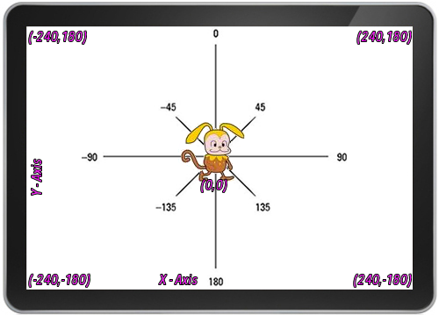

Scratch etiquette:
- always name sprites meaningfully (Sprite1 is not acceptable)
- always name costumes unless in a long animation sequence (Costume1 is not acceptable, try “facing_left”)
- Stage is called Stage which is fine but always name backgrounds e.g. "welcome", "gameOver"
- useCamelCase or under_scores when naming.. doesn’t matter which style you use, just be consistent
- always give variables meaningful names (e.g. score, timer, not ‘yeet’)
- remember target device:
  - if it is touch screen, make on-screen buttons to restart or reset your game, and don’t rely on the in-built scratch “green flag” or “stop sign”
  - if laptop, then think that perhaps your users might not have a precision mouse
- make it clear how to play your games. Always include instructions etc. The user should not have to think unnecessarily for themselves.

