Worksheet 3: Direction
Learning Intentions: We are learning to be able to …
Direct sprites using the scratch direction system.

Why are we learning this?
Turning is a part of animation and movement that we found out was so important last lesson.

Success Criteria: I will be successful if I can …
Be able to angle a sprite in the correct direction for the problem I am solving

Instructions:
Acquire and integrate knowledge:
Take note of the directional blue arrow, which by default points to 90 degrees (right), regardless of whichever way the sprite is first drawn:

Scratch by default aims sprites facing 90 (right), even if you drew the sprite facing upwards / downwards etc. Note the difference between Scratch and normal Cartesian coordinates:
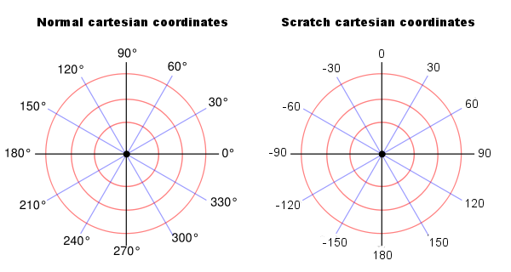

The blue line indicates which way the sprite is currently facing, regardless of how the sprite costume looks. Note the directional options on the set rotation style block – you will need them to answer the next question:

- What is the effect of the previous script on the cats costume when each one of these values is set in the set rotation style block?

Set rotation style block | Values | What happens to the costume when you run the script above with this value set?
 | left-right | Click here to enter text.
 | don’t rotate | Click here to enter text.
 | all around | Click here to enter text.

The Scratch direction system will still allow you to turn or point past 180 degrees – and the degrees will be added in a clockwise direction for positive (or anti-clockwise for negative). For example:

- Which way will a sprite be facing if the following block is run?
Script block | Direction of sprite after script block is run:
 | Click here to enter text.
 | Click here to enter text.
 | Click here to enter text.

Extend and refine knowledge:
We can calculate the rebound angle of a ball on a paddle via the following algorithm:

Rebound angle = 180 – [direction at collision]:

- Delete the cat, and add a blue paddle sprite (use a solid blue rectangle) with this script:

- Implement the above rebound angle algorithm on the tennis ball:

Use knowledge meaningfully:
- The game you have started created is called Pong, and is available online via the Atari Arcade (https://www.atari.com/arcade). It implements some of the skills you have learnt this far. (We will make Breakout, which is similar, later in the course).
  - Can you create a second player (player two)?
  - Can you create an unbeatable AI paddle?
  - Can you create a beatable AI paddle? (note - this is much harder than an unbeatable AI paddle, as it implies difficult but not impossible, meaning the computer has to make a mistake, which it is not programmed to do).

