Illustrate using a sketch or diagram a plan for your game. Annotate elements and interactions.

Evaluation in terms of meeting needs, innovation and sustainability.

- End user needs: Plot a line path on the graph below that illustrates where your game “fits”, in terms of being fun and challenging over time. Justify why you made this evaluation.

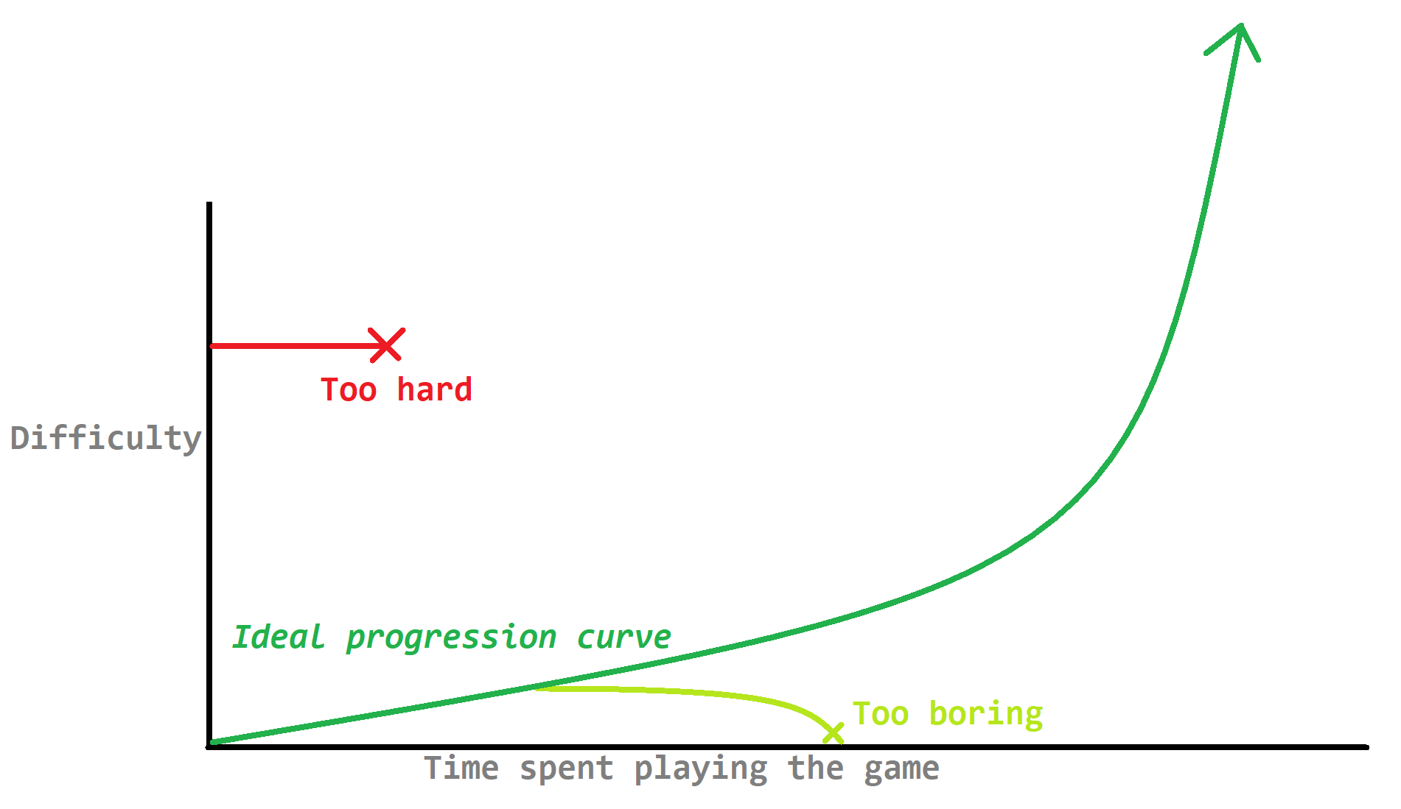

- Innovation: Evaluate how your game is unique, different or creative, in comparison to other games you have played, seen, researched or made.

- Sustainability: How well does your game encourage more participation in sport? Explain.

