Stimulus: 2D games with simple collision vector maths.
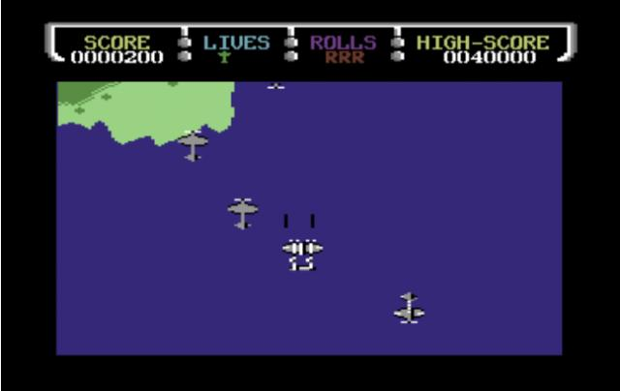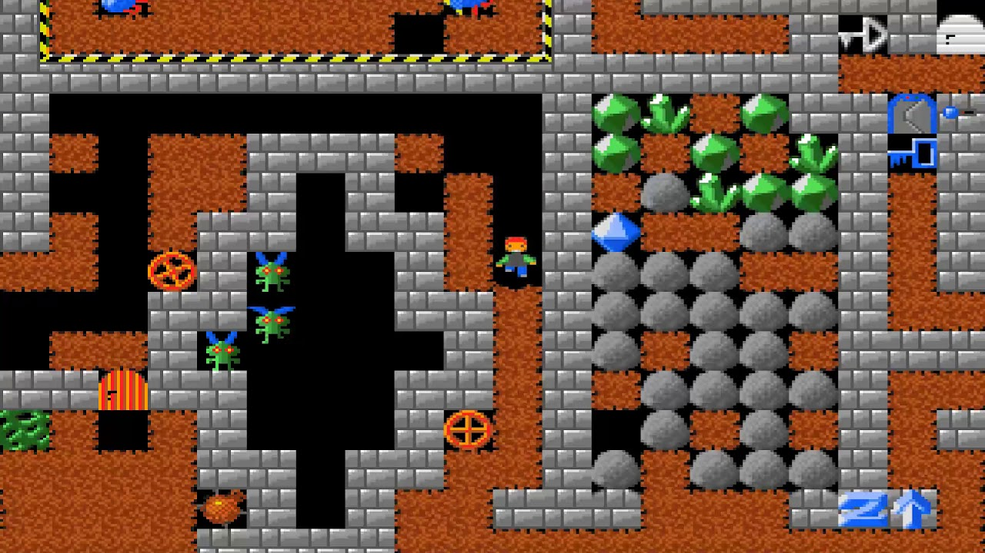

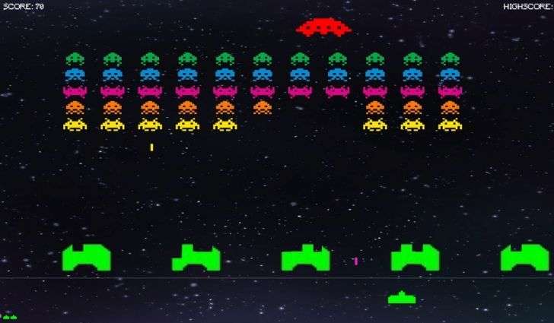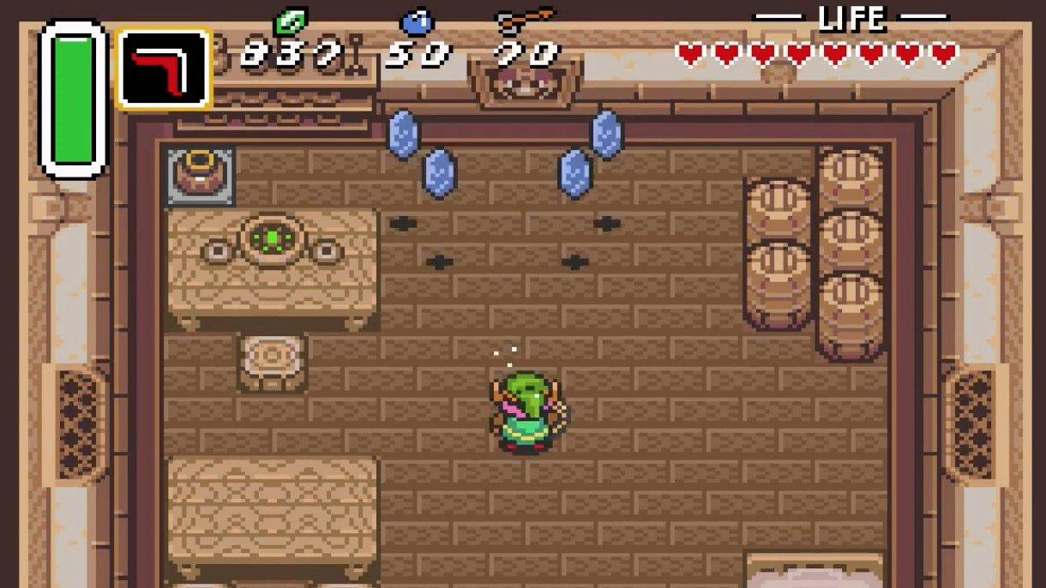

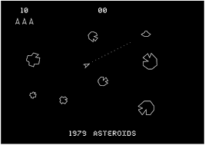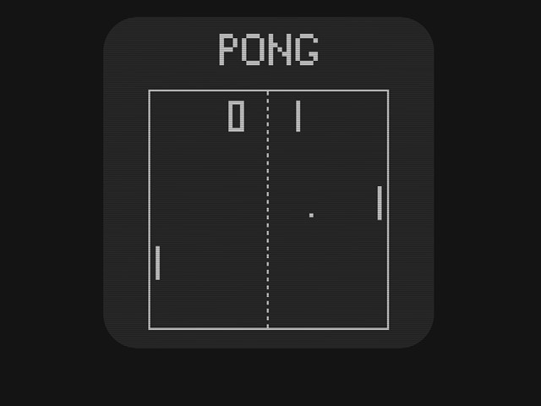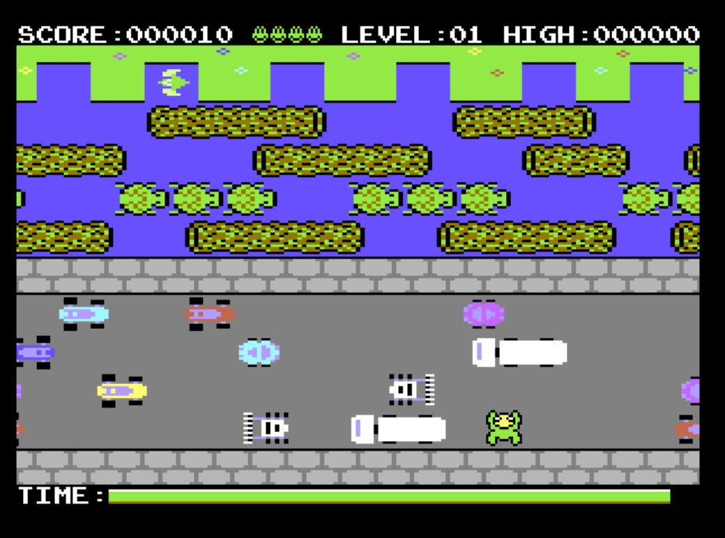

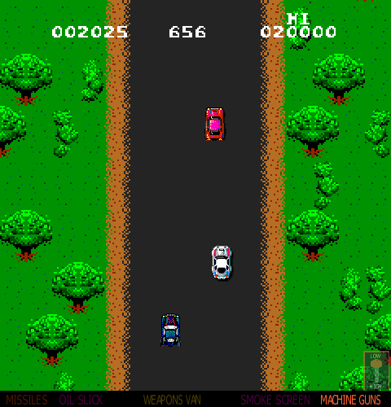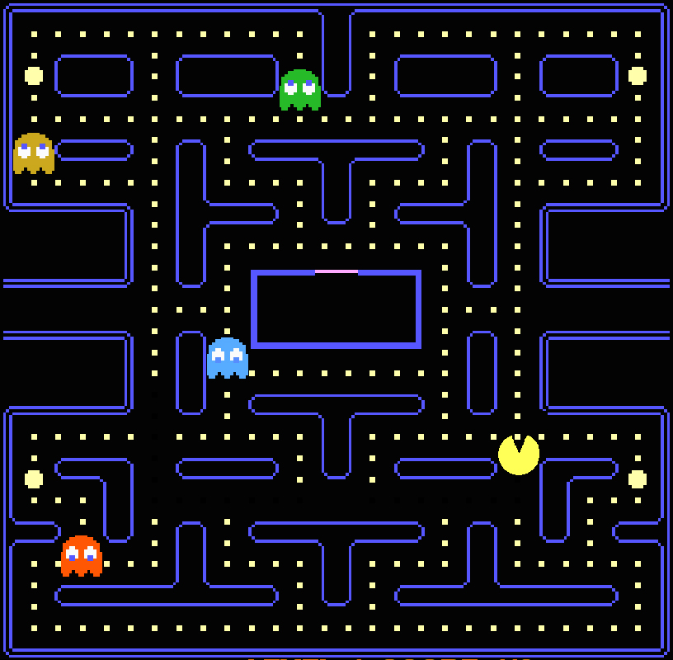

Digital Technologies project: digital solution
Section 1: Explore and Develop
- Analyse, determine and / or symbolise a plan for a game that utilises simple two-directional vector maths for collisions. In other words, not a platformer game.
- For the purposes of this exercise, any game that suffers from “platform stick”, “wall stick” or “collision stick” issues can be considered part of the platformer sub-genre (as this is what we are really trying to avoid here).

- A “collision stick” issue is when the speed (horizontal or vertical) of an object creates an unwanted condition whereby the object “gets stuck” in another object (such as a wall, boundary or other object).

Complete this task within a maximum of one A3 landscape page.

Section 2: Generate and Evaluate
- Generate a prototype game that illustrates the plan determined in Section 1.

Some tips:

- Stay native to the game engine studied in class. Engineering is not about finding a perfect solution – it’s about finding the best solution with what is available.

- Utilise royalty free assets if you wish. The focus is on gameplay.

- As these games will be exported to HTML5 for web playback, it is recommended you aim for either a 640x480 or 800x600 viewport window.

- /*comment at bottom of code in your main object in either STEP or CREATE event:

  - Explanations of functionality
  - Refinements
  - Recommendations
  - Testing
  - Evaluation in terms of “risk, sustainability and potential for innovation and enterprise” justified by data (use discussion or data from previous points a-d)

Submission Requirements
- Section 1: submit one digital document (maximum of one A3 landscape page)
- Section 2: submit entire project folder zipped (include evaluation in code comments)
Important Notes
- Use comments in code to explain understanding of programming structures, as well as pointing out refinements and on-going testing of code.
- Keep backups of your files. Save every 10-15 minutes of work.
- Final testing, refinements, evaluations and future recommendations should be neatly commented in an event in your most “significant” game object, e.g. objPlayer.Step
Getting Started
- Look at the examples of past completed assignments shown in class for inspiration.
- Look through past class notes, and resources from the website to help you plan.
- Brainstorm some ideas on an A3 sheet about games you like to play, and try to come up with a unique idea from these
Authentication Strategies
- Acknowledge any and all code snippets, tutorials, advice, information or help given.
- Students may be asked to explain their solution, or parts there-of, to determine authenticity.

Appendix A: QCAA Years 9 and 10 Digital Technologies standard elaborations (contextualised)
 |  |  | A | B | C | D | E
Processes and production skills | Investigating and Refining | Section 1 | purposeful definition and decomposition of complex problems in terms of functional and non-functional requirements | effective definition and decomposition of complex problems in terms of functional and non-functional requirements | definition and decomposition of complex problems in terms of functional and non-functional requirements | partial definition and decomposition of complex problems in terms of functional and non-functional requirements | fragmented definition and decomposition of complex problems in terms of functional and non-functional requirements
 | Generating and designing; producing and implementing | Section 2A | proficient implementation of modular programs | effective implementation of modular programs | implementation of modular programs | partial implementation of modular programs | fragmented implementation of modular programs
 | Evaluating | Section 2B | discerning evaluation of digital solution in terms of risk, sustainability and potential for innovation and enterprise | informed evaluation of digital solution in terms of risk, sustainability and potential for innovation and enterprise | evaluation of digital solution in terms of risk, sustainability and potential for innovation and enterprise | explanation of digital solution | description of digital solution
This will be marked digitally via the submission platform.

Appendix B: Australian Curriculum content descriptions
This assessment instrument is used to allow students to formally demonstrate the following Australian Curriculum Digital Technologies Years 9 and 10 Content Descriptions:
Explicitly measured
P&PS | Define and decompose real-world problems precisely, taking into account functional and non-functional requirements and including interviewing stakeholders to identify needs
P&PS | Implement modular programs, applying selected algorithms and data structures including using an object-oriented programming language
P&PS | Evaluate critically how student solutions and existing information systems and policies, take account of future risks and sustainability, and provide opportunities for innovation and enterprise
Implicit to the task (not formally measured)
K&U | Analyse simple compression of data and how content data are separated from presentation
P&PS | Develop techniques for acquiring, storing, and validating quantitative and qualitative data from a range of sources, considering privacy and security requirements
P&PS | Analyse and visualise data to create information and address complex problems, and model processes, entities and their relationships using structured data
K&U | Investigate the role of hardware and software in managing, controlling, and securing the movement of and access to data in networked digital systems
P&PS | Design the user experience of a digital system by evaluating alternative designs against criteria including functionality, accessibility, usability, and aesthetics
P&PS | Design algorithms represented diagrammatically and in structured English and validate algorithms and programs through tracing and test cases
P&PS | Create interactive solutions for sharing ideas and information online, taking into account safety, social contexts, and legal responsibilities
P&PS | Plan and manage projects using an iterative and collaborative approach, identifying risks, and considering safety and sustainability

Key:
K&U: Knowledge and Understanding
P&PS: Processes and Production Skills

