Stimulus: 2D platformer games.
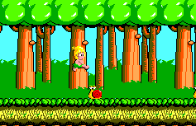

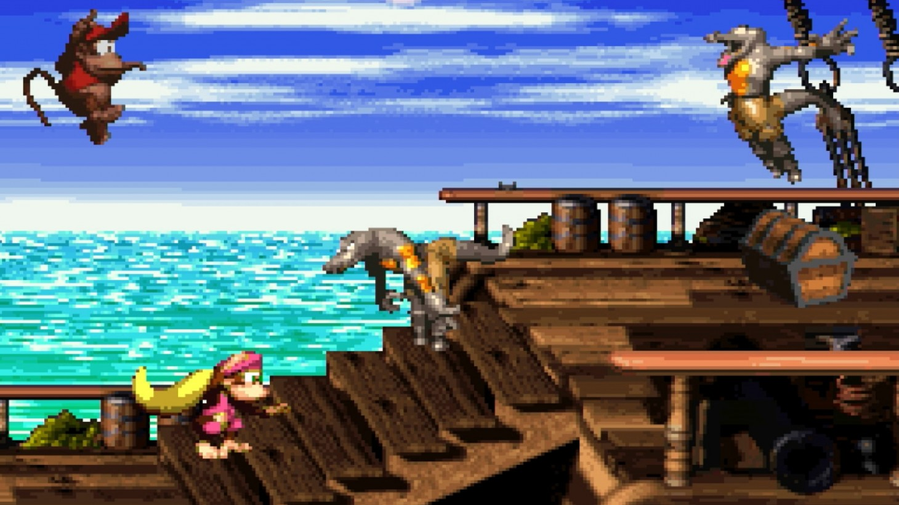
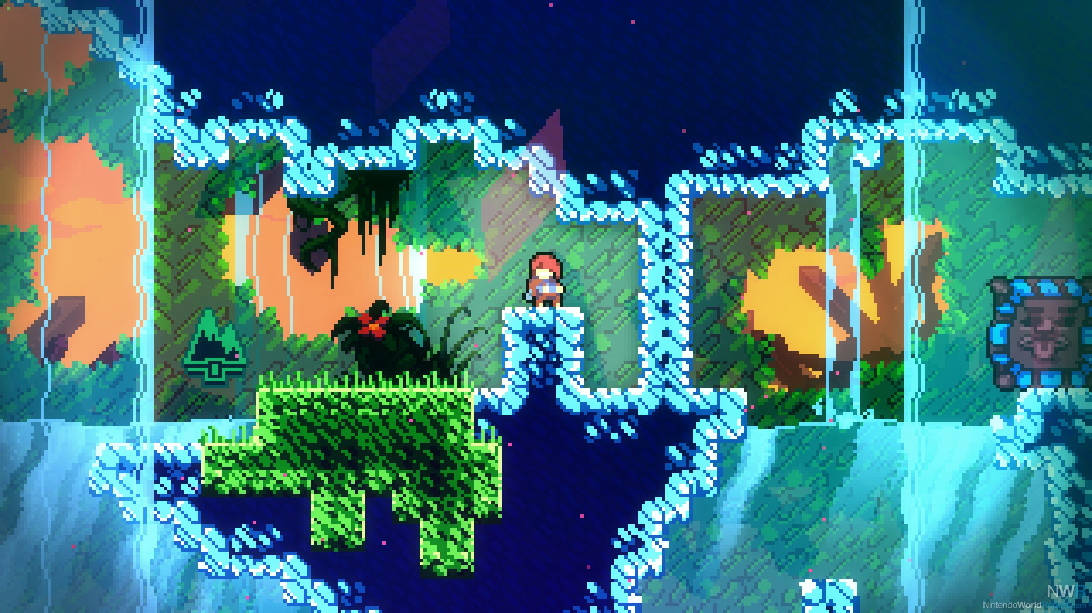

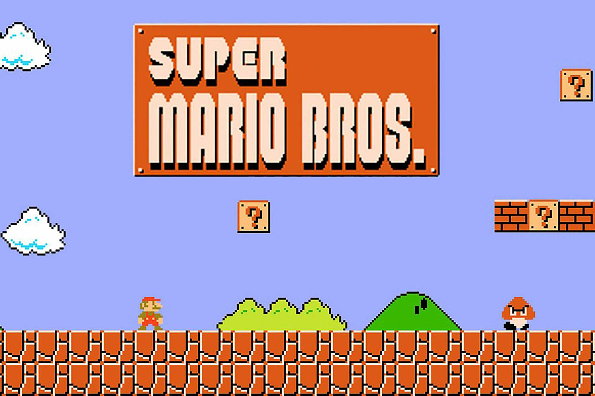
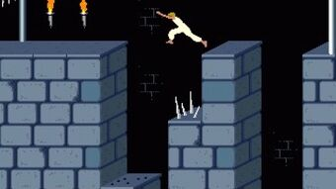

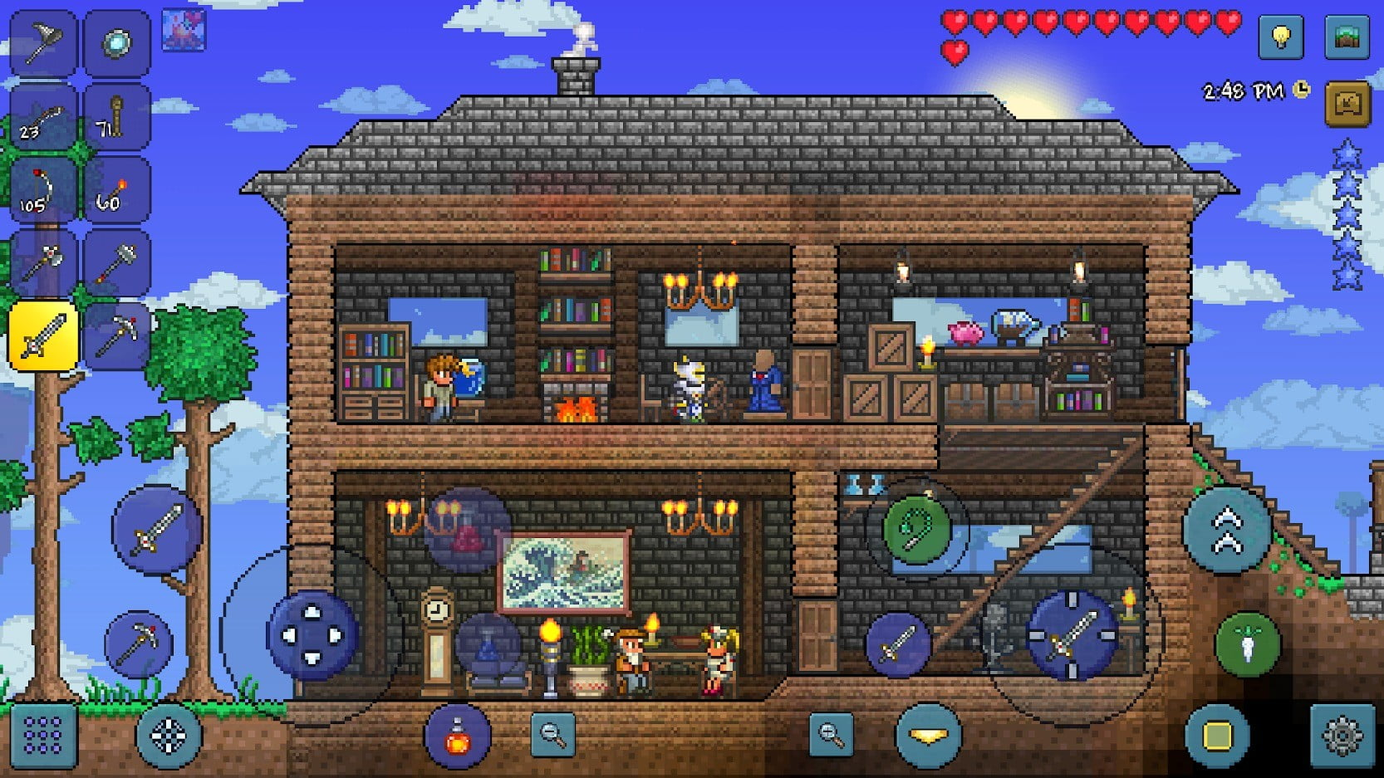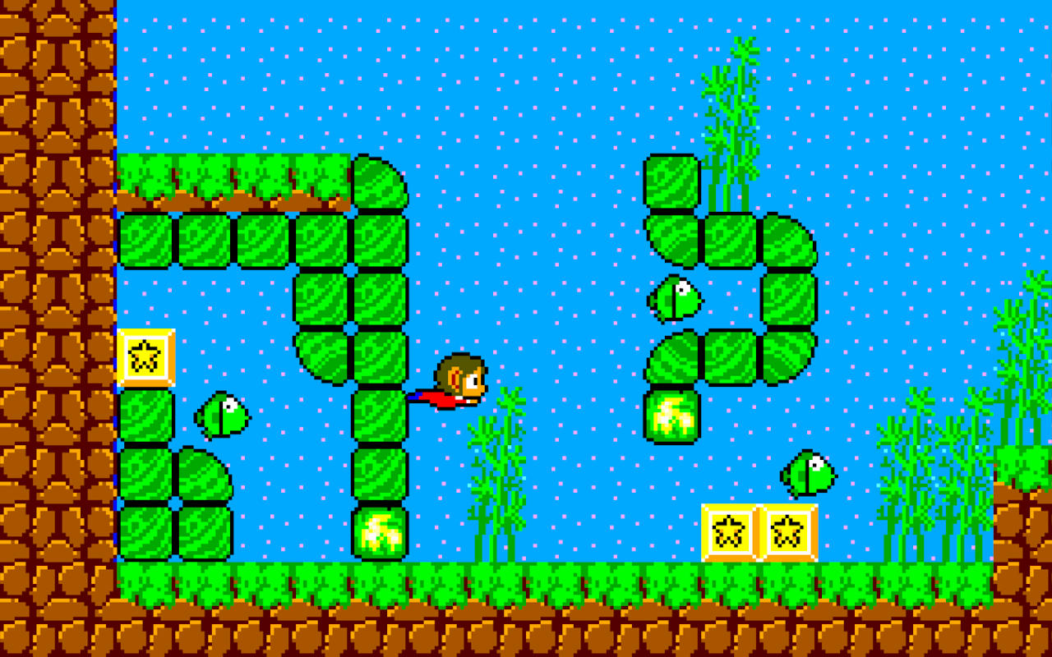

Digital Technologies project: digital solution
Section 1: Explore and Develop
- Analyse, determine and / or symbolise a plan for a game that fits within the platformer game genre (see stimulus).
- As this genre is limiting to the type of game you can generate, focus your plan on level layout, challenges, special skills or alternate mechanics, under the headings of:
  - Functionality (game physics, behaviours or triggers)
  - Accessibility (controls, sizing, on-screen help)
  - Usability (playability, focusing on learning curve and progression)
  - Aesthetics

Complete this task within a maximum of one A3 landscape page.

Section 2: Generate and Evaluate
- Generate a prototype game that illustrates the plan determined in Section 1.

Some tips:

- Stay native to the game engine studied in class. Engineering is not about finding a perfect solution – it’s about finding the best solution with what is available.

- Utilise royalty free assets if you wish. The focus is on gameplay.

- As these games will be exported to HTML5 for web playback, it is recommended you aim for either a 640x480 or 800x600 viewport window.

- /*comment at bottom of code in your main object in either STEP or CREATE event:

Specific iterations of your game, describing in each iteration:
- Version 1: base functionality, roadmap or next steps to reach version 2 (planning)
- Version 2: refinements, additions, fixes, removals, roadmap to version 3
- Version X

Submission Requirements
- Section 1: submit one digital document (maximum of one A3 landscape page)
- Section 2: submit entire project folder zipped (include evaluation in code comments)
Important Notes
- Use comments in code to explain understanding of programming structures, as well as pointing out refinements and on-going testing of code.
- Keep backups of your files. Save every 10-15 minutes of work.
- Final testing, refinements, evaluations and future recommendations should be neatly commented in an event in your most “significant” game object, e.g. objPlayer.Step
Getting Started
- Look at the examples of past completed assignments shown in class for inspiration.
- Look through past class notes, and resources from the website to help you plan.
- Brainstorm some ideas on an A3 sheet about games you like to play, and try to come up with a unique idea from these
Authentication Strategies
- Acknowledge any and all code snippets, tutorials, advice, information or help given.
- Students may be asked to explain their solution, or parts there-of, to determine authenticity.

Appendix A: QCAA Years 9 and 10 Digital Technologies standard elaborations (contextualised)
 |  |  | A | B | C | D | E
Processes and production skills | Generating and designing; producing and implementing | Section 1 | purposeful design and evaluation of user experiences | effective design and evaluation of user experiences | design and evaluation of user experiences | partial design and explanation of user experiences | fragmented design and statements about user experiences
 |  | Section 2A | proficient implementation of modular programs | effective implementation of modular programs | implementation of modular programs | partial implementation of modular programs | fragmented implementation of modular programs
 | Collaborating and managing | Section 2B | comprehensive planning and management of digital projects using an iterative approach | informed planning and management of digital projects using an iterative approach | planning and management of digital projects using an iterative approach | partial planning and management of digital projects using an iterative approach | fragmented planning and management of digital projects

This will be marked digitally via the submission platform.

Appendix B: Australian Curriculum content descriptions
This assessment instrument is used to allow students to formally demonstrate the following Australian Curriculum Digital Technologies Years 9 and 10 Content Descriptions:
Explicitly measured
P&PS | Design the user experience of a digital system by evaluating alternative designs against criteria including functionality, accessibility, usability, and aesthetics
P&PS | Implement modular programs, applying selected algorithms and data structures including using an object-oriented programming language
P&PS | Plan and manage projects using an iterative and collaborative approach, identifying risks, and considering safety and sustainability
Implicit to the task (not formally measured)
K&U | Analyse simple compression of data and how content data are separated from presentation
P&PS | Develop techniques for acquiring, storing, and validating quantitative and qualitative data from a range of sources, considering privacy and security requirements
P&PS | Analyse and visualise data to create information and address complex problems, and model processes, entities and their relationships using structured data
P&PS | Define and decompose real-world problems precisely, taking into account functional and non-functional requirements and including interviewing stakeholders to identify needs
K&U | Investigate the role of hardware and software in managing, controlling, and securing the movement of and access to data in networked digital systems
P&PS | Design algorithms represented diagrammatically and in structured English and validate algorithms and programs through tracing and test cases
P&PS | Create interactive solutions for sharing ideas and information online, taking into account safety, social contexts, and legal responsibilities
P&PS | Evaluate critically how student solutions and existing information systems and policies, take account of future risks and sustainability, and provide opportunities for innovation and enterprise

Key:
K&U: Knowledge and Understanding
P&PS: Processes and Production Skills

