Stimulus: Grid based layouts
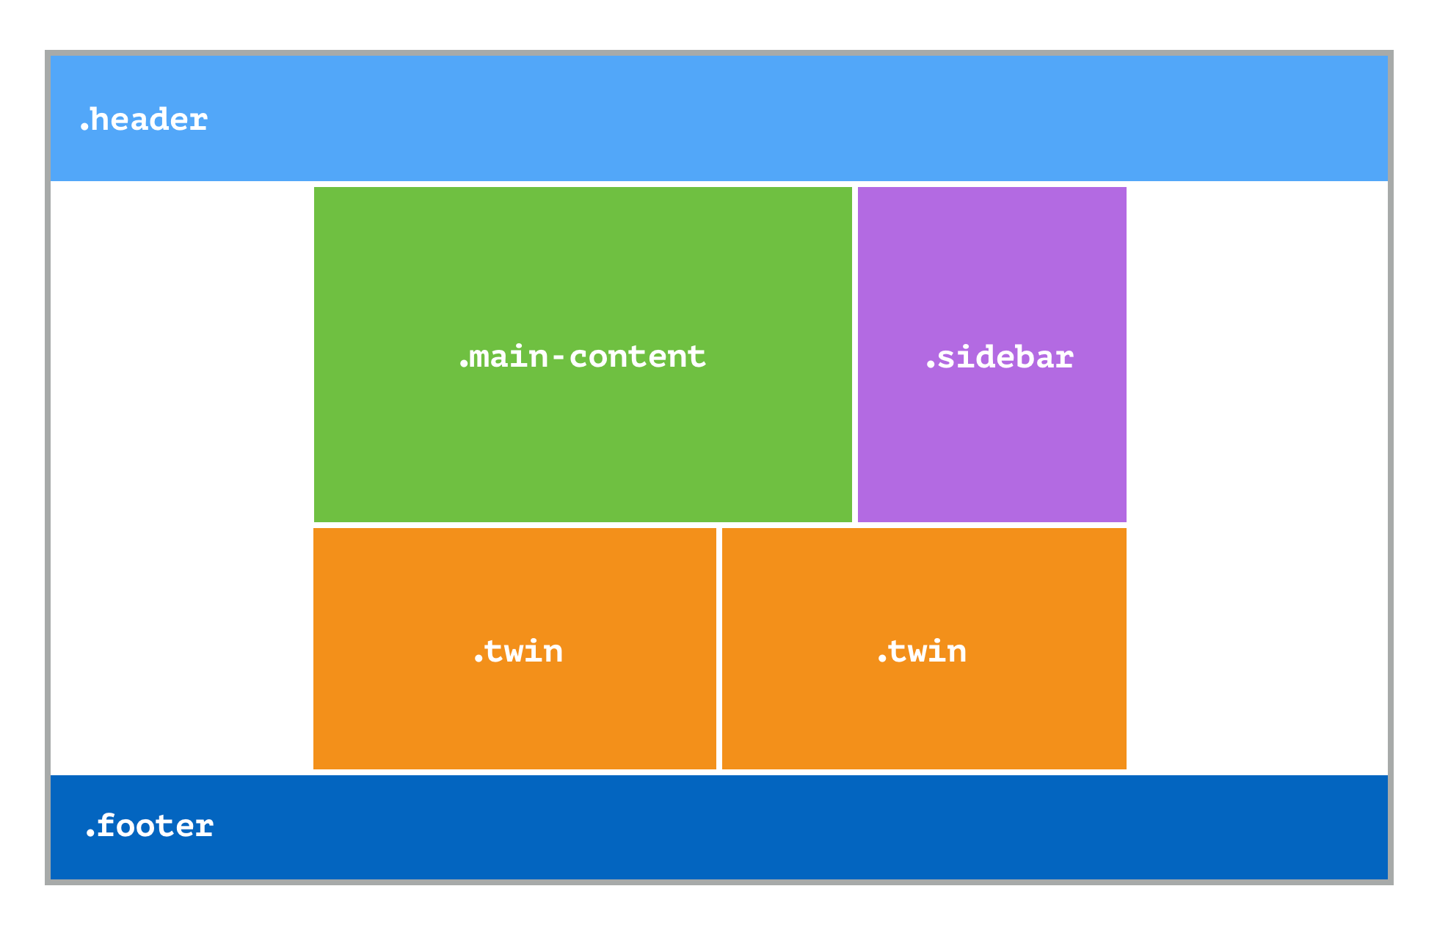

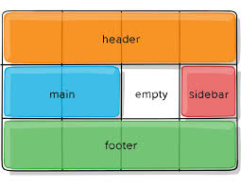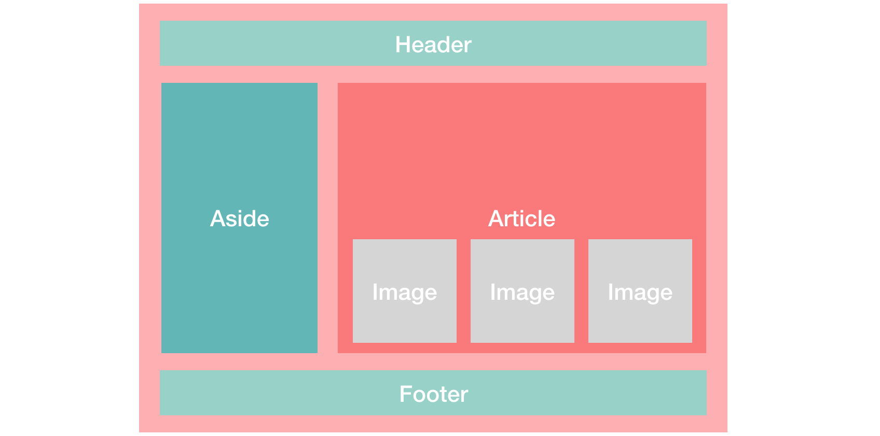

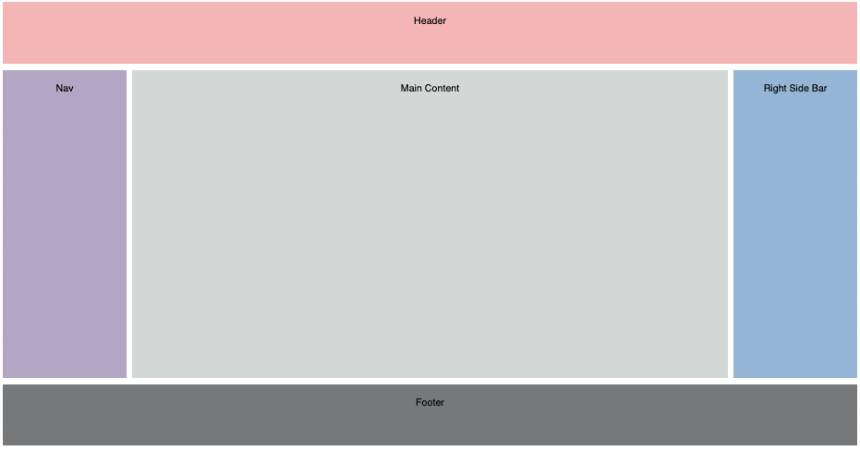

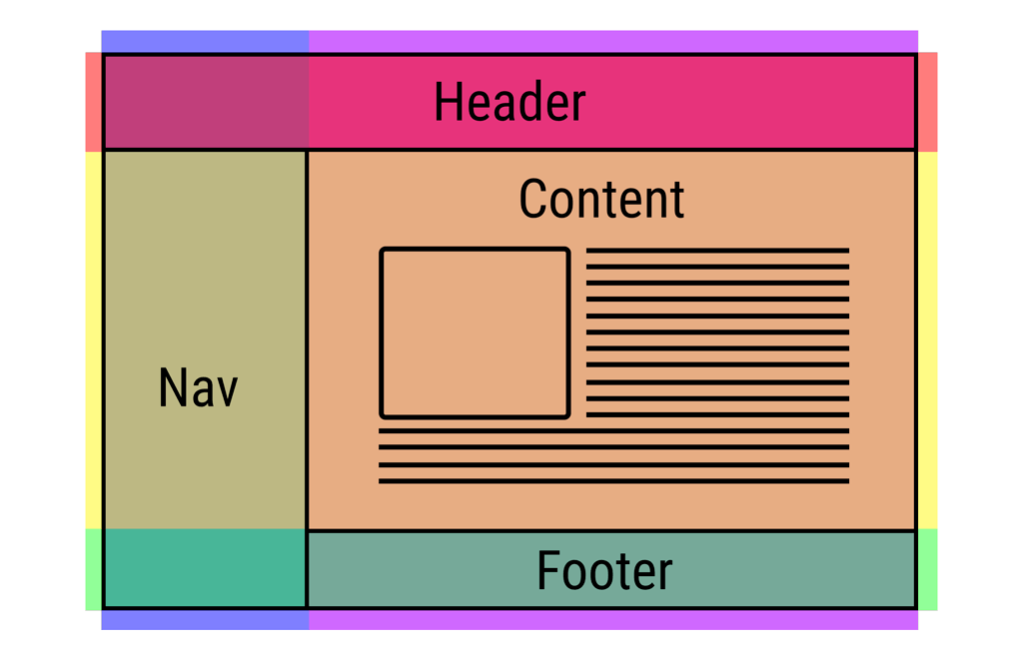
Digital Technologies project: digital solution
Section 1: Explore and Develop
Web content is the textual, visual, or aural content that is encountered as part of the user experience on websites. It may include – among other things – text, images, sounds, videos, and animations.

- Analyse and determine a plan for a static website for educational purposes to illustrate web content for a cross-curricular subject. The published content of your website requires teacher approval. As a guiding principle, approval of content will only be granted if the proposed content is deemed credible and of academic merit.
The website should address the following criteria:
Criteria | Description
Responsiveness | The website must present optimal viewing across a wide range of devices
User experience | The end user experience for engaging website content must be positive
Components of this website could include:
Component | Ideas
Presentation | - grid layouts:  - grid template areas or columns, with proposed sizes, in either pixels, percentage, viewport units or other units.  - responsive layouts when grid is resized.  - aesthetics:  - padding, margins, proposed content alignment, font sizes, types, colour schemes (colours as hex codes), borders, gradients, or other design ideas.  - page layout designs, navigation bar plans, sample content on one planned page to illustrate proposed "look and feel".  - files:  - imported files or external libraries (such as Font Awesome)  - JavaScript is not required but welcome (focus on UX of site).  - relative files (web pages saved locally), and a site map of how these files link together.
Content | - categorisation or hierarchy of content; image, video or animation file names, types, sizes, and dimensions; downloadable content (e.g., PDF files), folder structure on disk. Content per se is not required.
To complete this section, you should:
- Brainstorm the components of this website you wish to implement, and discuss, explain, or illustrate how you intend these components will be implemented.
- Complete this task within a maximum of one A3 landscape page.
Section 2: Generate and Evaluate
- Generate a website that illustrates the working components or ideas determined in Section 1.

- #comment in the source code of your main website page evidence of:
  - Feedback from sharing and collaboration online (get users to test your site)
  - Instructions how to:
    - Add new content (use) and edit existing content (maintain)
    - View content (transmission)

Submission Requirements
- Section 1: submit one digital document (maximum of one A3 landscape page)
- Section 2: submit all commented source code files (includes evaluation in comments)
Important Notes
- Use comments in code to explain understanding of HTML and CSS, as well as pointing out refinements and on-going testing of code.
- Keep backups of your files. Save every 10-15 minutes of work.
- Final testing, refinements, evaluations, and future recommendations should be neatly commented at the bottom of your most recent stable version file.
Getting Started
- Look at the examples of past completed assignments shown in class for inspiration.
- Look through past class notes, and resources from the website to help you plan.
- Brainstorm some ideas on an A3 sheet of paper.
Authentication Strategies
- Acknowledge all code snippets, tutorials, advice, information, or help given.
- Students may be asked to explain their solution, or parts there-of, to determine authenticity.

Appendix A: QCAA Years 9 and 10 Digital Technologies standard elaborations (contextualised)
 |  |  | A | B | C | D | E
Knowledge and understanding | Representation of data | Section 1 | comprehensive explanation of:  • why content data are separated from presentation | detailed explanation of:  • why content data are separated from presentation | explanation of:  • why content data are separated from presentation | description of:  • why content data are separated from presentation | statements about:  • why content data are separated from presentation
Processes and production skills | Generating and designing; producing and implementing | Section 2A | purposeful design and proficient implementation of modular programs | effective design and effective implementation of modular programs | design and implementation of modular programs | partial design and implementation of modular programs | fragmented design and implementation of modular programs
 | Collaborating and sharing | Section 2B | proficient sharing and collaboration online, with establishment of comprehensive and effective protocols for the use, transmission and maintenance of data and projects | effective sharing and collaboration online, with establishment of effective protocols for the use, transmission and maintenance of data and projects | sharing and collaboration online, with establishment of protocols for the use, transmission and maintenance of data and projects | partial sharing and collaboration online, using protocols for the use, transmission and maintenance of data and projects | fragmented sharing and collaboration online using protocols
This will be marked digitally via the submission platform.

Appendix B: Australian Curriculum content descriptions
This assessment instrument is used to allow students to formally demonstrate the following Australian Curriculum Digital Technologies Years 9 and 10 Content Descriptions:
Explicitly measured
K&U | Analyse simple compression of data and how content data are separated from presentation
P&PS | Implement modular programs, applying selected algorithms and data structures including using an object-oriented programming language
P&PS | Create interactive solutions for sharing ideas and information online, taking into account safety, social contexts, and legal responsibilities
Implicit to the task (not formally measured)
K&U | Investigate the role of hardware and software in managing, controlling, and securing the movement of and access to data in networked digital systems
P&PS | Develop techniques for acquiring, storing, and validating quantitative and qualitative data from a range of sources, considering privacy and security requirements
P&PS | Analyse and visualise data to create information and address complex problems, and model processes, entities and their relationships using structured data
P&PS | Define and decompose real-world problems precisely, taking into account functional and non-functional requirements and including interviewing stakeholders to identify needs
P&PS | Design the user experience of a digital system by evaluating alternative designs against criteria including functionality, accessibility, usability, and aesthetics
P&PS | Design algorithms represented diagrammatically and in structured English and validate algorithms and programs through tracing and test cases
P&PS | Evaluate critically how student solutions and existing information systems and policies, take account of future risks and sustainability, and provide opportunities for innovation and enterprise
P&PS | Plan and manage projects using an iterative and collaborative approach, identifying risks, and considering safety and sustainability

Key:
K&U: Knowledge and Understanding
P&PS: Processes and Production Skills

