On this page:
- Create a “Mind map”, which is a brainstorm of all your ideas surrounding this task.

- Try and classify where possible your ideas in the mind-map into categories and sub-categories
- Stimulus analysis – use the "scrap book" genre and floating text boxes to point out anything interesting from the task sheet or technical proposal (stimulus) around your mind map.

Cognitive verbs evidenced here might include: recognise, describe, explain, analyse, identify, determine, symbolise, communicate.
Contextual analysis
Mind Map – ideas for categories to use to break up your Digital Solution Web Application task might include:
- Task requirements
- Front end development
- Back end development
- Task analysis
- User analysis
- Contextual analysis
- Explore
- Develop
- Generate
- Evaluate and refine
- Problem analysis
- Features required
- Personal, social, ethical, or legal impacts
- Sustainability or economic impacts
- Prototype requirements
- Technical considerations
- Client-side development
- Server-side development
- Programming components
- Data structures
- Inter-relationships between UX and data
- Useability requirements – learnability, accessibility, utility, safety and effectiveness
- UX – principles of design or aesthetic
- Project methodology
- Risks, disclaimers, assumptions or limitations
- Milestones or benchmarks
- Scope and out of scope
- Submission requirements
- Core functionality
- Extended functionality
- Systems or success criteria

On this page:
- Determine a big list of “Prescribed Criteria”, which are determined from the requirements of the task sheet or technical proposal (stimulus).
- Determine a big list of “Self-determined Criteria”, which are determined from your own ability, research and experience building web applications.

- Draw a small tech stack diagram, that illustrates all the software, hardware and networking technologies you can think of that would be needed to power the live web application.

- If there is any analysis left over from the first page, feel free to continue that here.

Prescribed and self-determined criteria

Ideas you can frame your self-determined criteria around might include:
- Reliability – how will you determine whether the application is satisfactorily performing its intended task(s)
- Accuracy – look for logical threats to maintaining accurate records
- Maintainability – refers to the ease and speed at which a system can maintain operational status, especially after fault or repair.
- Security – such as delivering an application over a secure connection (HTTPS)
- Sustainability and scalability – what happens when the application “grows”?
- Efficiency – Efficiency seeks maximum productivity with the least / minimal consumption of system resources. Can you measure this somehow?
- Modularity – can your codebase be repurposed easily?
- Standards – such as meeting specifications for code design or system design
- Optimisation, either for navigation or searching
- Advanced application of useability principles, such as:
  - Accessibility – compatibility with assistive devices or semantic tags
  - Safety – error troubleshooting
Consider self-determined criteria as criteria that you (personally) know will make the application much better.
You want to “show off” in your Self-determined criteria.
Criteria: characteristics by which something is evaluated or appraised; the teacher stimulus or client (prescribed) or students (self-determined) develop criteria, e.g. specific needs, identified purpose, impacts, quality or effectiveness of solution.

Ideas you can frame your prescribed criteria around might include:
- Task requirements
- Documentation or video requirements
- Syllabus requirements (e.g. EDGE problem solving model)
- Base / basic / core aims of the application
- Non-negotiable useability principles (e.g. accessibility – meeting legal requirements)
- Minimum or mission critical utility requirements – what must the application be able to do?
- Simple measures of success – what are the primary aims of the solution?
- Standards or levels of acceptance – what is the lowest or baseline level of functionality that must be achieved?
Consider prescribed criteria as obvious criteria.
On this page:
- Synthesise your User Interface designs.

- Annotate them with useability principles.

- Justify elements and features of UI based on your previous analysis. Where possible, make links!

User Interface
Useability principles: principles used to improve the user experience, including:
accessibility: ability to be used by many different people, even people with disabilities
effectiveness: ability of users to use the system to do the work they need to do, includes reliability
safety: ability for users to make errors and recover from the mistake
utility: ability of the system to provide all the functionality that users need
learnability: how easy a system is to learn.

Source: Queensland Curriculum & Assessment Authority, "Digital Solutions 2019 v1.2 General Senior Syllabus". (2020). Retrieved 01/01/2021, from https://www.qcaa.qld.edu.au/downloads/senior-qce/syllabuses/snr_digital_solutions_19_syll.pdf
On this page:
- Continue to synthesise your User Interface designs, recognising and describing GUI components

- Keep annotating them with useability principles.

- Consider showing inter-relationship between UI / UX with algorithms / coded components. Where possible, make links!

User Interface

On this page:
- Brief amount of Cipher research
- Site map
- Variable table (a.k.a. “variable dictionary”)
In a table of variables, specify all variables that will be required by:
- The cipher puzzles themselves
- The web application (e.g. username)
For each variable:
- Specify its data type
- Specify sample values that the variable will hold
- Specify the limits or range of the values that the variable will hold

Ciphers and variables

Variable Dictionary for Cipher Puzzles
Name | Data Type | Sample usage, limits or notes
Plain_text | String | 15 characters maximum, sample value: "happy"

On this page:
- Write algorithms in pseudocode to power your site.

- Algorithms might include cipher algorithms, ranging in complexity (can take an extra page for this if necessary)

- Algorithms may also include web application algorithms for managing users, statistics, etc

Algorithms
The following information is a summary of this topic: https://digisoln.com/computational_thought/pseudocode
- Write BEGIN and END on every algorithm module.

  - Indent ...
  - ... consistently.

- When using IF remember to use THEN (an alternative branch is ELSE), and ENDIF

- WHILE remember to use ENDWHILE

- IF and WHILE only execute when TRUE

- Advanced: Modular algorithms can have parameters that can be swapped or passed in, E.g.: BEGIN get_area(radius)

- Advanced: algorithms can have local or global variables:
  - Local variables can only be accessed in the current module (such as temp_score)
  - Global variables can be accessed from all algorithm modules (such as privilege_level)

- Advanced: Functions can return values to other function calls. E.g.: area = get_area(10)

- If in doubt, just write Python code, and simplify it to ‘make’ it pseudocode.
On this page:
- Continue remaining algorithms in pseudocode to power your site.

- You may also like to use this space for screen shots of development, illustrating testing or problems, and refinements made

Algorithms

Sample algorithm written in pseudocode: Cipher
BEGIN Cipher
SET plain_code TO ['Z','A','B']
SET cipher_code TO empty array

FOR count = 0 TO length(plain_code)
SET ordinal = ord( plain_code[count] ) - 65
SET shift = (ordinal + 3) mod 26
SET cipher = shift + 65
APPEND chr(cipher) TO cipher_code
NEXT count

PRINT cipher_code

END Cipher

Code paste and annotate page 1.
- Avoid pasting any code you did not write. Borrowed code can be referenced in your reference list.

- Include both Python and Jinja2 code, and modularise your programming components (e.g. into application path routes for Python, or sections of content rendering for Jinja2).
- Annotate refinements made throughout: “evaluation of impacts, user experience (client-side) and coded components (server-side) and the digital solution against essential prescribed and self-determined criteria”

Code paste and annotate page 2 (if needed)

Code paste and annotate page 3 (if needed)

Code paste and annotate page 4 (if needed)

Code paste and annotate page 5 (if needed)

Code paste and annotate page 6 (if needed)

Any remaining code truncate at bottom of this page and refer to video

FIA2 Evaluation – fill in the tables:

Prescribed Criteria | Evaluation of:  - impacts (including Personal, Social, Economic, Ethical, Legal and Sustainability impacts)  - user experience  - coded components  - digital solution | Data for justification  - testing  - qualitive / quantitive  - screen shots?? | Refinements made /  Recommendations for future

Self-Determined Criteria | Evaluation of:  - impacts (including Personal, Social, Economic, Ethical, Legal and Sustainability impacts)  - user experience  - coded components  - digital solution | Data for justification | Refinements made /  Recommendations for future
Web Application needs to be minimalistic, appealing and practical | user experience:  The web application was not appealing. It lacked a consistent or professional layout and colour scheme.  Economic impacts / digital solution: It was minimal because it had barely anything on it. This meant the website loaded really quickly, so users didn’t waste their time waiting. | 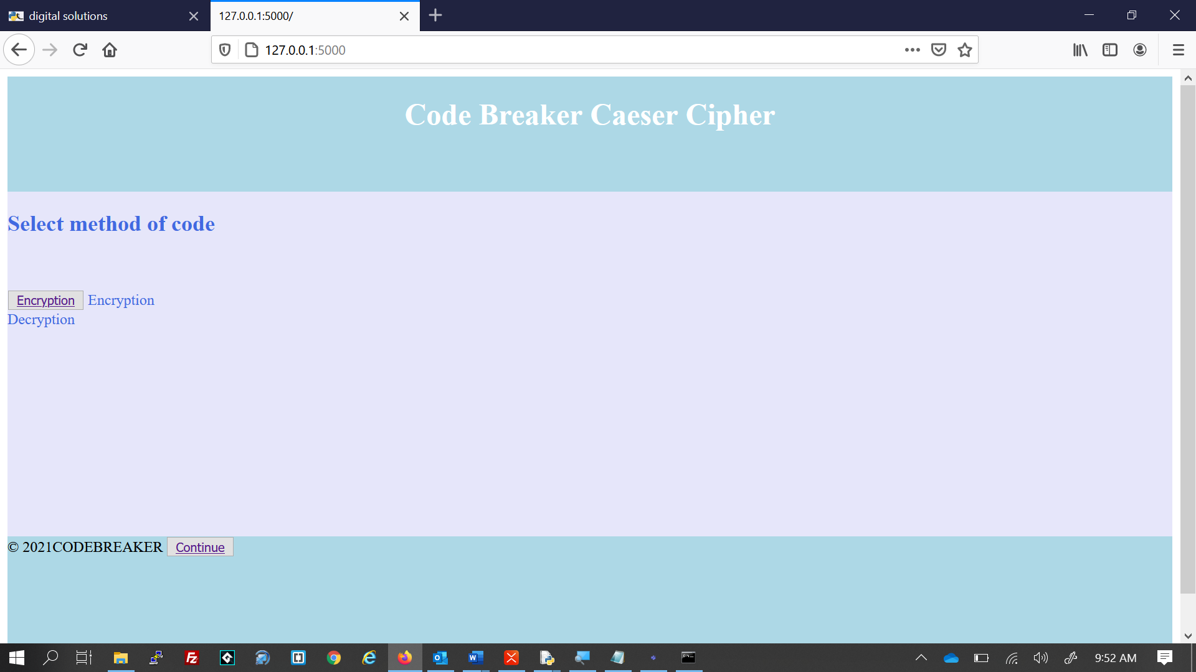 | Refinement

Reference List
Queensland Curriculum & Assessment Authority, "Digital Solutions 2019 v1.2 General Senior Syllabus". (2020).
Retrieved 01/01/2021, from https://www.qcaa.qld.edu.au/downloads/senior-qce/syllabuses/snr_digital_solutions_19_syll.pdf

