Stimulus: Slot Machine Addiction
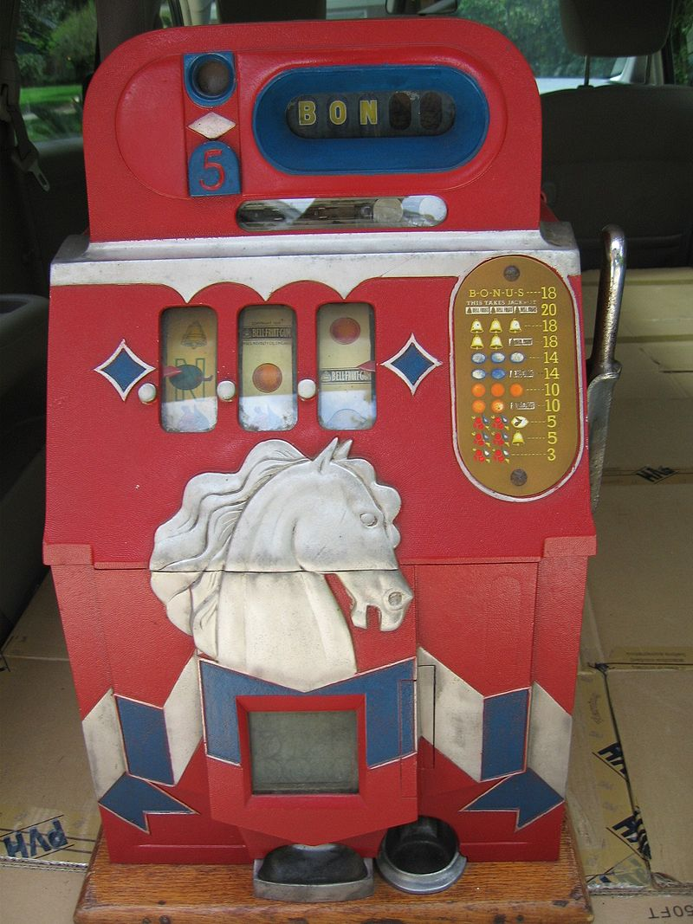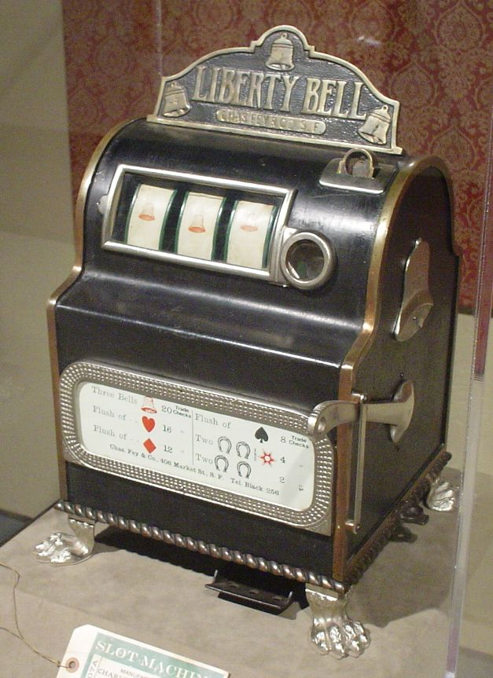

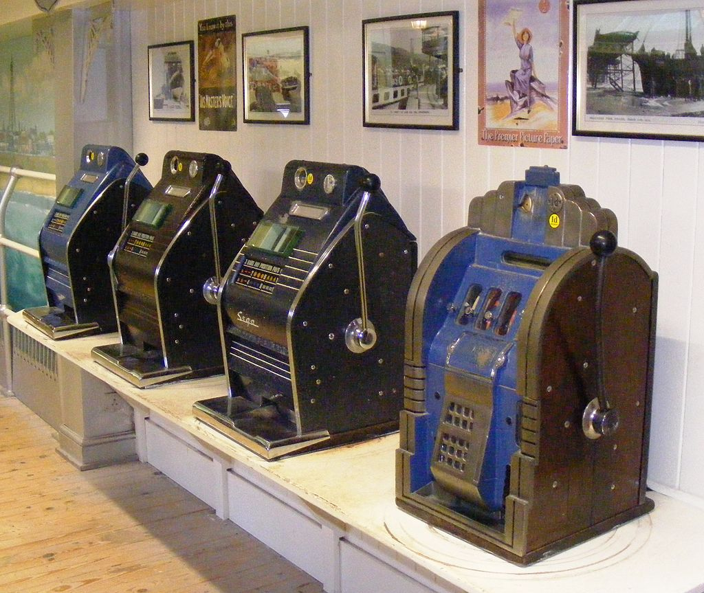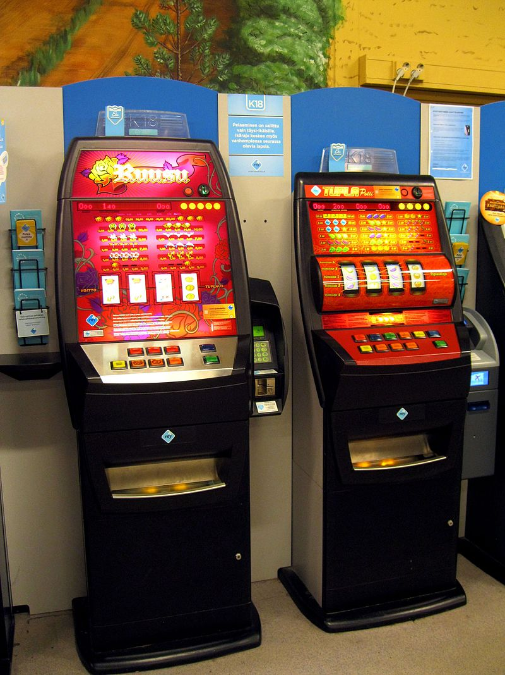

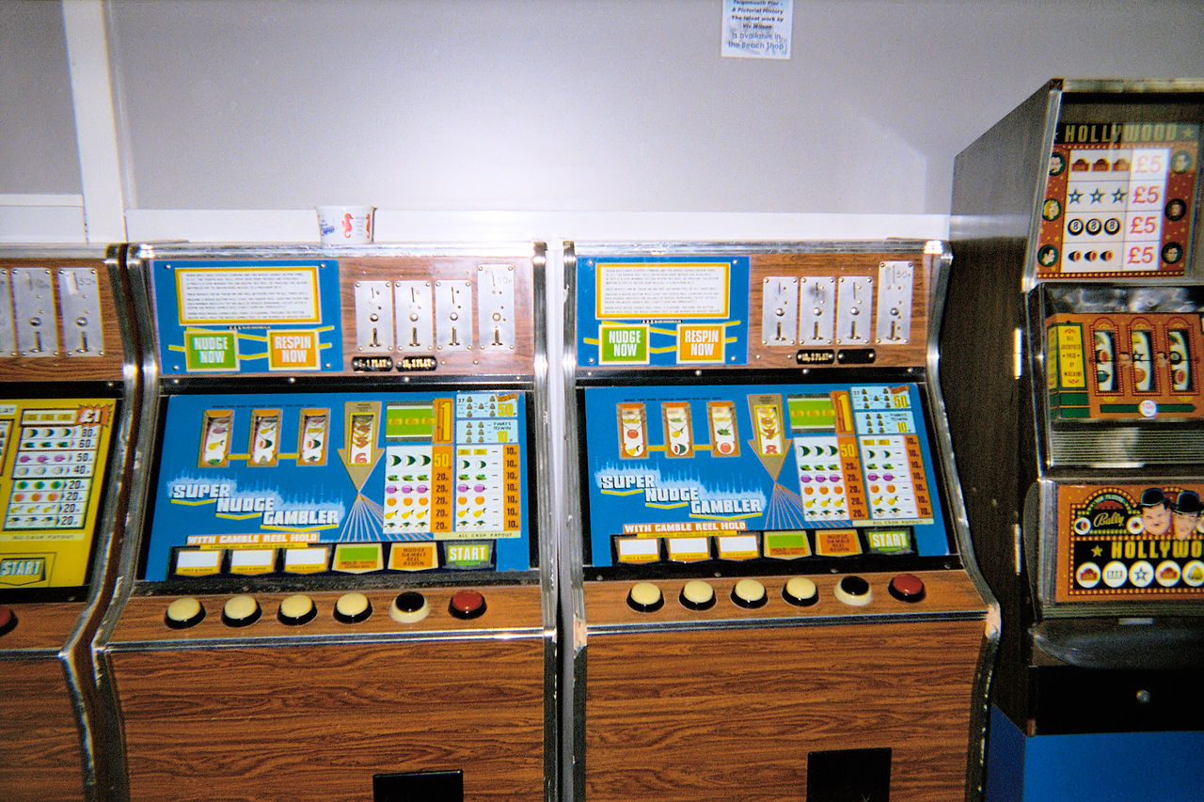

Digital Technologies project: digital solution
Section 1: Explore and Develop
"Poker machines are designed to be addictive and they cause massive social harm. Australians lose $23 billion a year, of which $14 billion goes through the pokies."
"Poker machines use flashing lights, upbeat music, near misses, sophisticated side games, free spin rewards, bonus features, 'less than bet' wins and encouraging messages to deceptively disguise total losses as partial wins."

- Analyse and determine an alternative video slot machine prototype that transparently accumulates and displays usage data for educational purposes to illustrate financial waste on slot machine. All currency transfer in this prototype is simulated (i.e., not real).
The prototype should address the following criteria:
Criteria | Description
User experience | the prototype should be user friendly and aesthetically appealing, with a robust (meaning free from error) user interface.
Data collection | the prototype should collect a range of usage data to provide an effective representation statistic of usage.
Components of this prototype could include:
Component | Ideas
Prototype implementation | - display images such as symbols, dice, coins, cards, or other pictures.  - generate a random display of images each time the script is run.  - generate a random display of images each time a button is clicked.  - determine win or loss, considering validation of user data (no cheating)  - generate feedback to the user, either via the console window or GUI.  - implement other features as discussed in this stimulus or class.
Data collection | - collect and display data via the console window or GUI on:  - accumulated time or 'spins' spent at the prototype machine.  - odds and amounts of user win and losses.  - machine / game odds. Data must be valid (accurate)  - win / loss history, log of activity or other statistical data of use.  - present and display the data in an appropriate format.  - privacy and security requirements of collecting, using and storing data
To complete this section, you should:
- Brainstorm the components of this system you wish to implement and discuss, explain or illustrate how you intend these strategies will work.
- Complete this task within a maximum of one A3 landscape page.
Section 2: Generate and Evaluate
- Generate a prototype simulation, or components of the prototype, that illustrate the working components or ideas determined in Section 1.

- #comment at the bottom of your main source code file a written response to the following question:

Analyse and visualise data to create information and address complex problems:
Test your digital solution on another end user and gather their spending or playing data using the tools you developed and predict the outcome based on your odds. With the data you gather, analyse, or visualise what this data means, how it trended against your prediction, and how it could be used to address the complex problem of slot machine addiction.

Submission Requirements
- Section 1: submit one digital document (maximum of one A3 landscape page)
- Section 2: submit all commented source code files (includes evaluation in comments)
Important Notes
- Visually simulate any necessary tasks that cannot be coded (such as inserting coin).
- A visual simulation could be as simple as an on-screen prompt, such as “Scanning rewards card... (waits 5 seconds) ... Scan complete.”
- Use comments in code to explain understanding of programming structures, as well as pointing out refinements and on-going testing of code.
- Keep backups of your files. Save every 10-15 minutes of work.
- Final testing, refinements, evaluations, and future recommendations should be neatly commented at the bottom of your most recent stable version file.
Getting Started
- Look at the examples of past completed assignments shown in class for inspiration.
- Look through past class notes, and resources from the website to help you plan.
- Brainstorm some ideas on an A3 sheet of paper that could assist with computer security.
Authentication Strategies
- Acknowledge all code snippets, tutorials, advice, information, or help given.
- Students may be asked to explain their solution, or parts there-of, to determine authenticity.

Appendix A: QCAA Years 9 and 10 Digital Technologies standard elaborations (contextualised)
 |  |  | A | B | C | D | E
Processes and production skills | Collecting, managing and analysing data | Section 1 | discerning selection and validation of data, taking account of privacy and security requirements | informed selection and validation of data, taking account of privacy and security requirements | selection and validation of data, taking account of privacy and security requirements | partial selection and validation of data, taking account of aspects of privacy and security requirements | fragmented selection and validation of data, taking account of aspects of privacy and security requirements
 | Generating and designing; producing and implementing | Section 2A | proficient implementation of modular programs | effective implementation of modular programs | implementation of modular programs | partial implementation of modular programs | fragmented implementation of modular programs
 |  | Section 2B | systematic prediction of results and testing | reliable prediction of results and testing | prediction of results and testing | partial prediction of results and testing | fragmented prediction of results and testing

This will be marked digitally via the submission platform.

Appendix B: Australian Curriculum content descriptions
This assessment instrument is used to allow students to formally demonstrate the following Australian Curriculum Digital Technologies Years 9 and 10 Content Descriptions:
Explicitly measured
P&PS | Develop techniques for acquiring, storing, and validating quantitative and qualitative data from a range of sources, considering privacy and security requirements
P&PS | Implement modular programs, applying selected algorithms and data structures including using an object-oriented programming language
P&PS | Analyse and visualise data to create information and address complex problems, and model processes, entities and their relationships using structured data
Implicit to the task (not formally measured)
K&U | Analyse simple compression of data and how content data are separated from presentation
K&U | Investigate the role of hardware and software in managing, controlling, and securing the movement of and access to data in networked digital systems
P&PS | Evaluate critically how student solutions and existing information systems and policies, take account of future risks and sustainability, and provide opportunities for innovation and enterprise
P&PS | Define and decompose real-world problems precisely, taking into account functional and non-functional requirements and including interviewing stakeholders to identify needs
P&PS | Design the user experience of a digital system by evaluating alternative designs against criteria including functionality, accessibility, usability, and aesthetics
P&PS | Design algorithms represented diagrammatically and in structured English and validate algorithms and programs through tracing and test cases
P&PS | Create interactive solutions for sharing ideas and information online, taking into account safety, social contexts, and legal responsibilities
P&PS | Plan and manage projects using an iterative and collaborative approach, identifying risks, and considering safety and sustainability

Key:
K&U: Knowledge and Understanding
P&PS: Processes and Production Skills

