|  |
| --- |
| **Stimulus: *Random number generation (RNG) games*** |
|  |

Digital Technologies project: folio

**Instructions:**

Complete a selection of tasks depending on your skill level, interest, and time available.

**There is no set number of tasks you must complete**. There is a criteria sheet at the end of this which will be used to make a holistic assessment of your production skills.

Your grade will be determined by your ability to be **purposeful**, **proficient,** or **effective** with your coding skill. Quantities of spaghetti code or [copy paste programming](https://en.wikipedia.org/wiki/Copy-and-paste_programming) will not achieve a high award for this folio.

You are encouraged to go 'above and beyond’ and adapt your creative ideas into each task to 'show off' your ability. Please ensure you stay task specific and manage your time effectively. Remember, this is not an assessment of quantity – it is an assessment of your mastery of digital production skill (i.e., coding ability).

There is no written component with this folio, however you must **comment all your written code** to evidence authenticity. Failure to do so will compromise your final award.

**Task 1: Five card draw**

Generatea script that generates 5 random cards and displays them on the screen:

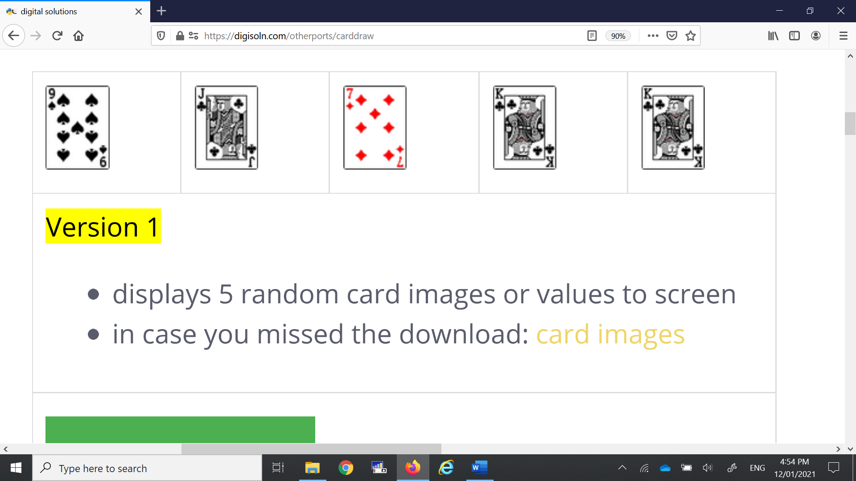

|  |  |
| --- | --- |
| **Extension** | **Description** |
| **No duplicates** | Prevent the same card from appearing twice. |
| **Sort** | From left to right, sort the hand into ascending order. |

**Task 2: Modified Yahtzee**

Generatea script that rolls 5 dice and displays them on the screen:



|  |  |
| --- | --- |
| **Extension** | **Description** |
| **Re-roll** | Add a button that can re-roll the 5 dice. |
| **Combinations** | How many of these combinations can you determine from the single dice roll?  Print the name of the *highest* *importance* combination shown in the dice to the console window or GUI: |

**Task 3: Cups**

Generatea game where the ball appears randomly under one cup. When you click on one of the 3 cups, the cup chosen lifts and shows what’s underneath:

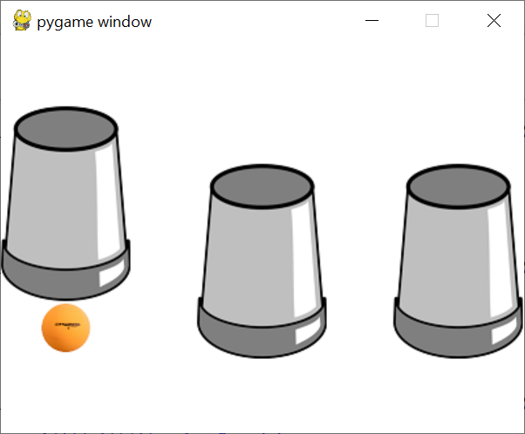

|  |  |
| --- | --- |
| **Extension** | **Description** |
| **Replay-ability** | Turn the cups game into a replay-able game, where after a guess, the game puts the cup back down and replaces the ball randomly amongst the 3 cups. |
| **Monty Hall problem** | Simulate the Monty Hall problem with the cups game (this is difficult):  Once the user picks a cup, do not lift the cup – instead, the game AI should reveal one of the two unchosen cups that *does not* contain the ball. Following this, the user is offered the chance to *swap* their guess to the other unrevealed cup. The game then proceeds as normal. |

**Task 4: Picture / word card game**

Generatea picture / word card game for children that shows a picture and offers them the word options to click on:

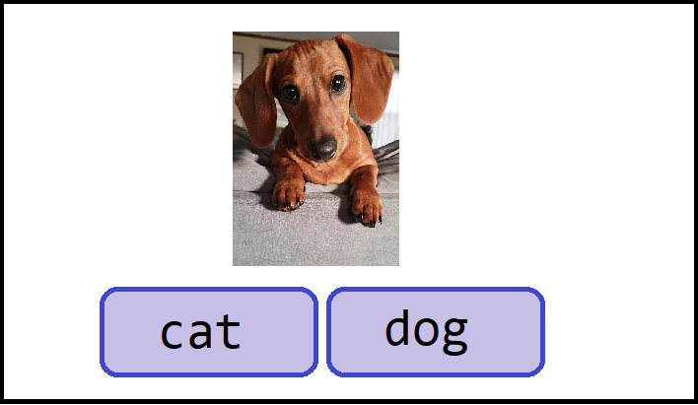

|  |  |
| --- | --- |
| **Extension** | **Description** |
| **Practise maths** | Adapt this game to be a maths game, so that the picture becomes a simple sum, and the answer buttons become integer values. The final prototype may contain some of the components illustrated below: |

**Task 5: PIN entry**

Generate a lock screen situation that works visually, like the following:

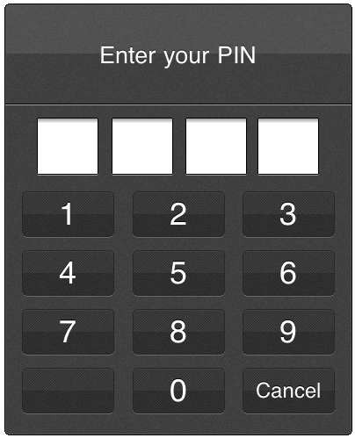

|  |  |
| --- | --- |
| **Extension** | **Description** |
| **Pattern** | Lock screens are evolving.  Some use patterns, shapes, retina, or fingerprint scans, etc.  Can you substitute numbers for a set of shapes? |
| **Gamify** | Add features to 'gamify' this application, such as:  - a hint or complex sum to solve that leads the user to the lock screen solution  - statistical tracker, such as attempts correct or incorrect  - countdown timer until passcode resets: |

**Bonus task: Procedural generation with grid-based movement**

This task is *purely for enjoyment* if you finish the previous tasks. It is a task that is far more difficult than the previous tasks, and it is not expected that you will finish this to a high or adequate functioning level.

***You do not have to complete this task*.**

Any attempts to this task, like all tasks, will be evaluated as per the criteria for this assignment.

***Grid-based movement:***

Develop a game that generates a 3x3 grid. 1 square (**blue**) represents the player. 1 square (**red**) represents the exit. The player can press a key up, down, left, or right, and in each case, the player can move 1 square per key press:

|  |  |  |
| --- | --- | --- |
|  |  |  |
| **Launch state** | **1st keypress: right** | **1st keypress: down** |

The aim of the game is to move the player towards the exit. When the player reaches the exit, the game is over (or another level grid is loaded – the choice is yours).

|  |  |
| --- | --- |
|  |  |
| **Gray square – blocked, cannot move onto square** | **Yellow square – enemy, dice roll turn-based combat** |

***Procedural (dungeon) generation:***

Additionally, you can randomly add:

* Impassable squares
* Enemy squares (with **dice roll turn-based combat** of your choosing)
* Scale up size of grid.
* Locked doors, keys, pickups, inventory
* RPG elements – skills, levels, or XP
* Other justified adjustments are welcome **within** **this grid-based, turn-based theme**.

Generate a script as best you can that can replicate or improve this basic application.

END OF ASSESSEMENT

|  |
| --- |
| **Submission Requirements** |
| * Complete each test in a new file. |
| * Submit all commented source code files digitally. |
| **Important Notes** |
| * Visually simulate any necessary tasks that cannot be coded (such as fingerprint scanning). |
| * A visual simulation could be as simple as an on-screen prompt, such as “Now scanning iris ... (waits 5 seconds) ... Scan complete.” |
| * Use comments in code to explain understanding of programming structures, as well as pointing out refinements and on-going testing of code. |
| * Keep backups of your files. Save every 10-15 minutes of work. |
| * Testing, refinements, or recommendations should be neatly commented in your source code files. |
| **Getting Started** |
| * Look at the examples from class to get an idea how to tackle these challenges. |
| * Look through resources from the website for ideas. |
| * Brainstorm some ideas with your friends or teacher if you can’t figure out how to start. |
| **Authentication Strategies** |
| * Acknowledge all code snippets, tutorials, advice, information, or help given. |
| * Students may be asked to explain their solution, or parts there-of, to determine authenticity. |
| * Please do not share your solutions but rather help students with their own line of work – **you may not necessarily be right or efficient**. |

#### Appendix A: QCAA Years 9 and 10 Digital Technologies standard elaborations (contextualised)

|  |  |  |  |  |  |  |
| --- | --- | --- | --- | --- | --- | --- |
|  |  | **A** | **B** | **C** | **D** | **E** |
| **Processes and production skills** | *Generating and designing; producing and implementing* | **purposeful** design and **proficient** implementation of modular programs | **effective** design and **effective** implementation of modular programs | design and implementation of modular programs | **partial** design and implementation of modular programs | **fragmented** design and implementation of modular programs |

*This will be marked digitally via the submission platform.*

#### Appendix B: Australian Curriculum content descriptions

This assessment instrument is used to allow students to formally demonstrate the following Australian Curriculum Digital Technologies Years 9 and 10 Content Descriptions:

|  |  |
| --- | --- |
| **Explicitly measured** | |
| P&PS | Implement modular programs, applying selected algorithms and data structures including using an object-oriented programming language |
| **Implicit to the task** (not formally measured) | |
| K&U | Investigate the role of hardware and software in managing, controlling, and securing the movement of and access to data in networked digital systems |
| K&U | Analyse simple compression of data and how content data are separated from presentation |
| P&PS | Develop techniques for acquiring, storing, and validating quantitative and qualitative data from a range of sources, considering privacy and security requirements |
| P&PS | Analyse and visualise data to create information and address complex problems, and model processes, entities and their relationships using structured data |
| P&PS | Define and decompose real-world problems precisely, taking into account functional and non-functional requirements and including interviewing stakeholders to identify needs |
| P&PS | Design the user experience of a digital system by evaluating alternative designs against criteria including functionality, accessibility, usability, and aesthetics |
| P&PS | Design algorithms represented diagrammatically and in structured English and validate algorithms and programs through tracing and test cases |
| P&PS | Evaluate critically how student solutions and existing information systems and policies, take account of future risks and sustainability, and provide opportunities for innovation and enterprise |
| P&PS | Create interactive solutions for sharing ideas and information online, taking into account safety, social contexts, and legal responsibilities |
| P&PS | Plan and manage projects using an iterative and collaborative approach, identifying risks, and considering safety and sustainability |

**Key**:

K&U: Knowledge and Understanding

P&PS: Processes and Production Skills