Project – Static Website
Plan, produce and evaluate a responsive, static website for the Summit business.

Overview of Idea (A&A2 – communication)

Note: The A&A2 communication criteria is measured throughout both product and written component.
A brief paragraph about the project. Restate the purpose of this project. Start with an overarching statement of how you intend to complete this task, such as “The following project will detail the design, development and evaluation of the Summit website.”

Software and Hardware Requirements (K&U1)
Identify and explain software and hardware requirements. Give thought to both development and deployment:
Development examples:
- Software
  - Languages / editors
  - Operating systems
- Hardware
  - Internet
Deployment examples:
- Browser compatibility
- Hardware / software etc..
Use of Proposed Solution in Society (K&U2)
Identify and explain how your proposed solution:
- will meet the needs of Summit:
  - How (exactly) could this website make Summit’s business more profitable?
  - How will the website be used by Summit’s customers?
  - How will the success of the Summit website be measured?
  - What are some of the considerations that need to be taken into account when building Summit’s website?
    - Device compatibility?
    - Accessibility / responsive layout / social, ethical or legal concerns?
    - How will content be updated in the future?
- will meet the needs of Summit’s customers:
  - Who is the primary target audience for this website?
  - How will this website be of benefit to Summit’s audience?
- can be justified (i.e. rationale), given the benefits to Summit and its customers
Analysis of Problem (A&A1)
A mind-map can best illustrate your brainstorming analysis. Stems may include:
- product analysis:
  - sections and sub-sections of website required
  - usability principles, such as accessibility / responsive layout / compatibility
  - benchmarks to meet:
    - Quantitative measures, e.g. speed and file size
    - Qualitative measures, e.g. ease of navigation
- process analysis:
  - methodology – what are the tasks required to deliver this product to the client?
  - end user requirements:
    - What are the staffing needs for Summit, in terms of training or updating content in the future? (e.g. changing prices / specials / competitions / advice on hiking trails etc.)
    - What are the end user needs, in terms of assumed knowledge or assumed baseline technology?
  - can you think of any potential risks or predicted issues / problems with developing, deploying or maintaining this project?
    - Delays
    - Data loss
  - are there any other project requirements that must be met or are worth considering?
    - Aesthetic considerations
    - Planning constraints

Synthesising a Plan – Annotated Design Illustrations (P&E1)
By hand or draw and scan – make sure these are annotated – illustrate and explain how your solution is going to work (visually) across multiple storyboards, for example:
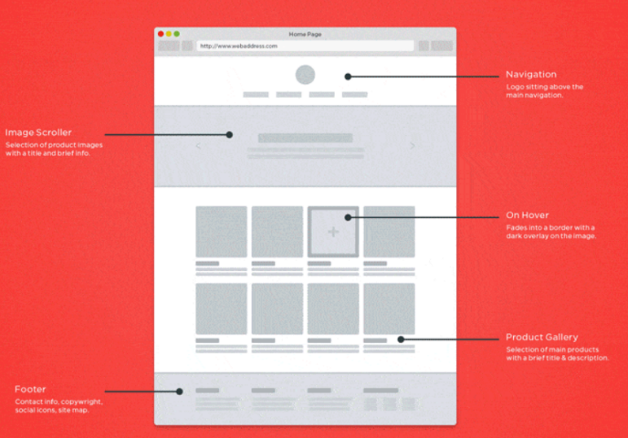

Production of Solution (P&E2)
Build your solution and screen record yourself describing both a demonstration of the working solution and all source components
There is a criteria for applying software and hardware concepts, ideas and skills to complete all set tasks listed (A&A3).

Evaluation and Future Recommendations (P&E3)
- A critical reflection of the solution:
  - Do you have some quantitative or anecdotal test data on how your solution worked, that can justify your claims?
  - Are there any errors or shortcomings, and what is the consequence of these?
  - Can you suggest future directions for short and long term improvement of your product?
- A critical evaluation of the process you took in developing this proposal:
  - What worked well? What was difficult? How could you have approached your issues differently? How did you resolve issues faced?
  - Where to from here?
- Overall, based on the actions and consequences identified in this evaluation, do you believe this product or project was successful? Why or why not? Explain, with reasoned evidence. Where this is doubt in judgement, what further evidence would you need to help minimize this doubt.

Use screen shots or evidence from your project where possible to help illustrate your judgements.

