Project – Animated Storybook
Plan, produce and evaluate a basic, animated storybook for the local primary school, that has simple interactive navigation controls and can be exported for web playback.

Overview of Idea (A&A2 – communication)

Note: The A&A2 communication criteria is measured throughout both product and written component.
A brief sentence or two about the project. What is this project for? Restate the task in your own words, and briefly describe what your animated storybook is going to be about.

Software and Hardware Requirements (K&U1)
Identify and explain software and hardware requirements you will need to complete this task, and for students to watch your animated storybook. Give thought to both production and playback:
Production:
- What hardware and software will you need to complete this task? List everything you will need here, such as:
  - Animation software
  - Laptop
  - Internet connection
  - What else might you need? Make sure you state the purpose of anything you list here.
Playback:
- How will students watch your completed animated storybook? What hardware and software will they need?
- How will you distribute the completed animated storybook to the local primary school?

Use of Proposed Solution in Society (K&U2)
Identify and explain:
- What is the aim of your animated storybook?
  - What is the learning intent? Is it going to:
    - Have a moral to the story, or be religious
    - Teach a skill, fact or knowledge
    - Have another intention, such as safety, or be musical, or something else
- Describe the target audience for your animated storybook:
  - Ages / education level
  - Interests and likes
  - Secondary audiences such as teachers and parents – what are they looking for in an animated storybook?
- How will your animated storybook improve the lives of:
  - The students – what will they “get” out of this animated storybook?
  - The parents and teachers – how will this project improve their lives as well?
- What are the constraints and limitations of developing something for younger students? Think both in terms of content (type, genre) and educational ability (attention spans, literacy ability etc.)
Analysis of Problem (A&A1)
A mind-map can best illustrate your brainstorming analysis. From your knowledge and understanding so far, analyse:
- product analysis:
  - What is the storyline? Characters? Sounds or animations? Playback controls?
  - What is the aesthetic / theme you are going for? Bright, fast, action, etc.
  - What other considerations must be made for the animated storybook to be successful?
- process analysis:
  - What methodology (i.e. steps or process) will you follow to deliver this project on time?
  - When it comes time to deliver the project, how will you assist the teachers sharing this with their students? Will they need any help? What difficulties might they face?

Synthesising a Plan – Annotated Design Illustrations (P&E1)
By hand or draw and scan – make sure these are annotated – illustrate and explain how your solution is going to work (visually) across multiple storyboards. See the example on the next page.

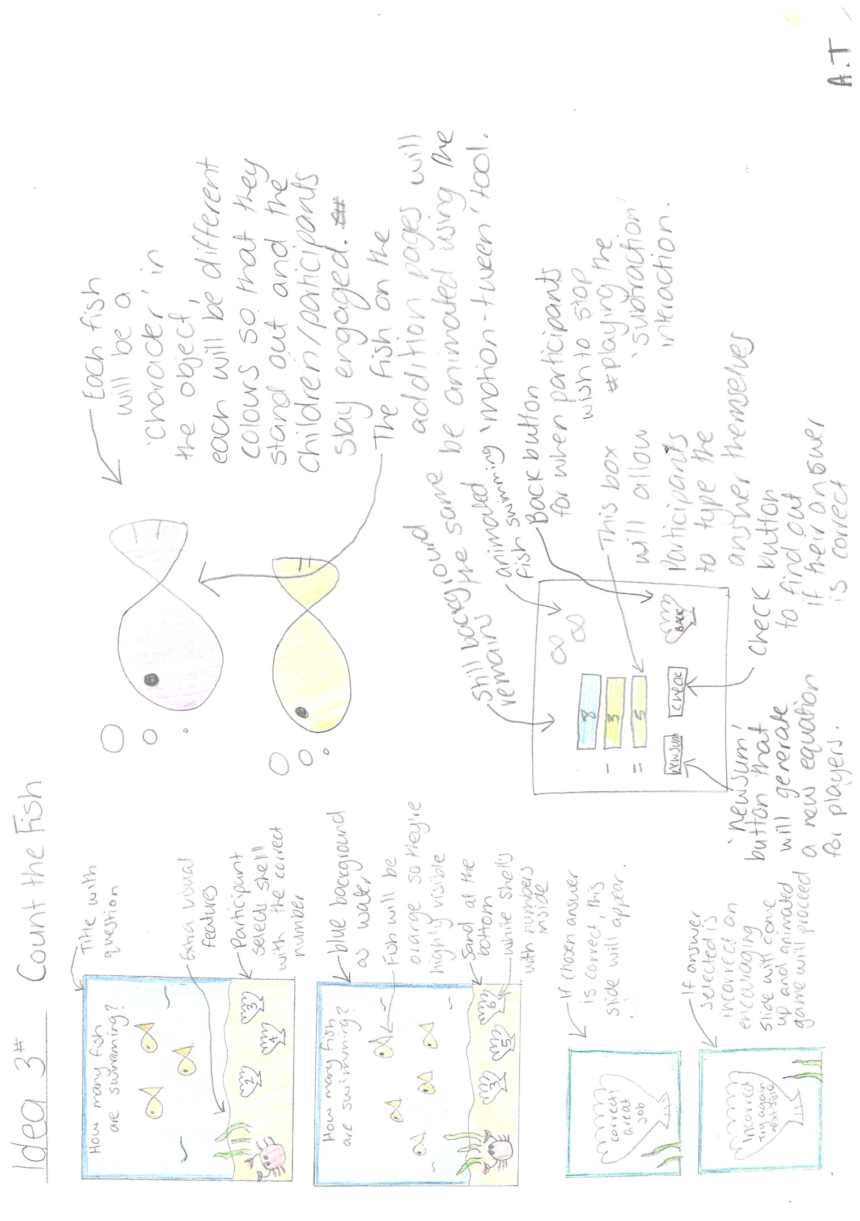

Production of Solution (P&E2)
Build your solution and screen record yourself describing both a demonstration of the working solution and all source components
There is a criteria for applying software and hardware concepts, ideas and skills to complete all set tasks listed (A&A3).

Evaluation and Future Recommendations (P&E3)
- A critical reflection of the solution:
  - Do you have some quantitative or anecdotal test data on how your animated storybook was received, that can justify your claims? Who watched it? What did they say?
  - Are there any errors or shortcomings in your animated storybook, and what is the consequence of these?
  - Can you suggest future directions for short- and long-term improvement of your animated storybook?
- A critical evaluation of the process you took in developing this proposal:
  - What worked well? What was difficult? How could you have approached your issues differently? How did you resolve issues faced?
  - Where to from here?
- Overall, based on the actions and consequences identified in this evaluation, do you believe this animated storybook – both the design and development of – was successful? Why or why not? Explain, with reasoned evidence. Where this is doubt in judgement, what further evidence would you need to help minimize this doubt.

Use screen shots or evidence from your project where possible to help illustrate your judgements.

