Project – HTML, CSS and JavaScript chance game
Plan, produce and evaluate a browser-based JavaScript powered “chance” or “simulation” game that interacts with DOM (Document Object Model) elements, such as HTML structure or CSS styling.

Overview of Idea (A&A2 – communication)

Note: The A&A2 communication criteria is measured throughout both product and written component.
A brief paragraph explaining your idea. Outline the theme of your game. Is it a game or a simulation of chance? Restate the purpose of this project and start with an overarching statement of how you intend to respond to this, such as “The following project will detail the design, development and evaluation of the Stock Market simulator solution.” … include your rationale (justification for solving this issue). This a brief synopsis.

Software and Hardware Requirements (K&U1)
Identify and explain software and hardware requirements. Give thought to both development and deployment:
Development:
- Software
  - Languages / editors
  - Operating systems
- Hardware
  - Internet
Deployment:
- Browser compatibility
- Hardware / software etc..

Use of Proposed Solution in Society (K&U2)
Identify and explain how your proposed solution:
- Will meet the needs of students studying stats and probability at an upper-primary school / middle-school level
  - How (exactly) could it fit into their course of study?
  - How will it be used by these students? (e.g. how often, or will it have questions or a worksheet, or will it be an extension activity)
- compares to existing solutions already in society for this problem

Analysis of Problem (A&A1)
A mind-map can best illustrate your brainstorming analysis. Stems may include:
- product analysis:
  - game or simulation “flow” or “play”
  - computational thought or calculations needed
  - analysis of interactivity (between user and elements on the page)
  - anything else? What about colour, aesthetics, page-load times etc.?
- process analysis:
  - end user requirements – what do students studying stats and probability at an upper-primary school / middle-school level need from a web-based “chance” or “simulation” game?
    - How will you meet these needs?
    - What about secondary audiences such as teachers of these students?
    - Is there any other user groups that could benefit or have an interest (good or bad) in your project?
  - can you think of any potential risks or predicted issues / problems with developing, deploying or maintaining this project?
  - are there any other project requirements that must be met or are worth considering?

Synthesising a Plan – Annotated Design Illustrations (P&E1)
By hand or draw and scan – make sure these are annotated – illustrate and explain how your solution is going to work (visually) across multiple storyboards, for example:
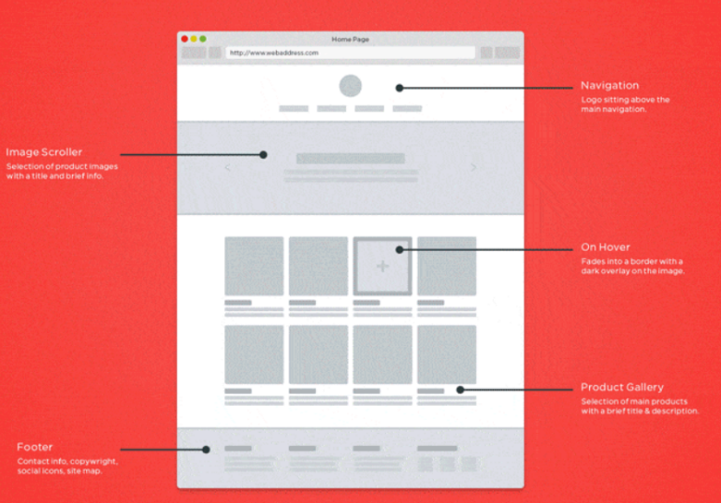

Production of Solution (P&E2)
Build your solution and screen record yourself describing both a demonstration of the working solution and all source components

There is a criteria for applying software and hardware concepts, ideas and skills to complete all set tasks listed (A&A3).

Evaluation and Future Recommendations (P&E3)
- A critical reflection of the solution:
  - Do you have some quantitative or anecdotal test data on how your solution worked, that can justify your claims?
  - Are there any errors or shortcomings, and what is the consequence of these?
  - Can you suggest future directions for short and long term improvement of your product?
- A critical evaluation of the process you took in developing this proposal:
  - What worked well? What was difficult? How could you have approached your issues differently? How did you resolve issues faced?
  - Where to from here?
- Overall, based on the actions and consequences identified in this evaluation, do you believe this product or project was successful? Why or why not? Explain, with reasoned evidence. Where this is doubt in judgement, what further evidence would you need to help minimize this doubt.

Use screen shots or evidence from your project where possible to help illustrate your judgements.

