Extended Response – Mobile Application Proposal Scaffold
Develop a mobile application proposal (600 – 1000 words) for a mobile device application that could be of measurable social benefit to local residents.

Overview of Your Idea
A paragraph explaining your idea. Outline the basic idea, methodology or sequence your proposal will follow, and what the reader can expect to have learnt after they finish reading your proposal.

Software and Hardware Requirements
Identify and explain software and hardware requirements:
- Hardware:
  - Device? Mobile or tablet? Brand? Model? How old a phone do you plan on supporting? Must it have a touch sensitive screen (for example)
  - Does it require use of telephone network?
  - Does it require use of internet connection? If so, what speed? 4G or 5G? What data and bandwidth usage do you expect? Will it work on WiFi?
  - Camera? Still or motion? Will your proposed application augment camera imagery?
  - Does it require use of other phone functionality, and if so, how, including:
    - Bluetooth
    - GPS
    - Accelerometer / gyroscope (orientation) / magnetometer (direction)
    - Barometer / proximity / ambient light sensor
  - What limitations will the application have to contend with, and how, including:
    - Battery life
    - Screen size
    - Processing capability
    - Data limits
    - Network limits / offline capabilities
  - Vocabulary – define any technical terms (this can be done in Appendix)

- Software:
  - Targeted Operating Systems – Android, iOS, or other, or both? What version (backwards compatibility?)
  - Distribution platforms? (Google Play, iOS App Store). Will this manage future updates for your software? Will this manage bans, invalid or hostile accounts (e.g. hackers / pirates)?
  - How much storage space on the phone will be required for the app to be installed?
  - Do you require secure account authentication? How will you achieve this? What data will you record and what data will live locally on the phone or mobile device?
  - What will your app require permission access granted to on the phone, and if so, why:
    - Photos / videos
    - Call logs
    - Location services etc.
  - Do you require any 3rd party applications or additional hardware to be installed?
  - Community forums, news, FAQ’s, advertising and complaints – how will you manage these?

Identifying the Use to Society
- What is the measurable social benefit of your application idea to local residents? Elaborate on this. You can use data or research in current trends in society here to help make your point.
- Target audience analysis – demographics and attitudes
- How is your proposed mobile application different (and more purposeful) from existing apps?
- List the ‘unique selling points’ of your app that are going to entice uptake of your app.

Analysis of Problem: Developing a Mobile Application of Measurable Social Benefit
What does this mobile app need to succeed? Draw a mind-map:
- Social issue being improved (and factors, stakeholders or rolls involved in this issue)
- Data (what data needs to be stored, collected or shared)
- Processes (what functions or features will the app perform using the data)
- Goals and risks (what is the intended good and potential bad that could come from this)
- Intangible elements (points that are interesting or worthy of consideration / analysis)

Synthesising a Plan – Annotated Design Illustrations
By hand or draw and scan – make sure these are annotated – illustrate and explain how your mobile app is going to work (visually), for example:
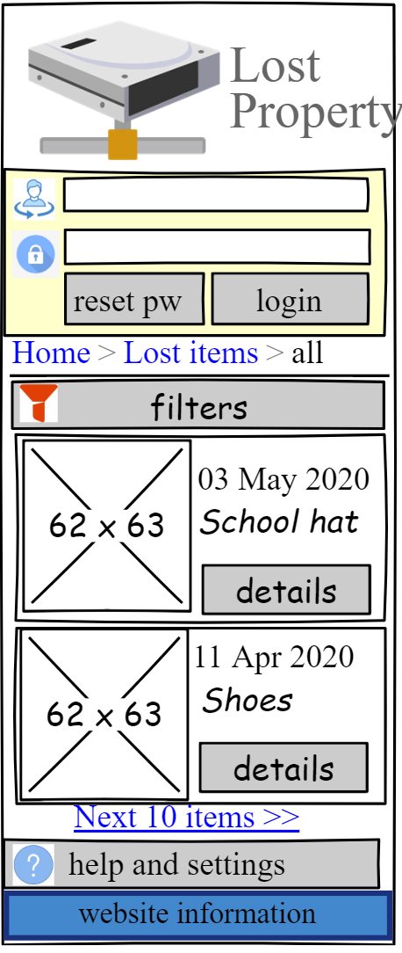
User can reset their password using the reset password button. This will send them a link to click on to change their password.

Evaluation and Future Recommendations
A critical reflection of the mobile app proposed, as well as the process you took in developing this entire proposal (e.g. coming up with the idea, drawing the illustrations, etc.), including:
- What worked well? What was difficult? What needs more work? Justify your conclusions with supporting evidence (e.g. use examples or snippets from your proposal to support your arguments made here).
- What needs to happen now? What else could or should be done? For what reason are you making these claims?
- Overall, based on the actions and consequences identified in this evaluation, do you believe (realistically) this app is going to be of measurable social benefit to local residents? Why or why not? Explain, with reasoned evidence. Where this is doubt, predict some strategies that could help minimize some of this doubt. Explicitly point out both success and failures in this mobile application proposal.

