Scaffold: Client server architecture
For a sound achievement, all tasks utilise the same common elements:
- To design a HTML form with input text fields, use: https://digisoln.com/flask/dom/textinput
- To add other form elements such as select fields or checkboxes, use: https://digisoln.com/flask/dom/choices
- Use a simple CSS grid for styling: https://digisoln.com/flask/rwd/grid_layout

- If you are finding this very difficult, and wish to achieve a sound result, look at producing the applications in a console environment:

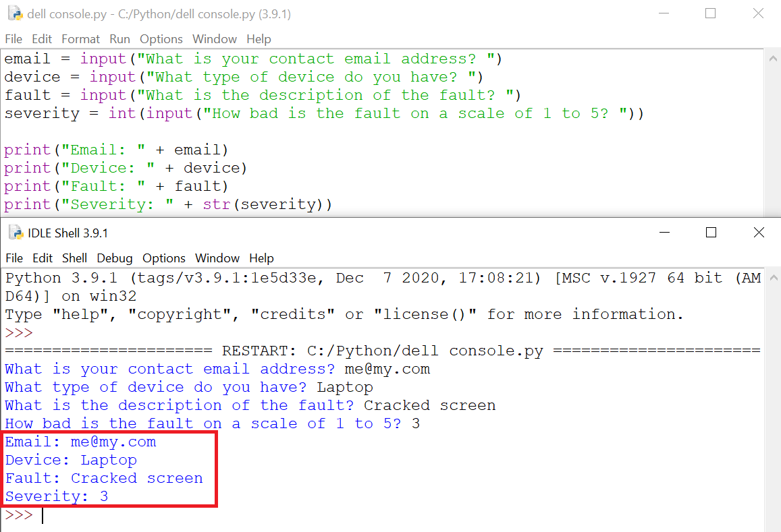

For a higher achievement, record the input server side using Flask:

- https://digisoln.com/units/WebApplications_FlaskJinja2/7.%20Flask%20GET%20and%20POST.html

Class examples relevant to these tasks include:

- https://digisoln.com/units/WebApplications_FlaskJinja2 (Flask + Python)

- https://digisoln.com/rwd (Responsive Web Design)
- https://digisoln.com/js (JavaScript, but to a much lesser extent)

