Section 1: Explanation of the control and management of digital systems.
- Analyse and determine security strategies for users of a simple digital messaging application:

Strategy: | Action: | Reasoning or Justification, thinking of utility and security:
Password Rules | A password must have a minimum length of 8 characters. | - Utility: 8 letters is not too many for one person to type or remember  - Security: 8 letters provide enough letter combinations that the password cannot easily be guessed
 | A password must have a maximum length of 15 characters. | - Utility: If more than 15 letters is allowed in a password, it might be too long or too hard to remember. The user might keep forgetting, and the password might be too big to store in memory.

- Symbolisation (illustration or diagram) of security strategies:

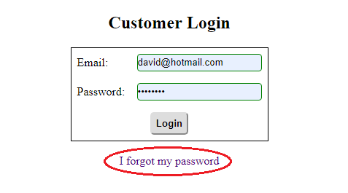
Forgotten passwords: I plan to implement a Forgot My Password feature. Because hackers might try to spam this to create a flood of emails, I will use a CAPTCHA to make this harder to spam:

