Section 1: Explanation of the control and management of digital systems.
- Analyse and determine an alternative video slot machine prototype that transparently accumulates and displays usage data for educational purposes to illustrate financial waste on slot machine:
Data Collection: | Metric recorded: | Explanation
Financial | Total money won or lost from first play to last play of a single user. | This will indicate to the user their net win or loss.
 | Total winnings. | Net wins, not including losses.
 | Number of wins.
 | Total money won or lost for all time users.
Time | Lost time
 | Frequency of wins
Mood change (?)
Data Collection strategies shown in table.
Some ideas have been shown.
User Experience samples below.
Annotate your own illustrations.

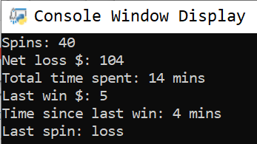

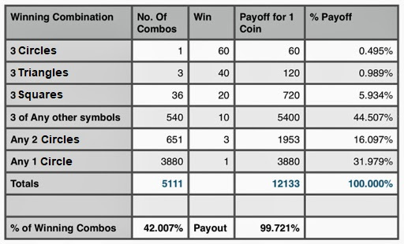
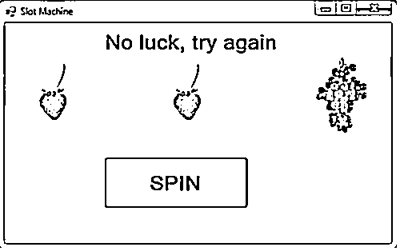
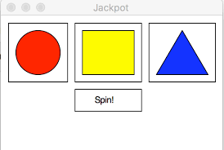
User clicks spin using the mouse.

