Worksheet 3: Collision
Learning Intentions: We are learning to be able to …
Create and understand collision events in GM

Why are we learning this?
Collision formulates the basis of interaction for all objects in games.

Success Criteria: I will be successful if I can …
- Explain the types of collision
- Diagnose and fix collision events that are erroneous
- Implement collision events that utilise low CPU usage

Instructions:
Acquire and integrate knowledge:
- Use previous GM file but remove all events on all objects, put ball somewhere in room and leave wall around border of room:
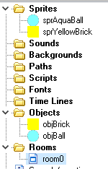

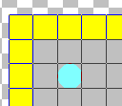

- Make objBrick “Solid”:
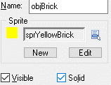

- On objBall:

Create Event:

Collision Event with objBrick:
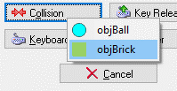

Play and test.

- Does anything seem to change if I choose not precisely bounce in the above example?
Click here to enter text.

- What do you think is the difference between random() and random_range()? Explain how these functions affect the speed and direction of the object in the above example.
Click here to enter text.

Extend and refine knowledge:
- Add a Key Press <Space> Event + Create Instance Action to the object ball:
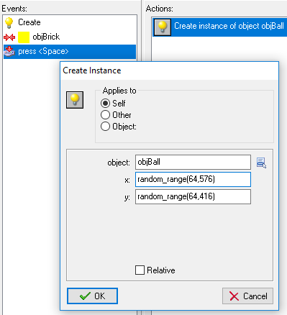

- Why do you think we have ranged 64 – 576 and not 0 – 640 which is the full room width?
Click here to enter text.

- Add another Collision Event to the ball, this time with itself:
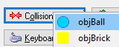
- Set Bounce action for Collision Event with itself:
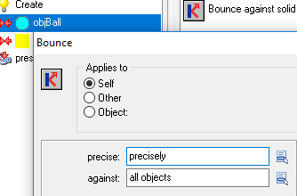

Test and play.

Aside from the balls spawning on top of each other, you will find that the game slows down a lot – which can be seen visually by the choppiness of the animation.

- If I change precisely to not precisely in the previous example, does it still happen as bad? What is the trade off?
Click here to enter text.

- “Precise” or “per pixel” collision checking is expensive but accurate… so no collision will be detected here yet (which is correct):

This is using a “bounding box” on the aqua ball and is a lot cheaper on the CPU, but not as accurate (this should be a miss, but is counted as a hit):

On the sprite you can turn off Precise collision checking yourself, and Modify the bounding box Mask if you like:
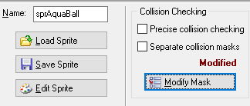

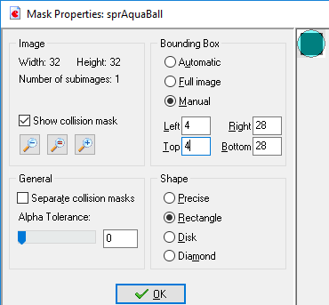

Most games have “hitbox” areas, as per pixel collision is too slow…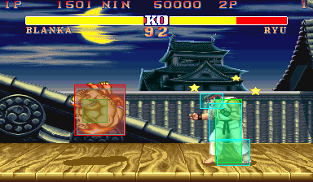

Use knowledge meaningfully:
- Investigate what is meant by the Sprite origin. Good developers will always Center their origins. Explain what this does:
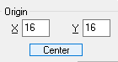
Click here to enter text.

- Practise importing a sprite sheet. Use the 4_web_based/gamemaker81/sprites.html resource to see how.

