Worksheet 3: Alarms, variables and other random tricks
Learning Intentions: We are learning to be able to …
Use alarms for timing and variables to change values.

Why are we learning this?
Intermittent and fluctuating activity adds variety to gameplay.

Success Criteria: I will be successful if I can …
- Use an alarm to trigger an event
- Reset an alarm
- Use a variable in place of fixed value
- Change the value of a variable

Instructions:
Acquire and integrate knowledge:
- Create a layout for a new game as follows. Note: objScore does not have a sprite, but is still placed in the game room, as is shown by the blue circle with red question mark:
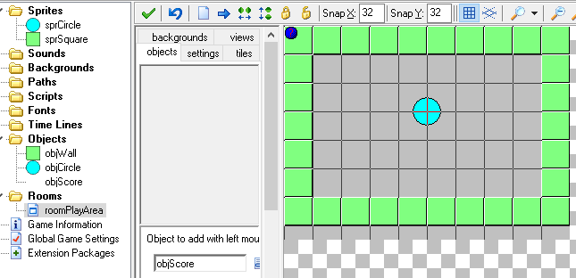

- Use the following Object Information to complete the remainder of the game:
Information about object: objWall
Sprite: sprSquare
Solid: true
______________________________________________________
Information about object: objCircle
Sprite: sprCircle
Solid: true
Create Event:
set variable mySpeed to 1
set speed to mySpeed and direction to random(360)

Alarm Event for alarm 0:
set speed to mySpeed and direction to random(360)
set Alarm 0 to 90

Collision Event with object objWall:
bounce not precisely against solid objects

Mouse Event for Left Pressed:
start moving in direction stop with speed set to 0
set the score relative to +1
if score is not smaller than 5
set Alarm 0 to 90
jump to a random position
set variable mySpeed relative to +0.5
set speed to mySpeed and direction to random(360)
______________________________________________________
Information about object: objScore
Sprite:
Create Event:
set the score to 0

Draw Event:
at position (0,0) draw the value of score with caption Score:

- Test and play. Explain how the game works:
Click here to enter text.

Extend and refine knowledge:
- Alarm events occur when the alarm reaches 0. It ticks down at the same speed as the room steps per second (by default: 30). Using the default room speed, what would I have to set my alarm to, so that it triggers in exactly 3 seconds?
Click here to enter text.

- Create a game that changes the sprite based on the direction I move:
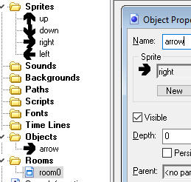
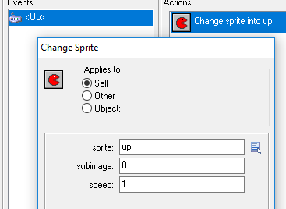
Note that speed in this example is the speed at which the sprite cycles through the sub-images within the sprite (like stepping through a sprite strip)… of course if you only have 1 image, this is irrelevant.

Use knowledge meaningfully:
- Can I use random_range(30, 150) when I reset my alarm? What is the effect of this?
Click here to enter text.

Dodging Squares From the Sky Game:
- Create a game with one sprite (sprSquare) and one object (objSquare). Use any solid fill colour for the sprite. Add the sprite to the object and these actions to the object (objSquare):
Create Event:
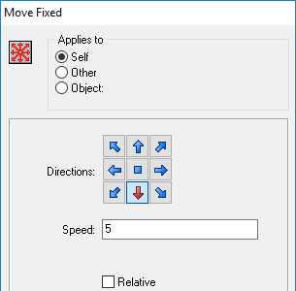

Other Outside Room Event:
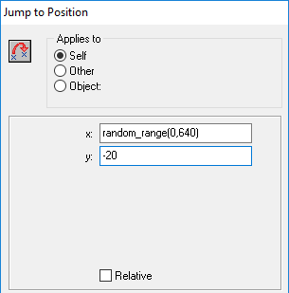
What is the effect of this so far when you play it?
Click here to enter text.

- Add a sprPlayer and an objPlayer to your game started in the previous question:
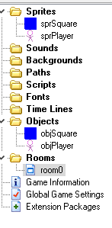
Make the player to be able to move left and right only.. and put the player at the bottom of the room. Add the Step event to the object square:
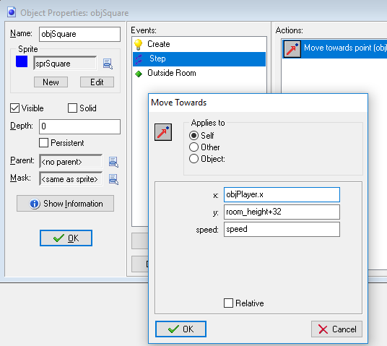
Explain how the above step event functions, and its impacts on game behaviour:
Click here to enter text.

