PhoneGap Server
- phonegap.com, click Start Now:
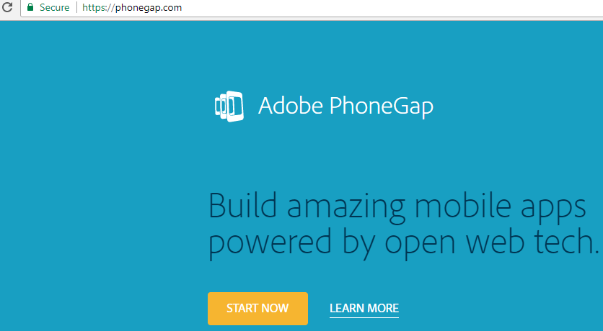
- Install desktop app:
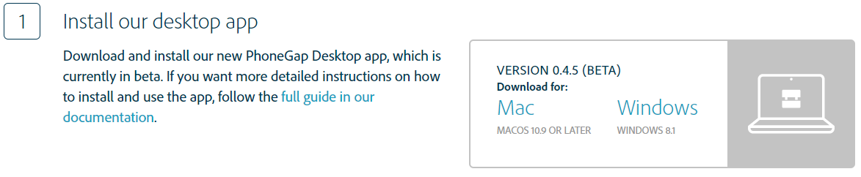
- All the default options are fine, keep hitting “Next”, “Install” and (eventually) “Finish”:
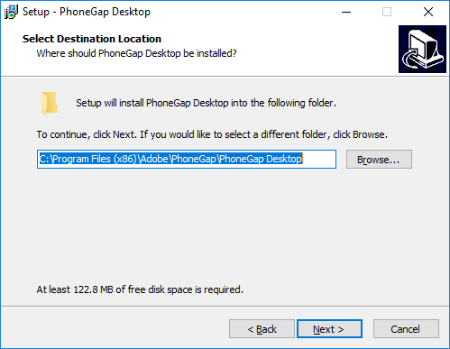

Emulator
- Using chrome browser, go to emulate.phonegap.com and click Get Ripple Emulator:
- Click + Add to Chrome button:

- You can enable from extension shortcut in Chrome menu in future:

PhoneGap Desktop App
- Launch PhoneGap Desktop App from start menu:
- Create new PhoneGap project…
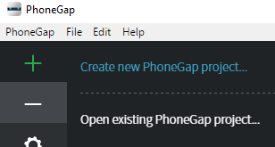
- Use Hello World Template and click Next
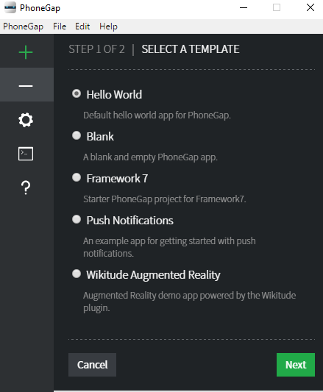
- Create a phonegap folder somewhere you can find it easily, all your projects will go into this folder (into sub folders of course):
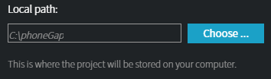
- Call project Hello World and click Create project:
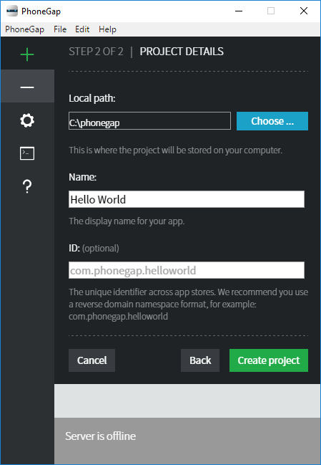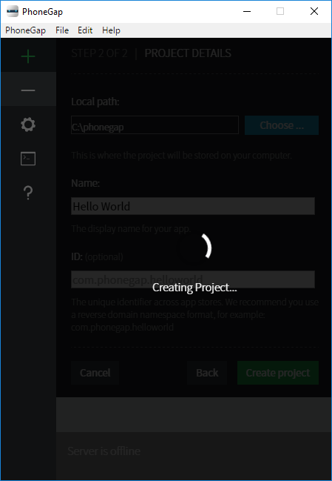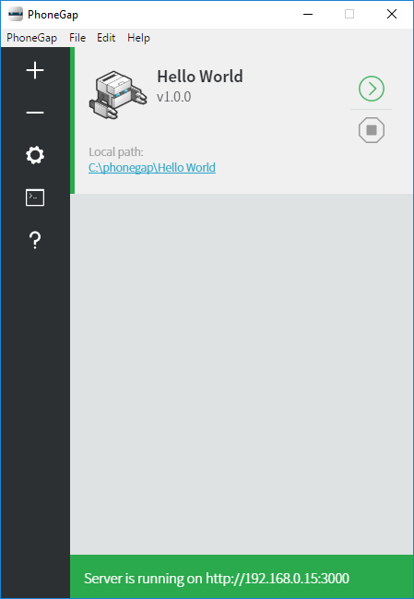
- ^^ Sometimes project does not appear, if not just close & re-open PhoneGap Desktop App

- Take note of IP address where it says “Server is running on http://.....”

Emulating in Browser
- Punch in your local server IP address (from previous step) into emulate.phonegap.com. You may have to enable the Ripple extension once you are there:
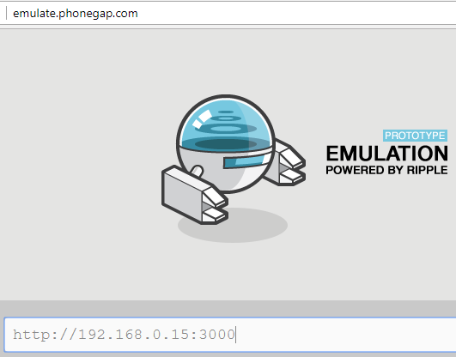
- Allow permissions etc.:
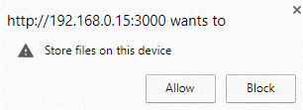
- If it is all working correctly, you should see this:
