Worksheet 10: More Challenges
Learning Intentions: We are learning to be able to …
Interpret and implement a digital solution from a plan

Why are we learning this?
Programming is a problem solving discipline, where teams work together to plan, build, test and refine digital solutions.

Success Criteria: I will be successful if I can …
Use everything I have learnt to develop a working solution in Scratch to one of the challenge problems.

Instructions:
Acquire and integrate knowledge:
Develop a solution, prototype or part thereof in Scratch to one of the following challenges:

Bear Challenge (aka Dodge the Boulders, Eat the Burgers):
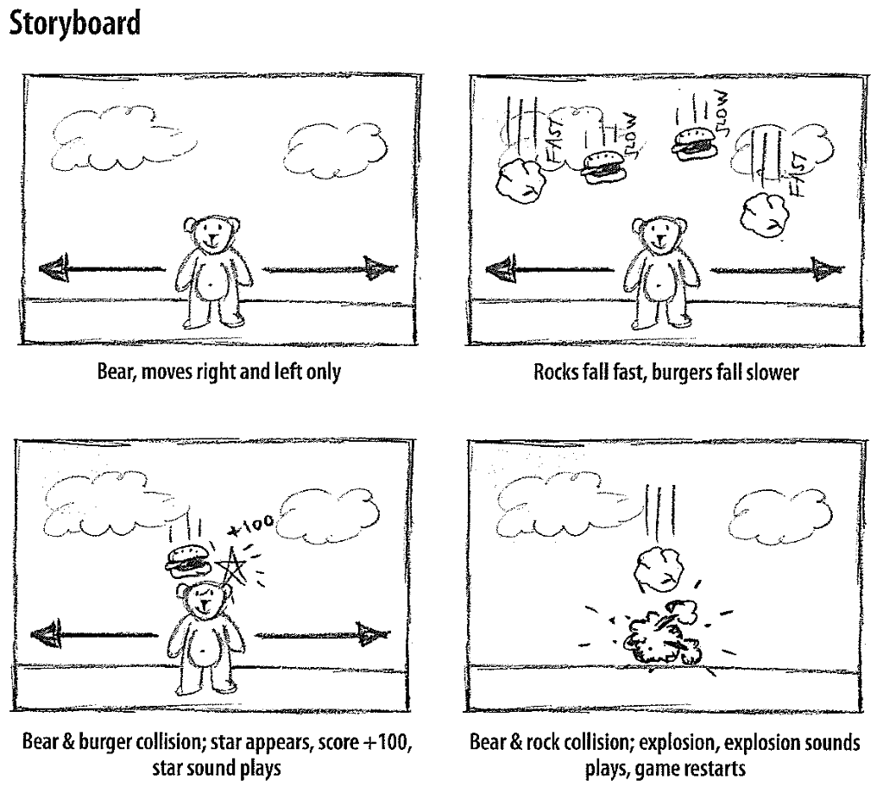

Frogger Challenge:
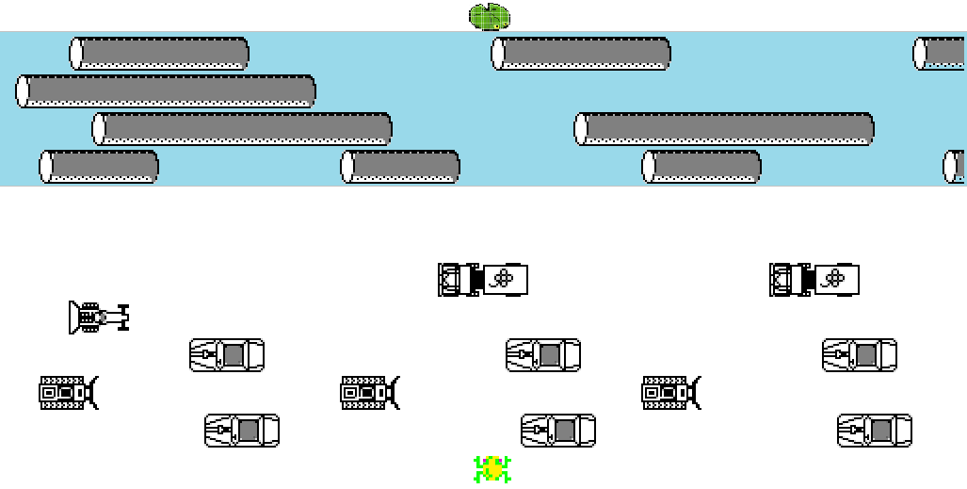

Spaceship (Asteroids) Challenge:
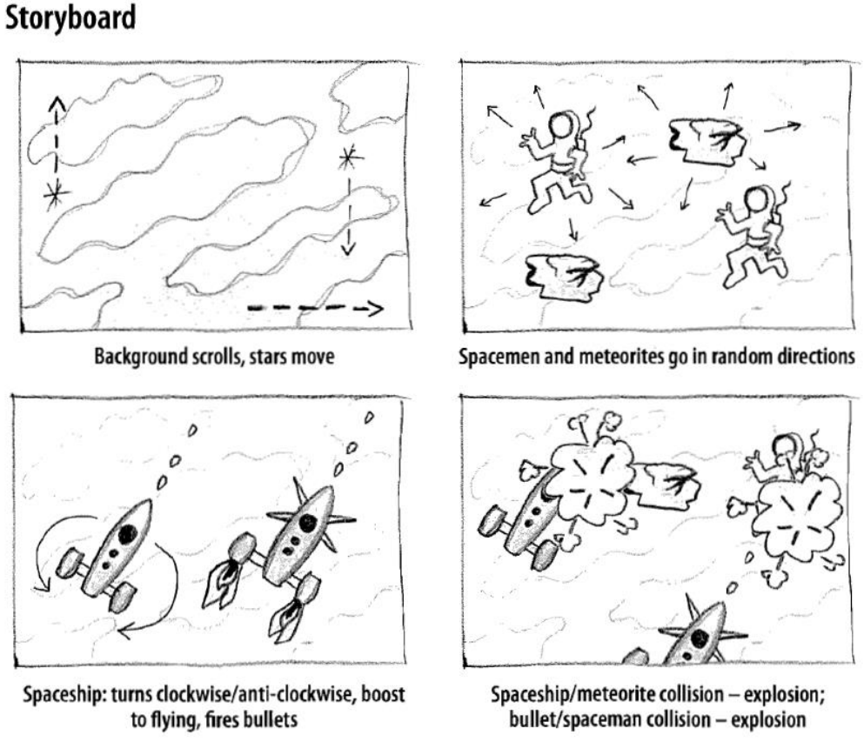

Forest Archery Challenge:
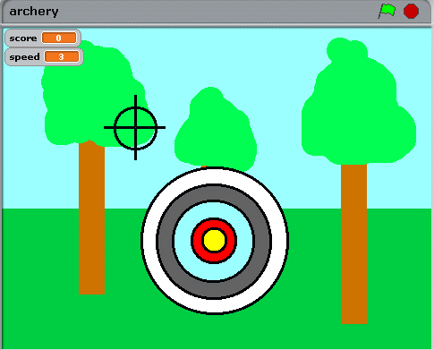
- Target moves around randomly but smoothly, altering direction every couple of seconds (so there is some prediction)
- Each time the player scores a hit on the target, the target shrinks (i.e. it decreases in size)
- If it gets too small after too many hits, it resets to its original size, but the speed increases
- There are points depending on where you hit on the target
- There should be a penalty for a miss
- The game could finish on a negative score. Alternatively, you could use a timer to signify the end of a game, and give bonus time for good performance.

Extend and refine knowledge:
Draw these images programatically (i.e. using the pen tool, and control blocks):

Image | Paste code here:
 | Click here to enter text.
 | Click here to enter text.
 | Click here to enter text.
 | Click here to enter text.
 | Click here to enter text.
 | Click here to enter text.
(Images sourced from: http://scratched.gse.harvard.edu/guide/download.html)

Use knowledge meaningfully:
- Create a Scratch level management framework that has a play state, end game state, and a start-up state, and uses broadcast to switch between these states. You can indicate the different game states by changing the backgrounds of the stage.

- You are exceptional for making it this far! Time for some advanced physics. Finish the advanced challenges:
  - Breakout
  - Platform / jumping / gravity
  - Swing / pendulum physics
  - Turret / catapult physics
  - Car drift physics

