Draw dude on swing:
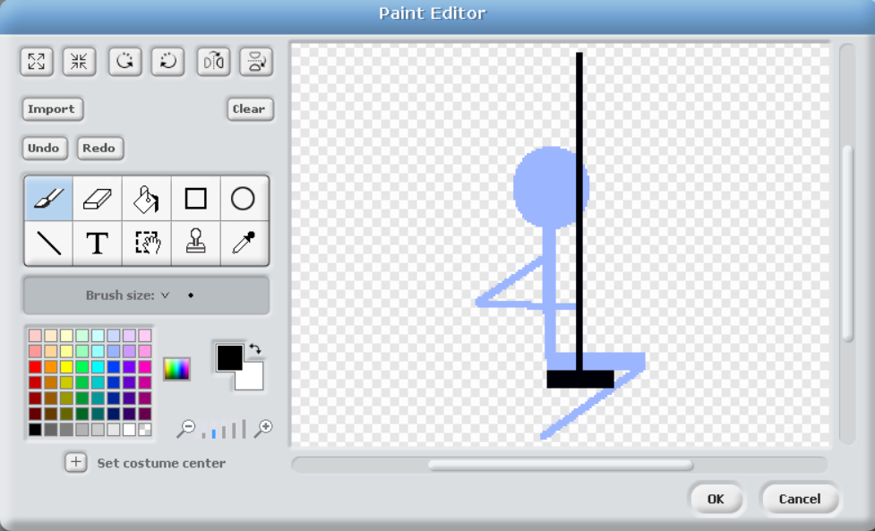
Rotate so it is aligned with empty sprite direction (new sprites always spline left-to-right):
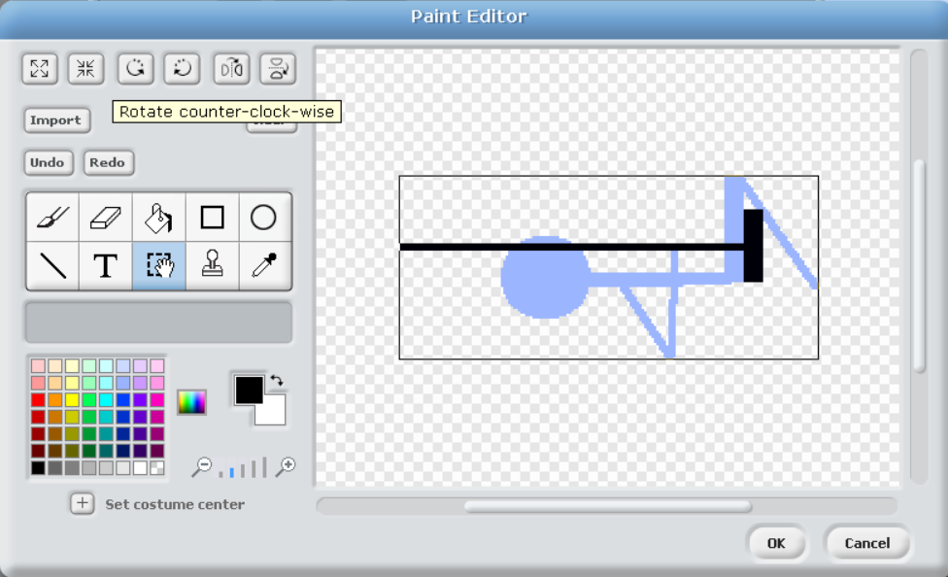
Set rotational point at top of swing – this is the pivot point – very important!:
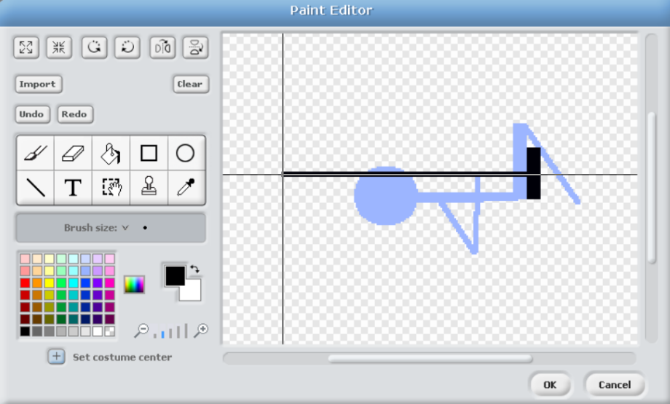
Code:
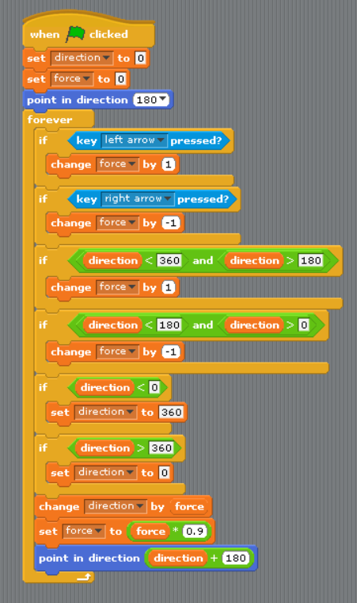

Challenges
Can you improve the game by implementing some of the following features?
- Turn the swing into a wrecking ball
- Can you make the wall deteriorate (health), and gradually (and visually) decay over collisions
- Can you turn this into a game

