Worksheet 4: Events
Learning Intentions: We are learning to be able to …
Make sprites respond to mouse and keypress events.

Why are we learning this?
Providing control to the user over our interactive elements greatly improves the UX.

Success Criteria: I will be successful if I can …
Develop a fluent interface to best control a main characters movement and direction faced based on the context I am working on.

Instructions:
Acquire and integrate knowledge:
Try each of the following scripts on a cat sprite on a new Scratch document. There will be questions after you have tried each of the control methods:

Control Method | Script
“Snap to a Grid”
“Moving and Turning”

“Always Moving”
“Follow the Mouse”

- Which of the above control methods might be best suited to a game of:
  - Pacman: Click here to enter text.
  - Frogger: Click here to enter text.

- If I wanted to make a sprite disappear when I clicked on it, I could use this script:
When I pressed space bar, I’d like to reset my game and show my hidden sprite. What script blocks would I use to do that?
Paste screen shot of your completed script here.

- If I wanted to make a two player game, I could use other keys on the keyboard within a keypress event:
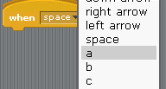
To fit two players on one keyboard though, I may have to select my keys carefully. What keys would you use for player one and two on a driving game? (e.g. accelerate, brake, turn left and turn right).
Click here to enter text.

Extend and refine knowledge:
We are yet to cover sensors, although sensors will often affect our movement. For example, the “Follow the Mouse” control method above can be implemented as a “Follow the Mouse Click”:

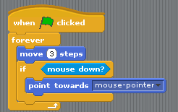

Similarly, we can rewrite the “Always Moving” control method above the same way:
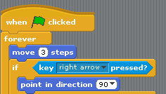

- Can you finish the re-written “Always Moving” control method?
Paste screen shot of your completed script here.

- Can you rewrite the “Moving and Turning” and “Snap to a Grid” methods the same way as well?
Paste screen shot of your completed script here.

Use knowledge meaningfully:
Looks, Pen and Sound:
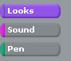
By integrating events with looks, sound and pen actions, you can make sprites change colour, shape and size, or build an electronic piano, or even create your own art drawing program. These worksheets will leave you to discover these effects yourself.

- Can you make a Scratch program that allows me to grow and shrink the cat?
Paste screen shot of your completed script here.
- Can you make a Scratch program that creates an electronic sound board using the instruments provided in Scratch?
Paste screen shot of your completed script here.
- Can you make the “Always Moving” control method above leave a line where it has travelled?
Paste screen shot of your completed script here.

