Worksheet 5: Sensors
Learning Intentions: We are learning to be able to …
Make sprites interact with other objects on the stage.

Why are we learning this?
Interaction between objects formulates the basis for collision triggers.

Success Criteria: I will be successful if I can …
Detect another sprites:
- Collision
- Movement and direction
- Current state

Instructions:
Acquire and integrate knowledge:
Zoom into the stage on a new sprite (with nothing drawn) to find the rotation point (aka pivot point, origin, or costume centre point):

Add a sprite that is a picture of a ball, with the costume centre in the middle centre of the ball:
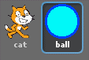

Run the following script on the cat:
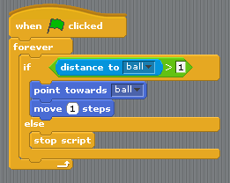

- If I change the above movement block to “move 5 steps” (instead of 1) the script will likely never stop running. Why not?
Click here to enter text.

- Here is the same script with a slightly different condition block. The previous condition block checked if “distance to ball > 1”, whereas the following condition block checks if “not touching ball”:
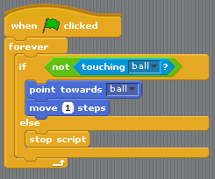
What are the two different results I get when I run each of these condition blocks separately (from question 1 and 2)?
Click here to enter text.

- Now I want to move my cat to the ball and stop, but only when I’m pressing space bar:

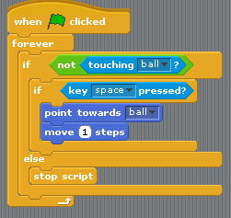
The “key space pressed?” condition in this circumstance is also part of a “nested” if-statement. Why do you think it is called “nested”?
Click here to enter text.

- Which condition would I change in the previous condition to make the cat move only when my mouse button was down? Also what would the new condition be?
Click here to enter text.

Extend and refine knowledge:
Draw a red line on the background of the stage that you do not want your cat to cross:
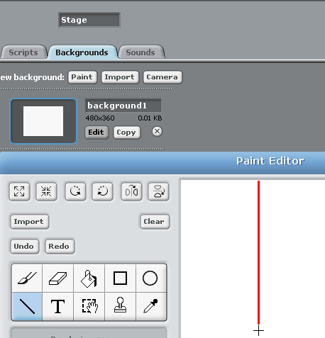

Add the following script. If your cat crosses the red line, it should bounce straight back:
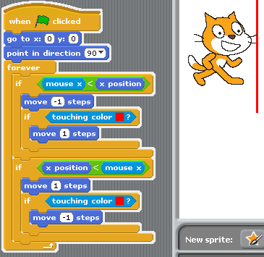

- Explain, in your own words, how the above script works.
Click here to enter text.

- Why wouldn’t this work as the script in question 5 intended? What goes wrong?
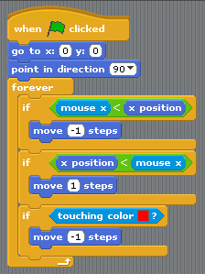
Click here to enter text.

Use knowledge meaningfully:
Have a go at creating a simple maze game (the following excerpt taken from http://scratched.gse.harvard.edu/guide/download.html):
Algorithm for moving explorer | Code
when the flag is clicked
repeat forever
if right arrow key is pressed point right
move 5 steps
if left arrow key is pressed point left
move 5 steps
if up arrow key is pressed point up
move 5 steps
if down arrow key is pressed point down
move 5 steps
if explorer touches the same
colour as the maze wall
go back to starting position

- Can you add some on-going background music, as well as different costumes for the different directions faced?
Paste screen shot of your completed script here.
- Can you add an enemy, that when I touch it, it sends me back to the start of the maze?
Paste screen shot of your completed script here.
- Can you make it a two-player game?
Paste screen shot of your completed script here.

