Worksheet 6: Challenge – Pacman
Learning Intentions: We are learning to be able to …
Make decisions on how to integrate user events with Scratch’s motion system for a particular context.

Why are we learning this?
The problem solving process is an action-ongoing process, which requires you to analyse, plan, implement, reflect and refine.

Success Criteria: I will be successful if I can …
Develop a solution to the Pacman problem, utilising:
o A best possible control system
o Sprite sizing, direction fixing or costume adjustment where necessary
o Obeys game play laws:
- Side wall boundaries
- Enemies

Instructions:
Acquire and integrate knowledge:
- Draw Pacman, setting costume center:
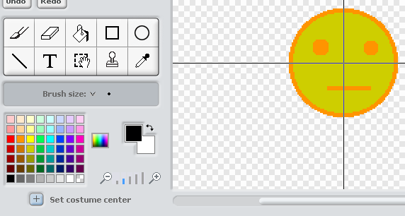

- Draw maze, using a simple outline of a maze on the background area of the Stage:
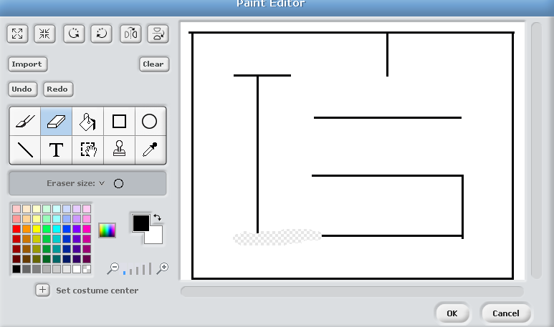

- add Code Blocks to Pacman:
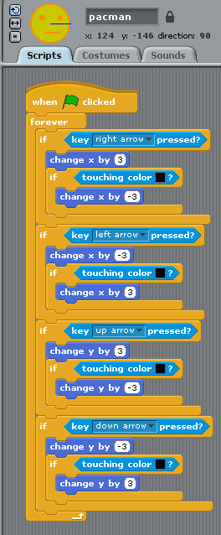

- Finished product, test and play:
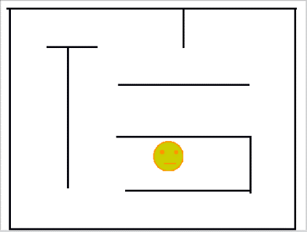

- Can you:
  - Add background music?
  - Add costumes for going up, down, left and right, that change?
  - Animate the costumes?

Extend and refine knowledge:
- Can you also:
  - Add an enemy?
  - Add edible pellets that hide when collided?
  - Add a second player?
  - Add a timer? (there is one available in the sensing blocks area)
  - Screen wrap a corridor / tunnel from one side of the screen to the other
  - Improve the control mechanics at all – i.e. can my Pacman maintain speed and direction without holding the keys down?

Use knowledge meaningfully:
- We haven’t studied variables yet, but if you want to read up on them here - https://wiki.scratch.mit.edu/wiki/Variable - you can, and perhaps you can also:
  - Add scoring
  - Add bonuses:
    - Super pellet pickups (invincibility, but only appear after some time)
    - Fruit (random appearing, increase score)

