Worksheet 7: Variables
Learning Intentions: We are learning to be able to …
Understand what a variable is and how it can help us in Scratch.

Why are we learning this?
Variables are used to perform logic, comparisons and other tasks in all computer programming languages.

Success Criteria: I will be successful if I can …
- Explain what a variable is
- Create a variable in Scratch
- Lookup and modify the value of the variable using code blocks

Instructions:
Acquire and integrate knowledge:
There are many definitions of what a variable is, but basically it’s a named place in memory that stores a type of value that can be used and manipulated:

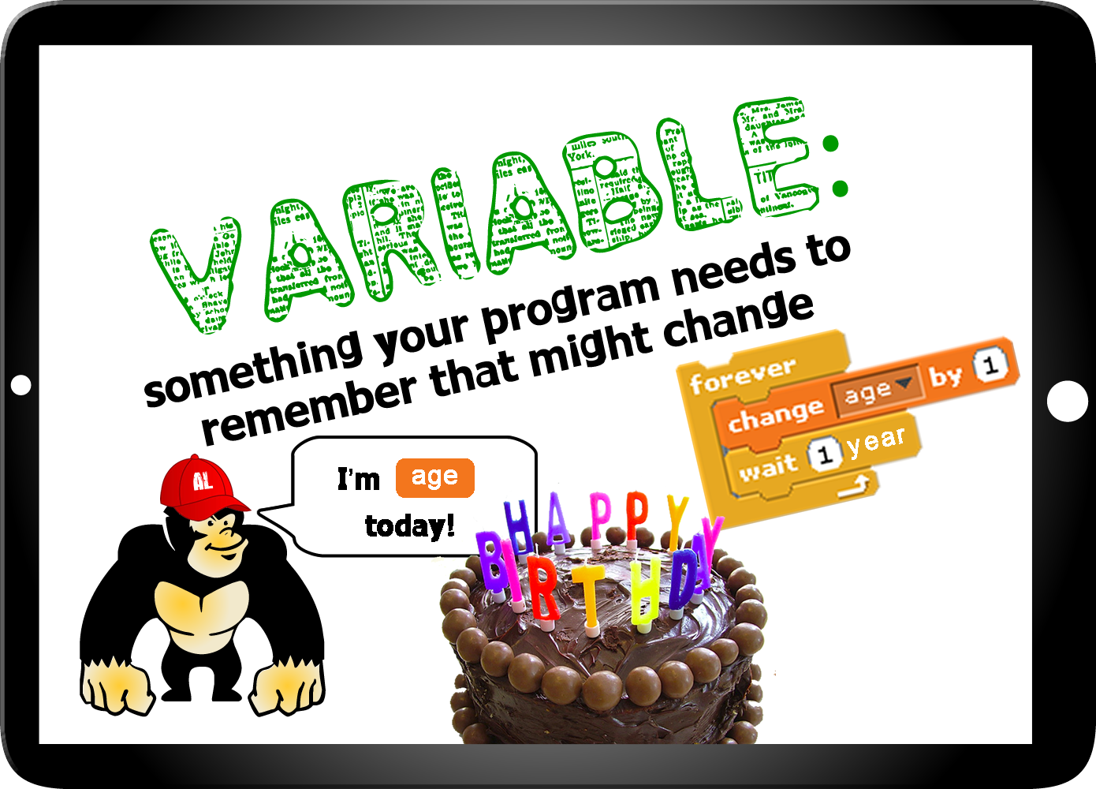

In Scratch we can can create variables for use in single sprites, or make them available to all sprites:
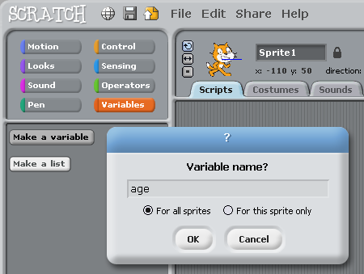

- Open a new Scratch file, and create the age variable as shown in the diagram above on the cat (the age variable can be used by all sprites)

- Add the following script to the cat:
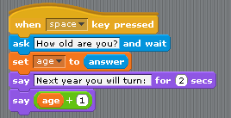

- Can you rewrite the above script, so that it asks the user for their name, and says hello to them. For example, my name is Herbert, so the program should ask me for my name, then say “Hello Herbert”.
Paste screen shot of your completed script here.

- Add a cat, ball and dog sprite to a new Scratch file, and create a variable (for all sprites) called score (it won’t matter which sprite you create the variable on, as it will be available to all sprites anyway):
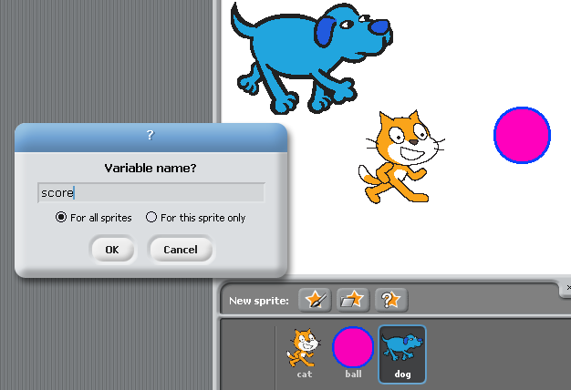

- Add the following script to the cat sprite:
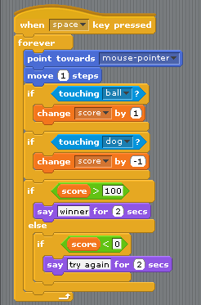

- Play the game (so far). What is one way you would recommend to improve it?
Click here to enter text.

Extend and refine knowledge:
- Implement your improvement from question 6.
Paste screen shot of your completed script here.

- The code blocks from question 6 have not been written using parallel scripting blocks (I.e. it’s all in the same event – when space key pressed. There is nothing wrong with this, however we could modularise this code – so that we have a block that deals with scoring, a block that deals with movement, etc. Can you re-write the code so that it mimics this concurrency using parallel scripting? Hint – this is how you can start:
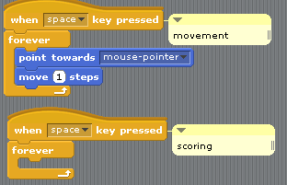
Paste screen shot of your completed script here.

- Explain in your own words what the different operators we have used so far mean, and give an example to help your explanation:
Operator | Explanation
* | Click here to enter text.
pick random to | Click here to enter text.
> | Click here to enter text.
< | Click here to enter text.
+ | Click here to enter text.

Use knowledge meaningfully:
Boolean logic is an important part of most programming languages. You can read about Boolean logic in Scratch here - https://wiki.scratch.mit.edu/wiki/Boolean_Block

Look at the following two examples of scripts running on the cat:

“And” Boolean logic
“Or” Boolean logic

- How will each of these examples of Boolean logic run differently?
Click here to enter text.

- Try this simple game of guess number by putting this on any sprite in a new Scratch file:

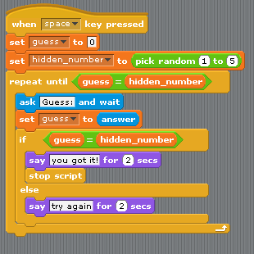

- You can compound Boolean logic statements, for example, if I wanted to only give 3 chances (or “try’s”) to the user to guess the number:
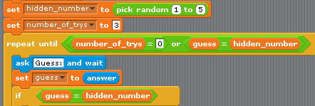
Can you finish this script, so that it only allows the user 3 guesses at the hidden number?
Paste screen shot of your completed script here.

- Can you add a scoring feature – such as number guessed right, number guessed wrong?
Paste screen shot of your completed script here.

- Can you turn this into a game of Higher / Lower, or Hotter / Colder? (you choose)
Paste screen shot of your completed script here.

