Worksheet 7: Challenge – Paper Scissors Rock
Learning Intentions: We are learning to be able to …
Integrate variables, conditions and control blocks to create game logic

Why are we learning this?
The block skills we are learning to program with here directly translate into coding syntax for the future

Success Criteria: I will be successful if I can …
Create and play a game involving game logic in Scratch.

Instructions:
Acquire and integrate knowledge:
Create any sprite on the stage, and add the script to it on the following page:

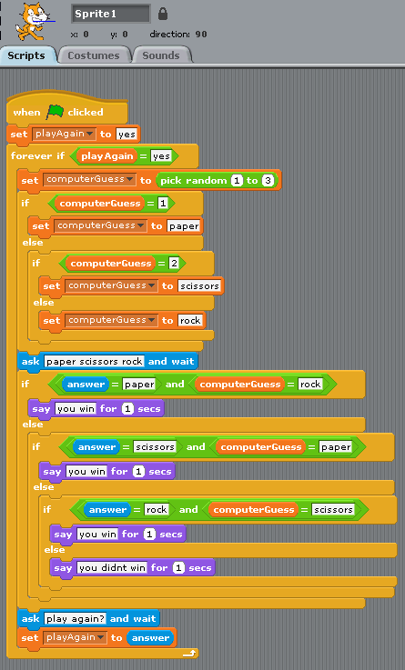

Test and play:
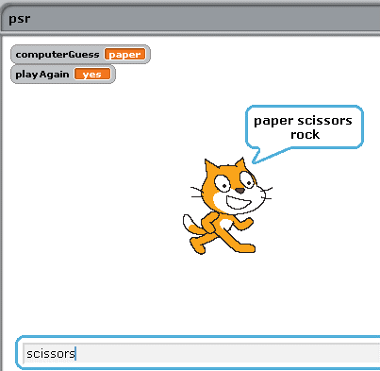

- Why is the game in its current state too easy?
Click here to enter text.

- How could you fix this?
Click here to enter text.

- Improve the aesthetics of this game, including the graphics and prompts.
Paste a sample screen shot of your completed game here.

- Add comments to the script, to explain each section to a fellow coder.
Paste screen shot of your commented script here.

Extend and refine knowledge:
- The variable usage in this current script is very poor. The variable “computerGuess” is initially assigned a random number value of 1 to 3, but then it is reassigned with a word value (“paper”, “scissors” or “rock”). This is bad programming practise – to change “data types” in this way. Your task is to fix this – create separate variables, one that holds the random number value, the other that is assigned the word value.
Paste screen shot of your completed script here.

- Animate the sprites, so that if I choose paper, a picture of paper should appear. Likewise, the computer should have a hidden visual image, that shows their guess when its time.
Paste a sample screen shot of your completed game here.

Use knowledge meaningfully:
- Can you add a scoring feature – such as games won, lost, tied, and total number of games played?
Paste screen shot of your completed script here.

Try this simple maths game:
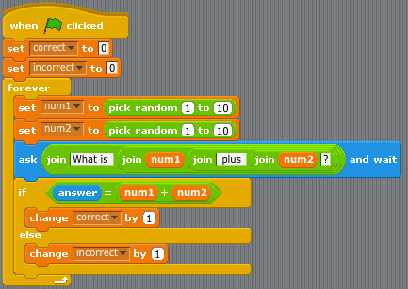

- Can you use the concepts of logic covered so far to simulate a dice roll?
  - Can you add the graphical face of the dice depending on roll?
  - Can you add a second dice, and tally (and display) the total?
Paste screen shot of your completed script here.

- Can you use the concepts of logic covered so far to simulate a card draw?
  - You don’t need to graphically display all 52 cards.. just stick to one suit (13 cards in the deck total)
  - Can you add a game play element to the card draw game?

