Worksheet 9: Broadcast
Learning Intentions: We are learning to be able to …
Broadcast messages between objects

Why are we learning this?
So that we can reuse bits of code by calling them when we need them, thus making our programs more modular

Success Criteria: I will be successful if I can …
- Send a message to another object
- Receive and act on a broadcast message

Instructions:
Acquire and integrate knowledge:
- Import the Computer and Switch images as separate sprites into a new Scratch project, and draw a circle to represent a “packet” of data (also in a new sprite):

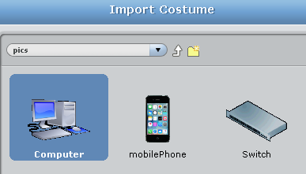
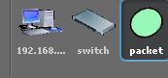
- Name the switch and packet sprites… but name the computer with a unique “IP Address”, in this case 192.168.1.1

- On the packet sprite, create three variables that will be used for all sprites – data, destination and source:

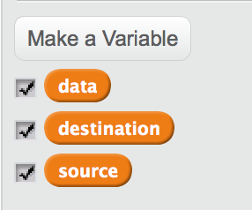

- On the computer sprite (currently named 192.168.1.1), add script: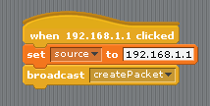
Hint: you’ll have to create a new broadcast message to make this work:

- Duplicate the computer sprite a couple of times, each time altering:
  - The name of the sprite (e.g. 192.168.1.2, 192.168.1.3, etc.)
  - The code block that contains the set source script – make sure it matches the same name of the computer it is attached to

- Back on the packet sprite, add the following script: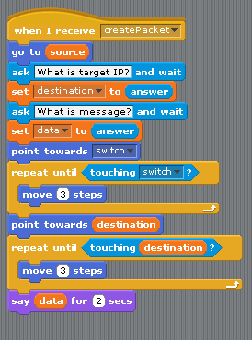

- You have simulated a model of a LAN. What does LAN stand for? (in computing terms, use Google if you have to) –
Click here to enter text.

- How did the broadcast message block make it easier to duplicate the computers?
Click here to enter text.

- Define these basic networking terms using Google:
  - Router: Click here to enter text.
  - Hub: Click here to enter text.
  - Switch: Click here to enter text.
  - Bridge: Click here to enter text.
  - Modem: Click here to enter text.

- Explain what is contained in the basic 3 sections of a network packet of data (use https://computer.howstuffworks.com/question5251.htm):
  - Header: Click here to enter text.
  - Payload: Click here to enter text.
  - Trailer: Click here to enter text.

Extend and refine knowledge:
- On a new Scratch document, import the computer, router and switch images into separate sprites. There is no code on these:
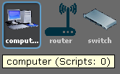

- Draw a new sprite named cable. It has two costumes, ethernet and fibre: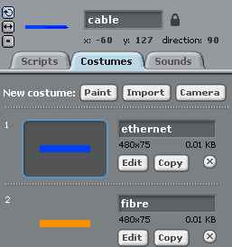

- In the Scripts tab for the cable, make a new variable for all sprites called cable_speed, and add the following script:
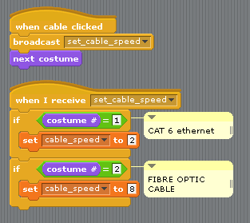

- Import the mobile image into a new sprite (and name it mobile). In the Scripts tab for the mobile, make a new variable for all sprites called wireless_speed, and add the following script:
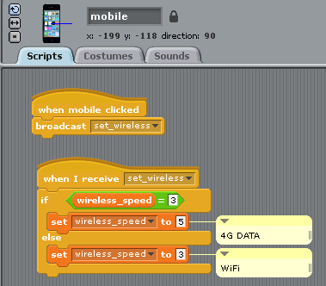

- Finally, draw a circle (in a new sprite) to represent a packet of data. Name it packet, and add the following script:
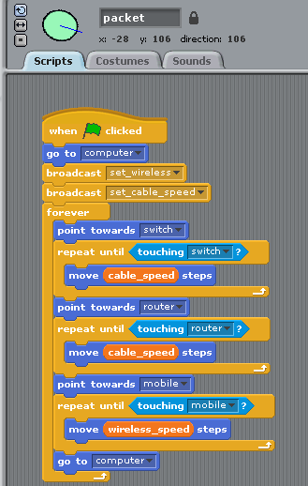

- You may have to do some calculations based on your own experience with network speeds in your area, as to the ratio of how much faster Ethernet / fibre / 4G / WiFi are (in comparison to eachother). Sometimes ISP’s cap speeds, other times network congestion can really affect your average speed. For example:
Technology | My Average Speed | Multiplier in Scratch
Ethernet | 100 Mbps | 1
Fibre optic | 400 Mbps | 2
4G | 250 Mbps | 2.5
WiFi | 150 Mbps | 1.5
I ended up doubling my multiplier in Scratch – as long as the animation is relative, it’s ok.
Research and adjust your own personal relative speeds in Scratch, then paste screen a shot of your completed script here.

- What other wireless or wired technologies are there, whether they exist now or in development (e.g. 5G). Make a list here and their relative speeds:
Click here to enter text.

Use knowledge meaningfully:
- Discuss the advantages and disadvantages of a wireless and wired network.
Click here to enter text.

- Imagine a small elevator / forklift style “bucket” with 3 buttons to control it in a warehouse:
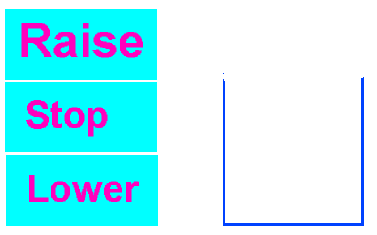
Use broadcast messages to remotely control the “bucket” using the 3 on-screen buttons.
Paste completed script here.

